פעולה 9 גלאור רביב ומור כהן, LA
פעולה – מיהו גיבור?

קהל יעד: ח'-יב'

מטרה: להעמיק את מושג הגבורה והגיבורים שלנו היום

עזרים: *שבילי גבורה – יצחק שדה, מודפס לכל החניכים
* לוח משחק (לוח סקוטשים) של העיטורים בצה"ל.

מהלך הפעולה: 1. סרטון
2. בחירת תוכנית המסמלת גבורה
3. הגדרת המושג 'גיבור'
4. שבילי הגבורה – יצחק שדה
5. גבורה בצה"ל – משחק על עיטורים שונים

פעולה:
- סרטון – גיבורים בסרטים, ראיון של אנשים שונים- מי הגיבור שלך? , ראיון של אנשים מבית הספר העונים לשאלה זו, תמונות של אנשים שונים היכולים להיות גיבורים.
(קישור לסרט: http://www.youtube.com/watch?v=XDLlswlwd2U )

- בחירת תוכנית המסמלת גבורה – (נספח 1) מציגים בפני החניכים 3 תוכניות טלויזיה בסימן גבורה שהקרינו בארץ לקראת חנוכה. אחרי שקוראים את כל התוכניות, אומרים לחניכים שערוץ בארה"ב עושה 'שבוע גבורה' וביקשו שנשלח תוכנית אחת בנושא גבורה.
- שואלים את החניכים: איזו תוכנית הייתם שולחים? למה? מדיינים על הנושא.

- הגדרת המושג גיבור – ע"פ הדיון הנ"ל, מבקשים מהחניכים להגדיר מיהו גיבור. ( אפשר לעשות 'סערת מוחות' ולרשום על הלוח , ע"מ שיהיה יותר ויזואלי)

- שבילי הגבורה –(נספח 2) מחלקים לחניכים דף עם הקטע הנ"ל של יצחק שדה. מציגים את יצחק שדה, שהיה איש צבא, מראשי הפלמ"ח ומייסדי צה"ל, ואז קוראים איך הוא מגדיר גבורה. דיון על הקטע.

- גבורה בצה"ל- משחק – גם בצה"ל נותנים עיטורים שונים כאות הוקרה לגבורה, עוז וכו'. ננסה להכיר את העיטורים ולהכיר מס' חיילים שקיבלו אותם:
- מכינים לוח סקטושים בצורה כזו:

שם העיטור | הסבר העיטור | חייל שקיבל את העיטור
עיטור הגבורה
עיטור העוז
עיטור מופת
צל"ש

התלמידים צריכים להתאים את ההסבר לעיטור- ואת המקרים של החיילים השונים שקיבלו את העיטור. (נספח 3)

נספחים:

נספח 1:
Show #1

In the 1st show, a military sergeant spoke about his part in a mission to take over an enemy’s base in the south.

“It was pitch black outside…we could not see a thing. We had to pass a fence and reach the base, but the barbed wires were tangled…our General screamed out: Who is doing the job?
Without even thinking, I immediately jumped up and volunteered. I had to lie down on top of the barbed wire fence so that the rest of my friends could pass the 1st obstacle. I got up from the fence and bullets were being fired all around me…I started running to the enemy’s base while throwing grenades and firing my weapon at the enemy. An enemy’s bullet scratched my right hand, but I kept running…I had to…I wasn’t scared, I knew somebody had to do it…If not for me, the mission might fail…It was extremely difficult. All of my fellow soldiers were liying down under the base’s entrance because of the heavy fire that was aimed at us…and then I decided I must stop he enemy’s fire. I got up, ignoring the heavy fire and attack we were under, and I threw a grenade towards the source of the shootings. My life was at risk…I did it for my country, my land…”

Show #2
In the 2nd show, Nadya Toutreshtein, a new immigrant from Russia spoke about the mission of printing a Hagada for Pesach in Russia.

“ It was about a month before Pesach, and we wanted to have an appropriate Seder for Pesach, but we did not have Hagadot. There were laws forbidding Jews to celebrate Pesach and to buy Hagadot…but I decided I was going to do it, no matter the cost.
I dressed up as a Christian priest, and I entered a church. At the church, I went to the library and snuck out one Hagada. In order to create more copies of the Hagada, I recruited a few friends that were active in the Jewish community to help me out. We opened a small printing house for Hagadot for Pesach. The risk was enormous…If we were to be caught, we would have been sent to Siberia…I don’t wish that to anyone…
We went to the stores and bought only two sheets of white paper at a time...any more would have raised a suspicion...We found an old machine...I told my neighbors I was going away for a week but really I stayed in my basement, so that they would not hear the noise from the machine…It was hot and crowded, we had very little water…Several times we heard knocks on the door, my heart almost stopped beating…Finally, with much effort, we successfully printed 6 copies of the Hagada LePesach, 1 for each 2 families. It was also forbidden to have the Seder, so I risked my life again and we had it in my basement…Today, in Israel, things are quite different…”

Show #3

In the 3rd show, Avi, a teacher, talked about a child he worked with in the mentoring program they had at school. (Big Brother Big Sister Program). Avi received a shy, closed second-grader that had terrible complications both at school and at home. At first, the pairing between them seemed unfitting, but something in the boy’s eyes caught Avi and he decided to try to work with him anyways.

“The beginning was very difficult…many long hours I tried to break the barrier the child built around himself. It was a great challenge. Slowly, however, my efforts started paying off… At the same time, I suddenly felt as if my whole life is revolving around this child. I started getting lower grades at school; I neglected my connection with friends and stopped doing the hobbies I used to during my free time.
My friends started mocking me: “Is the child willing to let you out for a few hours?!” I started turning from a popular and loved person to a source of laughter and sarcasm. I felt awful…The hardest part was when I had to decide if to participate in the school’s basketball championship (Which I really wanted to be in) and leave the second-grader or to continue working with him but give up the championship…my social state was at stake…At the end of the year, I received the school’s Mentoring Award.”

נספח 2:
Yitzhak Sadeh, (1890-1952) was the commander of the Palmach and one of the founders of the Israel Defense Forces at the time of the independence of the State of Israel.

Pathways to Valor (Heroism) -- Yitzchak Sadeh

Heroism is not the peak of achievement. It is a pathway towards a goal, a path that allows for no shortcuts. Like all paths, it has its branches, and sometimes those branches lead downwards. The true path always leads in one direction: to the top of the mountain. We try to find the path to heroism for ourselves, despite the risk falling off course, of falling into the abyss.
Let us note that the essence of heroism is not bravery, but rather a readiness to sacrifice oneself. Heroism can even manifest itself in the coward, so long as he is willing to make such a sacrifice. Indeed, true heroism reveals itself in the way we live our lives each day. We normally associate the term “heroism” with those in the military, for understandable reasons: the soldier is willing to sacrifice himself, is that not the ultimate sacrifice?
This, however, is far from the only pathway to the peak of heroism. It may be a pathway that we idealize, but recall that there are thousands of trails to the top of the mountain.
Heroism takes precedent over all moral values in that the sacrifice that it demands is not a cruel or selfish one, but is rather the ultimate form of giving. At its core, heroism in the love of the other.

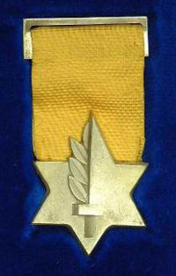
נספח 3:
Israeli military decoration

Medal of Valor
The highest Israeli military decoration. The medal is awarded for an act of heroism in front of the enemy, at a risk of life.
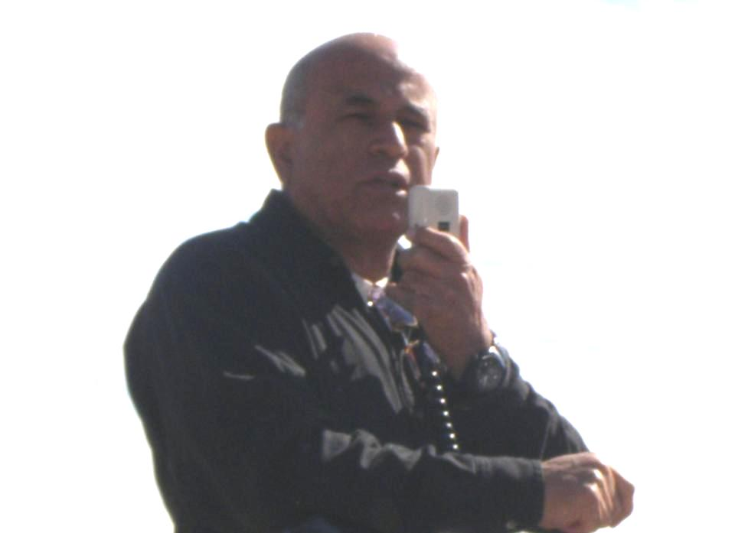
To this day, 40 medals have been awarded: 12 during the Independence War, 5 during the Sinai War, 12 during the Six-Day War, 8 during the Yom Kippur War and 3 others awarded on other occasions.

Avigdor Kahalani
During the Yom-Kippur War, Avigdor Kahalani commanded a hastily assembled group of tanks and crews from different armor units. The group repelled a vastly superior Syrian force which had overrun the Israeli positions in the first days of the war, in the Golan Heights region of northern Israel. During the battle Kahalani stood outside the tank turret so all the soldier would be able to see him. It is a rear thing to do and almost cost Kahalani's life. The battle proved to be one of the turning points of the war. After the war, the valley where it took place was littered with dozens of burned Syrian tanks and was renamed "Emek Ha-Bacha" ("The Valley of Tears").

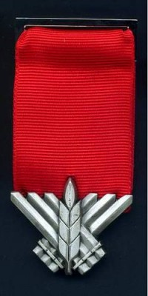
Medal of Courage
The medal is awarded for an act of gallantry at the risk of life, during fulfillment of combat duty.
To this day 220 awards have been made, the latest were in 2005 after a period of 23 years in which the medal was not awarded. In 2007 it was announced that the medal would be awarded to six soldiers who fought during the Second Lebanon War.
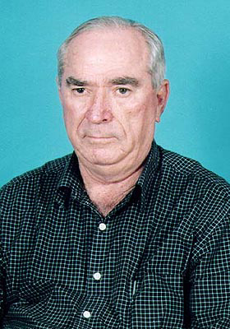

During a raid to Syria in 1955 Rafael Eitan went in front of his soldiers. While standing on a cliff facing the enemy's fire, he destroyed a shooting spot which prevented the Israeli soldiers from moving.

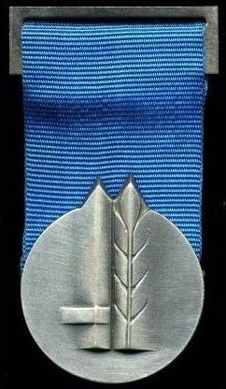
Medal of Distinguished Service
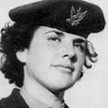
The medal is awarded for an act of exemplary bravery in the line of duty. To date, 600 medals have been awarded, the last in 2007. Two recipients have been awarded the medal twice.

Esther Arditi was a medic in the Israeli air force. A week after she started her service, a military plane was crushed during training near Arditi's base. Ester, only 17 years old, drove on the ambulance even though she didn't have a driving license. When she came to the burning plane she heard the navigator's shouting and hurried to rescue him. After she putted the injured navigator in a safe place she returned the plane to save the pilot. Few seconds after she went out the plane with the pilot the plane exploded. Esther Arditi is the only female who received the Medal.

Chief of staff citation (Tzalash)
The citation is awarded for an act of excellence that is not reach with its rank to a medal.

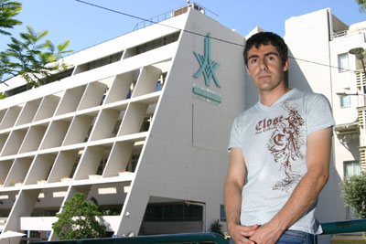

Haitem Saab
During the Second Lebanon War a building, with soldiers from "Orev" company, was attacked with Anti-tank guided missiles. Numbers of soldiers were injured and Haitem Saab, a doctor in the medical corps who volunteered to go the war, was one of them. Dr. Saab was injured in his eyes, got shards in different parts on his body and because of the shocks wave his ability to hear got weaken. Despite his condition he refused to evacuate and start providing first aid to at least ten soldiers. When the tank arrived to get the injured soldiers Dr. Saab stayed until the last soldier was released.

