Prayer for the Safe Return of Israel's POWs and MIAs
May He who blessed our fathers, Avraham, Yitchak and Yaakov, Yoseph, Moshe and Aharon, David and Shlomo bless, guard and protect our prisoners of war and IDF soldiers missing in action, including:
Ron ben Batya (Arad),
Zachariah Shlomo ben Miriam (Baumel),
Yekutiel Yehuda Nahman ben Sara (Katz)
Zvi ben Pnina (Feldman),
Omer ben Hadra (Suewed),
Binyamin ben Edna (Avraham),
Adiel ben Zipora (Avitan),
Elchanan ben Rivka (Tannenbaum),
and our brothers who are imprisoned in Iran, among all our other brothers who belong to Am Yisrael and are in distress and being held captive for the sake of this community which prays on their behalf.
May Hashem be filled with mercy for them, and bring them out of darkness and the shadow of death, may He release their bonds and save them from anguish, and return them speedily to their families and may salvation come swiftly. And may the words of the Nevi’im be fulfilled, as it is written: "Those redeemed by God will return and arrive at Zion with glad song and eternal gladness on their heads, joy and gladness shall they attain, and sorrow and misery shall flee”
and let us say, Amen.

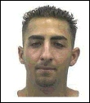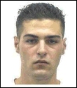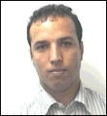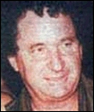
Adi Avitan
219 Days Missing
Omar Souad
219 Days Missing
Benny Avraham
219 Days Missing
Elchanan Tennenbaum
211 Days Missing

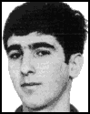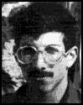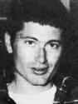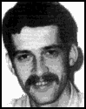
Ron Arad
5324 Days Missing
Zechariya Baumel
6912 Days Missing
Tzvi Feldman
6912 Days Missing
Yehuda Katz
6912 Days Missing

