Ehud ben Gera
Written by- Sarah Gordon
sygordon@gmail.com

Many of the ideas from these shiruim are adapted from the book "Shofet HaShoftim" by Yisroel Rozenson, published by Machon Herzog.

Machal Shiur #6:

Goals: The chanichim should see Ehud Ben Gera’s strengths as a leader, in how he used creative measures to save Am Israel, and how he used his own weaknesses to his advantage in battle.

Background: The best way to teach this is to probably read the Ehud story pasuk by pasuk (or 3 at a time) and point out to the chanichim the crucial details needed to appreciate a very peshat but cool reading of the text. Try to make it as interactive as possible. All the questions I’ve asked below are questions you should be asking the chanichim to get them to start thinking critically and seeing the text in this new light. Basically it’s the story they know from 1st grade, but when you look at it from a peshat perspective, you start to appreciate all the details and the leadership brilliance of Ehud.

Trigger: Ask the chanichim who here has watched an episode of 24. If they haven’t, feel free to kick them out of Machal. Why is Jack Bauer such a cool character? What are his characteristics as a leader? How is he able to save the day all the time? Jack Bauer in general is someone who thinks on his feet, creatively and can think out of the box to come up with creative solutions to problems to get the job done. We will see that it is the same with Ehud ben Gera (lehavdil). He is Jack Bauer!

Let’s begin: (All of the following is straight from Ralbag on these pesukim).
Perek 3:12: Shoftim cycle begins. Point out who the bad guy is and what is happening. Bnei Israel have been under occupation for 18 years (parallel it to countries in Europe under occupation by the Nazis in WW2, how would people in those countries; Poland, Denmark, France feel, and that was for only 4-5years). What do you think the morale is like now for the Jewish people? Weak! Maybe G-d abandoned them, maybe Hashem has broken His brit with them because of their sins. Then Bnei Israel cry out and G-d wants to save them, and sends Ehud.

Can Ehud just go in and organize an army to attack Moav? Why not? He can’t because the people are too weak, they have no morale, no training and no weapons – they have been under subjugation for 18 years.
So if you were Ehud what would you do now, how would you win this battle? What are ways to weaken an enemy if you don’t have an army with which to stage a frontal attack? (Get suggestions from the chanichim) One good way is to assassinate its leader! Why? Bc then army will have no leadership, will be confused, scared…etc. It’s a great way to gain an advantage and win the war without having a real all out battle. This is exactly what Ehud ben Gera (aka Jack Bauer of the Shoftim) will do.

15: Ehud is a lefty. This will be important later. He sends a gift to king of Moav. Why would he do that? Ehud wants to assassinate the king, but to do this he has to get into castle!! Most important thing to remember in Ehud’s plan is that this is not a suicide mission! Ehud needs to get in, kill king, and get out alive.

Now why send a gift? Chances are the king knows a rebellion by the Jews is about to happen and is very suspicious. Now Ehud brings a group of people (group less suspicious then one person) to bring a gift. What are they saying? In this time of rebellion we are siding with you, we are loyal Jews. Why is this smart? What will the king now think of Ehud and friends? That they are trustworthy! This won’t just get them into the castle, but it will also establish Ehud as someone trusted by the king at this time of rebellion (24, Season 3, when Jack goes underground with the Mexicans).

16: Every great assassination needs a murder weapon. Pretend you’re Ehud and you are going to assassinate someone. What type of weapon do you need? Remember, this is not a suicide mission. You need a discreet weapon, one that you can hide, but also one that will be effective and do the job of killing the king. So Ehud makes a 2 double sided sword and puts it on his right side. What is this 2 cornered sword? At first it sounds like one of those 2 ended light sabers that Darth Maul used in star wars. But really it’s just a regular sword, which has a blade which is sharp on 2 sides.
If you look at the picture from Da’at Mikra at an archeological sword from that time, a 2 bladed sword was just a regular sword that had 2 sharp edges (I love scanners, and breaking into the MMY office, yay technology).
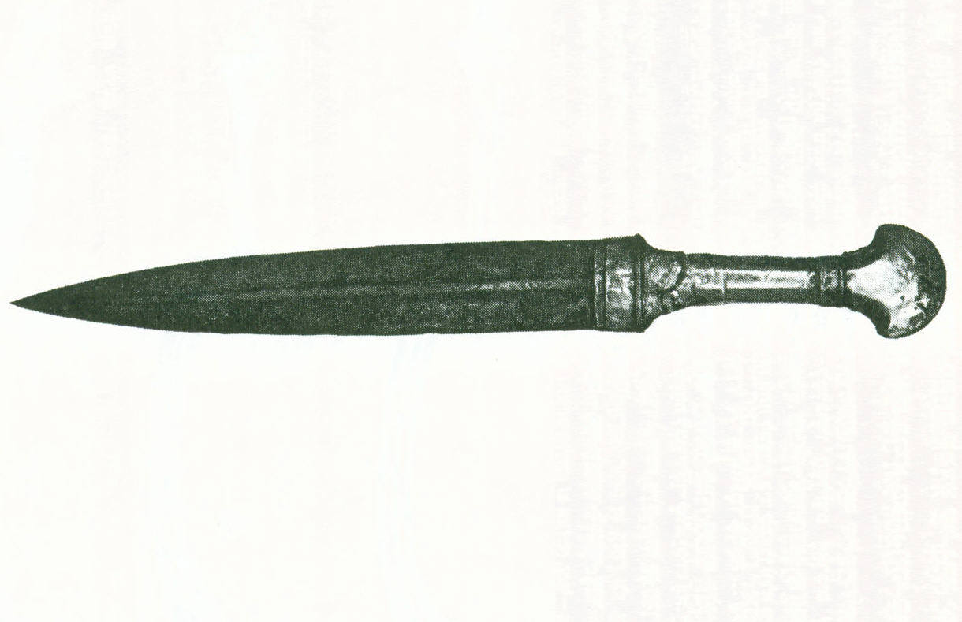

Ok….so Ehud made a normal sword – where’s the chiddush???
Ah! Look at the 2nd picture from Da’at Mikra – all swords then looked like scythes and plow tools. They were huge, curved and sharp only on one side (unlike the previous “2 sharp sides” sword). Why couldn’t Ehud sneak this murder weapon in?? Bc it is huge! He’d never make it past security with this type of a weapon.
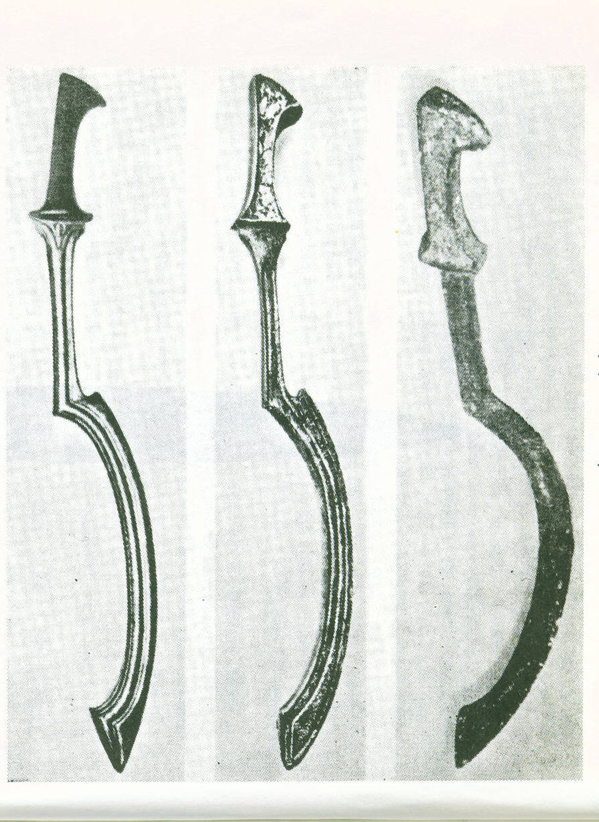
What type of criteria for an assignation weapon would you use if you were Ehud? Has to be small, easy to hide, and able to kill quickly!! This 2 sided sword is smaller, lightweight, easy to hide and super sharp!

Now Ehud hides it on the right side. Why? Remember, he’s a lefty and lefty’s draw with their left hand and keep their sword opposite on their right side. Most people being righties, have their sword on their left and draw with their right. So if you’re the security guards for Eglon’s castle and you’re watching Ehud walk in, you’re looking for hidden weapons where? On the left side, but his is on the right!! So Ehud/Jack Bauer manages to sneak in an assassination weapon into the castle!

17: Ehud gives Eglon the present and Eglon was very fat. This will be important soon. The Tanakh is foreshadowing in the story.

18: Finish giving gift. Everyone leaves including Ehud. What about the mission? Why does he leave? He leaves now to not look suspicious. To complete convincing the king that he is trustworthy and only came to give a gift. Now the king and the guards will look at him as a friend.

19: Ehud doubles back alone and comes back to the palace to tell the king he has a secret to tell him, the king kicks everyone else out of the room.

Firstly, we see from here that Ehud works alone!! Most dangerous part of mission, doesn’t want to risk anyone else. Is this a good leadership trait or a bad one?

On one hand, Ehud sends people to go rally the troops and get together the best attempt they can at an army (it won’t be good since that’s why he’s trying to do an assassination attempt) because once he kills the king, he will send a signal for Jews to attack in an uprising. Since the key moment is to attack and take advantage of the confusion that will ensue once the king is killed.
Now let’s look at the brilliance of Ehud’s plan. When Ehud returns now to the castle, what do you think the castle guards will say? Will they stop him? No, they will probably let him right in without even searching him because 5 minutes ago they saw him as the loyal guy bringing the king a gift! Ehud has established credibility! (Ask the chanichim, have you ever gone through security somewhere and then had to run out. When you came back in did they check you again or just let you right through since they already knew you?)

Now why did Ehud say he had a secret? Because if he would kill the king with other ppl in the room, he would be dead in a second and this is not a suicide mission, Ehud intends to get out alive. By saying it’s a secret he has room to talk to the king alone with out it looking shady.
What is this secret he tells the king he has? We said before that the king fears rebellion, now he has loyal Ehud here with a secret – its probably a secret of what? Probably the news of who is running the rebellion!! So of course he trusts Ehud and kicks everyone else out.

20: Ehud gets king to move closer. Why? Because the king will scream if Ehud tries to kill him from across the room, and if he screams, 30 guards will run in and kill Ehud. The only way to kill the king without getting caught is to do it by surprise.
21: Ehud takes the sword from opposite side of self (so by surprise to Eglon), and stabs king, king is so fat sword gets swallowed up. Why is this good? No murder weapon now to get rid of!!! (Nes Nistar!) Also this shows us why the Tanakh had to tell us before that Eglon was fat.
22-24: Eglon’s guts spill out on floor, gross, but good bc now it smells like a bathroom. Ehud locks the doors (to conceal murder) and the king’s chambers had a separate part as a bathroom. Ehud goes out and says the door is locked bc king is in bathroom. And place smells so they believe him!! Perfect cover story! Ehud escapes, runs halfway back to Israel and blows shofar signaling Jews to attack.
25: The servants wait until “bosh”, until its embarrassing already, what is taking the king so long?, something must be wrong. They break open doors and see the king is on the floor “met” – dead. Now what’s the word for killed? It’s “harag” – killed. But it doesn’t say that because it’s not obvious that king was murdered, could be maybe his appendix burst – which buys Ehud more time, because if they thought murder he would be their first suspect!! So now they are trying to figure out what the heck happened to the king, they don’t even suspect foul play and this gives Ehud more time to escape!

Meanwhile Jews win, kick out Moav – and all is quiet on the western front until next time Jews sin (until the Shofet dies as per Shoftim cycle).

Leadership Lessons from Ehud:

First, ask the chanichim what they think you can learn from Ehud’s leadership in this story. What leadership traits can we take out of this to apply to our own lives?

- Shoftim 3:28: Ehud gives credit and thanks to Hashem. He’s a good shofet!! Lots of times his plan could have gone horribly wrong, but Hashem was helping him behind the scenes (like Megillat Esther). Reminds the people to thank Hashem and that Hashem was behind all of this (like we spoke about Yehoshua as a ruchani leader in our 1st shiur).
- Look at Malbim 3:15: Comparing Ehud and Otniel ben Kenaz: Otniel had ruach Hashem (Shoftim 3:10) and his story is about 5 pesukim long. Ehud doesn’t have ruach Hashem, has to come up with a crazy Jack Baur plan to pull off saving the Jews, and his story takes 20 pesukim to tell. Ehud wasn’t born with leadership skills and talents, Otniel was, but both saved the day!!! This shows how even people who aren’t natural leaders can succeed. Lots of times we see people who naturally have leadership skills and don’t really have to work for anything. Or that kid who always gets 100 on tests without studying. That’s Otniel ben Kenaz. But Ehud ben Gera is a different lesson – that even if you aren’t naturally good at something (he was a lefty – nothing against lefties but you wouldn’t expect him in biblical times to be such a swordsman, doesn’t have ruach Hashem), you can use the skills that you have and a lot of hard work and achieve the same goals and be a leader.
- Ralbag 3:15: Ehud fought with tachbulot – schemes, he had to use his own creativity and hishtadlut (initiative) to fight and win battle, but still believed and thanks Hashem for help. Now in this stage of living in Eretz Israel, and no longer being in the Midbar, Am Israel must rely on tachbulot and natural means to fight their wars, and then Hashem will respond and help them – but it’s still possible to win even with no more open miracles.

Conclusion: The chanichim should see the cool peshat reading of this story in Tanakh, and should see all the valuable leadership lessons from Ehud, and how he used creative ways and leadership skills to help save Am Israel, despite his and the nations personal handicaps.

