Parshat Vayishlach

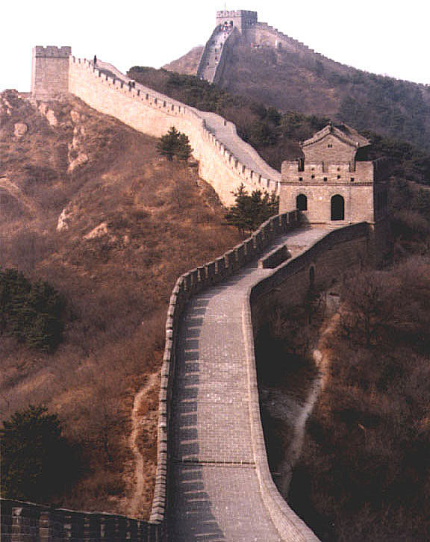
The Security Fence

Aims OF Peula:

- To learn that there is a security fence and its purpose

- To understand that Israel has a right to defend itself and has a deep caring for human life

- To realise that Israel has been singled out unfairly
A few weeks ago we were learning about how we must make Aliya and how amazing it is to live in Israel, and whilst I still do believe this is true and we should live there, to say everything is completely rosy would not only be a lie but rather stupid and blind to the truth. Every week so far we have dedicated the meetings in memory of a victim of terror so we obviously know that there are problems in Medinat Yisrael but one thing we as a mazkirut are worried about is that people don’t necessarily know enough. It is because of this we have used this weeks choveret to educate about a very contentious subject, that of the security fence. Please don’t let your political views sway your opinions of this weeks choveret especially as almost everyone in Israel is for the fence and the point of this choveret is to inform people of the facts, so please hold back your opinions for the time being and have respect for others and lets go………

Why did Israel decide to build the fence?

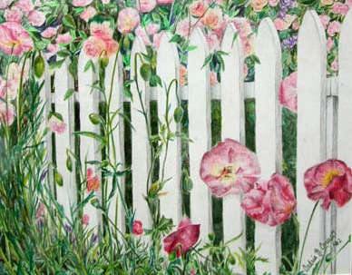

Once upon a time there was an old man, and this old man lived in a small house with a small garden in a small town. Every day he would go into his garden and sit and do a bit of gardening, prune the roses, cut the grass and then just make sure that his garden looked nice. After this he’d lie down with a Pims, sunbathe and have a bit of a snooze. One day as he was lying there he heard a loud noise from next door. So, he got up from his chair and peered over the fence, and suddenly he saw that there were new neighbours moving in. Time passed by and these neighbours seamed to be making more and more noise, and causing more and more problems to the little old man. So, one day he went to knock on their door and he asked the new neighbours if they could please start to show more consideration for the old man. But, the neighbours disagreed because they were jealous of the old mans stunning garden. After this, things just seamed to get worse and worse, until one day the old man had just had enough. So, he got out the good old yellow pages and called a company to come round and build a new fence in his back garden that was even higher than his current fence, to try and keep the neighbours out. This fence seamed to work at first, until the council came round and complained that the old man never got planning permission. To be continued…

As a result of the unceasing terror, Israel decided to erect a physical barrier. The absence of such a barrier makes infiltration into Israeli communities a relatively easy task for terrorists. No terrorists have infiltrated from the Gaza Strip into Israel in recent years, because an electronic security fence already exists there.

The decision to build the security fence was taken only after other options were tried, but failed to stop the deadly terrorist attacks. Despite its numerous commitments, the Palestinian Authority has failed to fight terrorism. The obligations that were violated by the Palestinian Authority were contained in the Oslo Accords and subsequent agreements, as well as in the Roadmap that was presented to the sides in May 2003. Had there been no terrorism, Israel would not have been compelled to build a fence to protect its citizens. The Palestinians must dismantle the terrorist organizations, confiscate weapons, arrest the planners and perpetrators of terrorist acts, stop incitement and resume security cooperation with Israel; all these steps are required by the Roadmap. These measures are imperative for renewing the peace process.

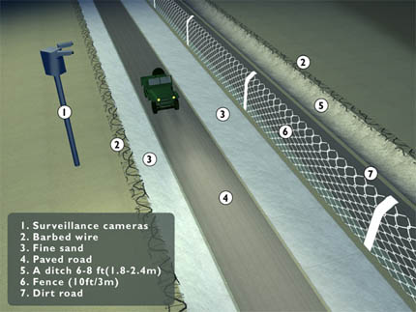
Fence or Wall?

Despite the many pictures being shown in the international media of a tall concrete wall, more than 97% of the planned 720 km. (480 mile) security fence will consist of a chain-link fence system. Less than 3% of the fence will be constructed of concrete. The short concrete sections are intended not only to stop terrorists from infiltrating, but also to block them from shooting at Israeli vehicles travelling on main highways alongside the pre-June 1967 line. The security fence forms a strip approximately the width of a four-lane highway. At its centre is the chain-link fence that supports an intrusion detection system. This technologically advanced system is designed to warn against infiltrations, as is the dirt "tracking" path and other observation tools.

Whether you agree with the fence or not one thing is for sure, since the erection of the fence there have been far less successful terrorist attacks and because of its success the terrorists are going further south to try and cause havoc. “But surely it is unfair that the people on the other side of the fence who don’t want to blow us up are being held prisoner in their own homes and part of their homes are being taken away for the fence to be built”. The world seems to be constantly criticising Israel for these points but…….

The route of the fence has been determined solely on the basis of security needs and topographical considerations.
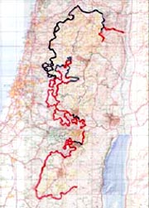
The fence is being built in such a way that, if necessary, the relevant parts can be moved to different locations. In this context, it will be remembered that when Israel withdrew from southern Lebanon, in fulfilment of UN Security Council Resolution 425, the UN delineated the border between Israel and Lebanon. Israel moved its security fence, sometimes only a few meters, to comply with the new border.
Israel has made the use of public lands a priority in building the security fence, in order to avoid, as much as possible, the use of private lands. If this is not possible, then the private land is requisitioned, not confiscated, and it remains the property of the owner. Legal procedures allow every owner to file an objection to the use of their land. When private lands are used, owners are offered full compensation, in accordance with the law; this compensation is offered both as a lump sum and also on a monthly basis.

Taking into consideration Palestinian humanitarian needs
In addition to its efforts to ensure the security of its citizens, Israel attaches considerable importance to the interests of the local Palestinian residents. Israel recognizes the necessity of finding an appropriate balance between the imperative need to prevent terrorism and defend its citizens, and the humanitarian needs of the Palestinians.
Most Palestinians will be on the eastern side of the fence. They will not be cut off from their commercial and urban centres. No Palestinians will have to relocate. Israel will make every effort to avoid causing hardship and interference with their daily lives. Dozens of crossing points have been set up to enable the movement of people and goods. The security fence was located, to the greatest possible degree, on unused land to avoid harming agriculture. Palestinian farmers will have access to their fields and will reach them through special gates that are being built into the fence. Trees affected by the construction will be replanted.

So the Israeli government are left with the dilemma of on the one hand they have to defend their citizens but on the other hand they have a moral obligation to not completely ruin and destroy the lives of the innocent bystanders from the other side they do see it as a dilemma and do their best to achieve both objectives but the world don’t seem to acknowledge this.

Decision Dismisses Israel's Arguments, Accepts Palestinian Claims Without Reservation
The International Court of Justice (ICJ) issued its decision on the Israeli security barrier on July 9. The Court announced that Israel violated international law in the routing of the security fence and called on Israel to dismantle sections built in the West Bank and East Jerusalem. In a statement to which U.S. judge Thomas Buergenthal and Dutch judge Pieter H. Kooijmans dissented, the court further called on the international community to refrain from rendering "aid or assistance in maintaining the situation created by such construction" (of the fence). In its decision, the Court easily dismissed the arguments of Israel, along with those of 22 other nations who submitted written briefs, while accepting without reservation the arguments of the Palestinians and their supporters.
On December 8, 2003, the General Assembly (GA), in a special emergency session adopted a Palestinian-initiated resolution sending the issue of Israel's security barrier to the International Court of Justice (ICJ) in The Hague for an advisory opinion on the question: "What are the legal consequences arising from the construction of the wall being built by Israel, the occupying Power, in the Occupied Palestinian Territory." The Palestinian Authority and supporters had attempted to have the Security Council pass such a resolution, however these efforts were unsuccessful, and they turned instead to the General Assembly, where anti-Israel resolutions are routinely supported by the majority of member nations. The resolution passed 90-8, with 74 countries abstaining.
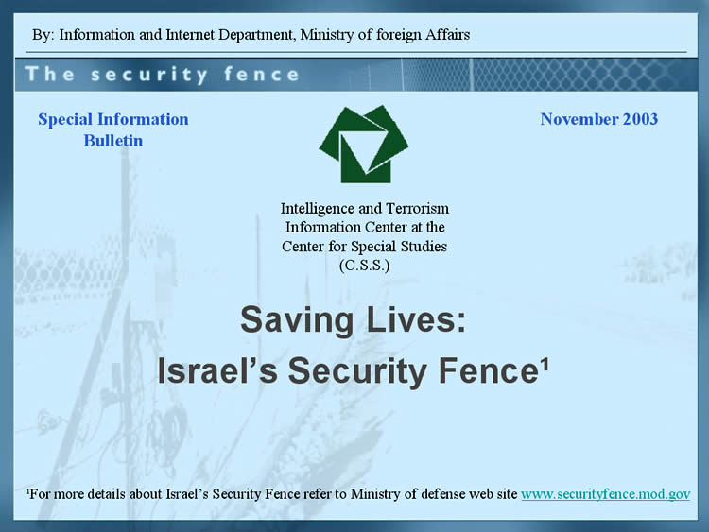
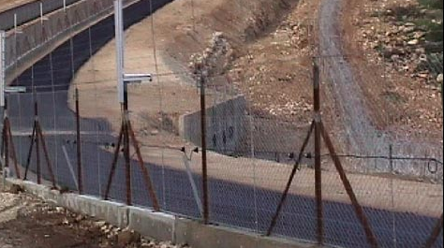
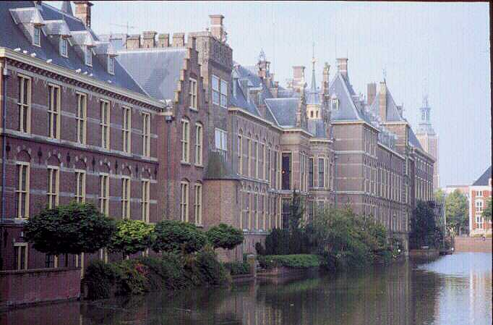

How many other countries have a security fence?
Other Beefed-Up Borders
India-Pakistan: India has been building a 1,800-mile-long fence to keep out Pakistani militants.
Kuwait-Iraq: Kuwait has built 150 miles of border fences and beams.
North Korea-South Korea: Two barbed-wire barriers sandwich the 2.5-mile-by148-mile Demilitarized Zone separating the countries.
United States-Mexico: Roughly 60 miles of fence aims to keep illegal immigrants out of California.
Zambia-Angola: Zambia is building a 620-mile border fence to keep out sick cattle from Angola.
Cyprus: A 112-mile fence separates the Turkish from the Greek side.

- Did any of you know about these security fences?
- Why does everyone in the world know about Israel trying to defend its borders but not about the other countries?
- Why have The Hague condemned Israel but not the other countries?
- Why is the temporary security fence being compared to the, what was intended to be permanent and segregating Berlin Wall?

Ok, I know that we as Jews are slightly paranoid sometimes about anti-Semitism and claim that we are being persecuted unfairly etc and sometimes we are being paranoid. Criticising Israel is not by definition being anti-Semitic however criticising Israel for doing the same as other countries and only criticising Israel is being anti-Semitic. We need to be aware of what other people around us are saying and we must also know how to respond and realise the flaws in their arguments. Israel may not be perfect but no country is and we have to be ambassadors for Israel here and fight their cause and show the world that they are wrong and essentially are being anti-Semitic. Some people may not even realise that they are being anti-Semitic (a lot do) and it is up to every one of us to write letters to the press and call up radio stations and also speak the non Jews we know to fight Israel’s cause and show the world just how wrong they are.

We are loud, We are proud, We’re JEWISH
Games

1. To learn why we have a security fence

Trigger – When everyone comes in, sit in a circle and one madrich starts hailing abuse at the other.

The quiet madrich should then try and negotiate with the other madrich.

Divide the group into three or four smaller groups. Give each group five items they must have, five items they can trade with and some money. They have to then negotiate with other groups to get the five items. The first group with all five wins. The madrichim should stir it up by cheating and trying to steal.

2. To realise that Israel has a right to defend itself an has a deep understanding of human life

Following this you can set the meeting up to the original scenario and continue where you left off. This time asking the chanichim to negotiate with the madrich. The quiet madrich should then get up and ask the chanichim to help build a barrier to try and keep the other madrich and bay.

Then take one of the chanichim and blindfold them and ask another chanich to guide them across the fence.

Then the other madrich should allow them to come into the meeting on a condition that he/she behaves themselves and does cause any trouble.

3. To realise that Israel has been singled out unfairly

Then the other madrich should allow them to come into the meeting on a condition that he/she behaves themselves and does cause any trouble.

Following this sum up how everything we did related to the different stages Israel went through when setting up the security fence

Inconspicuously send someone out of the room and explain to the rest of the group that for the next few games we are going to single out that person for no reason.

