National Religious Party (Mafdal)

Effi Eitam - National Religious Party (Mafdal) Chairman

Efraim Eitam (Fein) was born in Kibbutz Ein Gev. He holds an MA from Haifa University and studied at the Royal College of Defense Studies in London.
Eitam retired from the IDF in 2000 with the rank of Brigadier General after thirty years of military service. He served as commander of an armored division in the IDF Northern Command and commanded the Israeli forces in southern Lebanon in 1998-1999. He also commanded an elite commando unit in the Entebbe rescue mission in July 1976. He was awarded the medal of valor for courage under fire in the Yom Kippur War.
In April 2002, Efraim Eitam was selected leader of the National Religious Party and appointed Minister without Portfolio. In September 2002, he was appointed Minister of National Infrastructures.
He is married and has eight children.

Mafdal (NRP) –

15th Knesset – 5 seats
16th Knesset – 6 seats

Officially established in 1956 through the merging of Mizrachi, Ha-poel Mizrachi and other religious Zionist supporters. In the past, the Mafdal was identified with the right wing, but in recent years its policies and calls for a national unity government have placed it in the center of the political landscape.

The National Religious Party promotes combination of orthodox Judaism and Zionism with a modern orientation. Precursors to the present party served as coalition partner of Mapai-led governments from 1948-1977. The Mafdal was officially established in 1956 through the merging of Mizrachi, Ha-poel Mizrachi and other religious Zionist supporters.

In 1977, the Mafdal's coalition with the Likud ended 29 years of Labor government; up until 1992, it joined all governments as part of the coalition or national unity government. Although its socialist foundations stem from the religious kibbutz movement, the Mafdal is now usually identified with the "right" because of its territorial position. In fact, many of its supporters live in communities established in Judea, Samaria and the Gaza Strip. The party initially joined Ehud Barak's government in 1996, yet after Ehud Barak's proposed territorial concessions to the Palestinians were announced, the Mafdal left the government.
The Mafdal's platform emphasizes the centrality of Judaism to Israel on the religious, cultural and political levels. It seeks unity with secular Jews for whom the Jewish nation and Zionism are paramount.

Pluralism
Mafdal urges amendment to the Law of Return and the Population Registration Law to the effect that only a person born to a Jewish mother or converted according to halacha (normative religious law) will be considered a Jew. The party does not recognize the right of Conservative and Reform Judaism to rule on halachic matters.
Favors legislation to ensure the Jewish nature of the State.
Strongly supports military service, but does not favor coercion into universal military or national service.
Supports the religious status quo; opposes separation of religion and state.
The Mafdal recognizes the government as a secular authority.

Jerusalem
Jerusalem is the spiritual and political capital of the State of Israel and the Jewish people opposes all division of the city.
The NRP opposes any Palestinian or international sovereignty over the Temple Mount.

Peace Process
Accepted the Oslo Accords as a fait accompli, but would proceed with caution.
Supports direct, bilateral negotiations with Arab states.
Opposes withdrawal from the Golan.

Palestinian Issue
There will only be one state between the Jordan River and the Mediterranean Sea: the State of Israel.
Opposes creation of a Palestinian state.

Settlements
No part of Israel will be given over to a foreign government or authority and no Jewish settlement will be uprooted.
Against the relinquishment of "settlements" under a peace agreement.
Retention of the Terrorities based on security, biblical and Zionist beliefs.

Social / Economic Policy
The NRP is largely responsible for the fact that parents can choose to send their children to state-funded religious schools, the establishment of religious courts endowed with legal authority over all issues of personal jurisdiction in the Jewish community and the exclusive use of kosher food in the Army and government functions.
The NRP represents the middle class and is relatively moderate on religious affairs, but in the last 30 years it has moved further to the right, urging widespread Jewish settlement in the Territories.

Demographic Issues
The Mafdal is an ardent supporter of Jewish immigration to Israel and has made efforts to address the issue of non-Jewish immigrants coming to Israel under the Law of Return. The efforts are primarily designed provide a way to encourage the non-Jewish population to convert to Judaism within a liberal interpretation of Jewish Law. In order to stem the tide of non-Jewish immigrants and avoid the inherent problems they present the Jewish State, Mafdal would support an amendment to the Law of Return.
Mafdal believes that immigration to Israel, coupled with limited Palestinian self-rule is a suitable answer to the demographic challenges the Palestinians of Judea, Samaria and the Gaza Strip pose to the Jewish character of Israel.

Economy & Social Welfare
The Mafdal is largely responsible for the fact that parents can choose to send their children to state-funded religious schools. In addition, the Mafdal spearheaded the movement to establish religious courts endowed with legal authority over all issues of personal jurisdiction in the Jewish community. The Mafdal was also the progenitor of legislation calling for exclusive use of kosher food in the army and at government functions.

Religion & State
Supports the religious status quo and opposes separation of religion and state. The Mafdal recognizes the government as a secular authority, yet party policy calls for making Israeli law consistent with halacha (Jewish law), particularly in regard to the Law of Return.
The Mafdal strongly supports military service for all citizens, but does not favor the coercion of ultra-orthodox into military or national service.
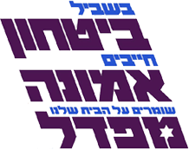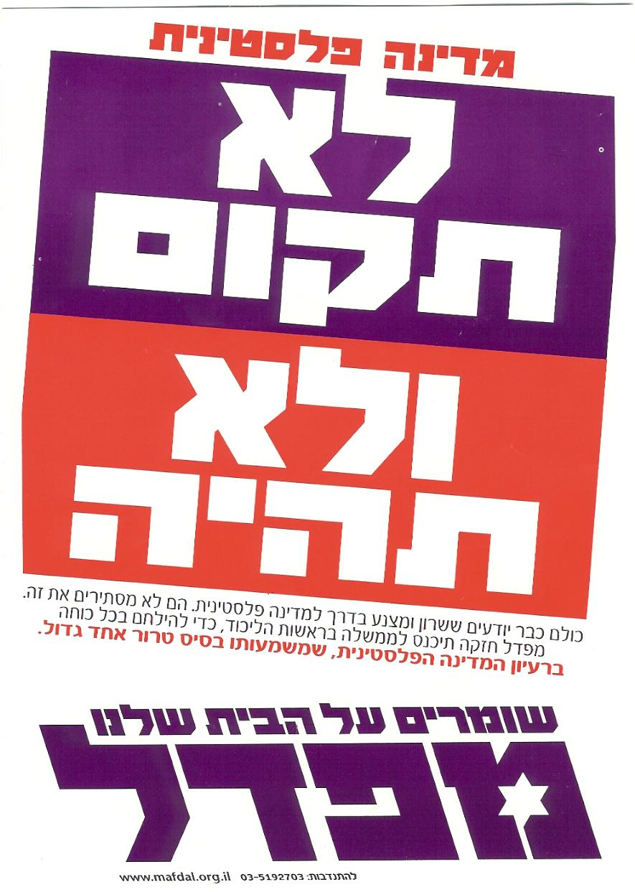

1. A Jewish State Vs. state for all citizens.  Mafdal | The core belief “the Land of Israel for the People of Israel according to the Torah of Israel” commits the N.R.P. to doing everything possible to further the security and integrity of the Land of Israel as a Jewish state.
2. Separate state & Church  (Synagogue)  Mafdal | Supports the religious status quo and opposes separation of religion and state. The Mafdal recognizes the government as a secular authority, yet party policy calls for making Israeli law consistent with halacha (Jewish law), particularly in regard to the Law of Return.
3. Settlements dismantling  Mafdal | Communities in the territories are an integral part of the State of Israel. Mafdal opposes relinquishing land to the any foreign state or authority and rejects outright the notion that Jewish settlements should be uprooted.
4. National Priorities  Mafdal | Religious and secular, Sephardim and Askenazim, right and left, old-times and new immigrants – we are all one people. The N.R.P. works toward national unity, absorption of immigration, and bringing people together from all sectors of the population. Without hatred and without coercion. Gently, pleasantly, and with a smile.  The N.R.P. actively promotes Torah in Israel and strengthens national religious institutions: Zionist rabbinical training institutes, Zionist Kollels, Yeshivot gevohot, Hesder Yeshivot, Yeshiva high schools, and more. The N.R.P. encourages Zionist rabbis to take on active roles as teachers in Yeshivot, and as spiritual leaders in cities and in neighborhoods.

