The Mishkan

By Michael Sedley

Goal:
To learn about the keilim in the Mishkan and where they were placed.

Steps:
1. How did it look?
2. How will it look?
3. Summary

Things to prepare:
Ideally there should be at least 10 kids in a group.
1.30m (100”) rope
2.curtain, sheet, or talit
3.Pictures of or models of the following vessels:
  - Aaron HaBrit
  - Menorah
  - Shulchan (for Lechem HaPanim)
  - Mizbeach Hazahav

1. How did it look?
Explain to the group that we are going to try to find out how the Mishkan looked, and what the main vessels were and what they were used for.
Mention that we are only looking at the Heichal itself, not the Chatzer (courtyard) that surrounded it.

- Get four chanachim to hold the rope so that they make a rectangle (with Narrow ends in North and South). Tell them that this represents the walls of the Mishkan.
- Discuss how the Mishkan was divided – see if they know that the Mishkan was divided into 2 sections, the Kodesh, and the Kodesh HaKodshim.
The kodesh and Kodesh haKodhim were divided with a Parochet.
The Mishkan now looks as follows (dots represent chanachim)
Rope
Sheet
West
- Take out picture of the Aaron, ask the chanachim where it belongs in the Mishkan.
- Give The Aaron to one of the Chanachim who has to stand with it in the correct position (in the Kodesh haKodshim)
- Repeat with the Other Keilim, until the keilim are positioned in the Mishkan (see diagram below)

Conclude with a discussion about the purpose of each of the Keilim.
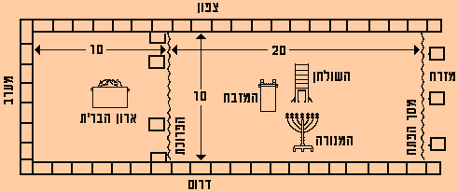

The following pages contain pictures you can use, although you may be able to find clearer pictures in the back of some Chumashim

The Menorah The Aaron
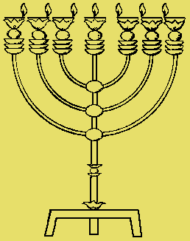
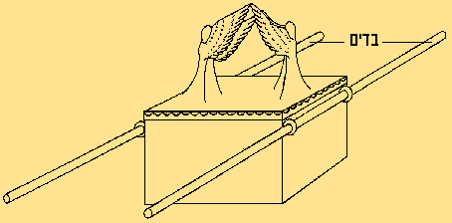

The Shulchan The Mizbeach haZahav


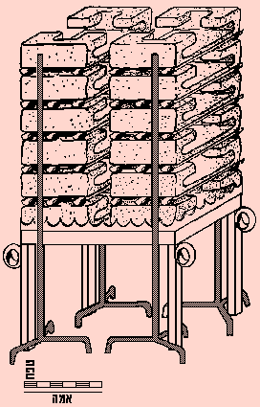

2. How will it look?
Discussion:

Read out loudly supposal situations that can happen when we will have Beit Mikdash. Let the chanichim move from one side of the room to the other side if they think it will happen. Ask questions and try to make them think about their opinion.

In the beit hamikdash…
- Will the cohen gadol will be a …chasid, Bnei Akiva , modern orthodox?
- On pesach, shavuot and succot everyone will come with their first fruit to Jerusalem?
- I spoke lashon hara on the teacher. Now I’ll miss two weeks of school because I need to go to beit hamikdash to bring a korban.
- Cellular phones will be prohibited in the mikdash.
- The cohen gadol will speak every week in the main hall to the public.
- The king of am Israel will be chosen in democratic elections every 4 years.

Add more examples.

Summary:
We pray 3 times a day for hashem to build beit hamikdash . We should think what are the things we are asking for, what place do we want them to take in our lives and how will our be affected by the beit hamikdash and should it affect it at all…

