Rav Naftali Tzvi Yehuda Berlin

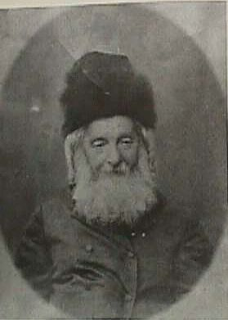
Rabbi Naftali Tzvi Yehudah Berlin (The Netziv)
(1817-1893)
The Netziv was Rosh Yeshiva of the famed Volozhin Yeshiva for almost 40 Years until it was closed by the Russian government in 1892. Founded by R. Chaim of Volozhin, the Yeshivah flourished, increasing from 100 to 400 students.
As a young man the Netziv was undistinguished, but by virtue of his extraordinary diligence grew to become one of the greatest scholars and leaders of his time. The prevalent method of Talmudic study was that of deep analysis of the "sugya" (topic) at hand. The Netziv’s approach was to immerse himself in all the relevant passages from the entire Tannaitic literature, always striving to go back to the earliest sources. Similarly, he paid special attention to the Gaonic literature and the earliest Rishonim, who were closer to the Talmudic period. He believed only in this manner could the text being studied be properly understood. His approach was strongly encouraged by R. Dovid Luria.
The Netziv emphasized study of Chumash and Nach and gave a shiur on the weekly parsha every day after morning prayers. He was an early supporter of the Chovevei Tzion movement and strongly supported the resettling of Eretz Yisroel. However, he was opposed to the selling of the Land for the Shemittah year. Contrary to the view of Rav Hirsch he opposed separate communities.
During the Netziv’s time in Volozhin the Yeshiva produced great scholars, including R. Issur Zalman Meltzer, The Dvar Avrohom, Rabbi A. Shapiro, R. Avrohom Y. Kook, R. Moshe M. Epstein and R. Zelig R. Benges.
The Netziv’s works include his famed commentary on the Sheiltos of Rabbi Achai, his Commentary on the Song of Songs and Meishiv Davar, a collection of his Responsa.
The Maskilim could not bear the success of the Yeshiva and constantly sought its demise. Their continuous barbs were noted by the government who demanded that the Yeshiva curriculum and hours of study be completely revamped. It is often said that the Yeshiva was closed because of the Netziv’s refusal to permit secular subjects to be studied. The fact is that the government’s demands were such that if adopted the Yeshiva would have totally lost its character. For example, one of the demands was that secular subjects be studied until 3:00 PM and that night study cease.
Left with no choice the Netziv felt compelled to close the Yeshiva. His entire existence was linked to the Yeshiva and after its closing his health began to decline. He passed away less that two years after the closing. His two sons were Rabbi Chaim Berlin and Rabbi Meir Bar-Ilan.

