Modern Orthodoxy

Aims:

- To learn that Avraham was the first modern orthodox jew

- To learn what modern orthodoxy is

- To realise that the we might differ from the charedi world but that doesn’t mean we don’t get on with them

Rotem Weinberger
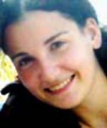
Dec 25, 2003 - Cpl. Rotem Weinberger, 19, of Kfar Sava was one of four people killed in a suicide bombing at a bus stop at the Geha Junction, east of Tel Aviv, near Petah Tikva.
The suicide bombing took place during the busy evening rush hour. The bomber, carrying a medium-sized bomb, approached the bus stop at the Geha Junction at about 6:30 P.M. and blew himself up, killing two people immediately and mortally wounding a third, who died en route to the hospital. A fourth person, who was seriously injured, died in the hospital a few hours later. The Popular Front for the Liberation of Palestine claimed responsibility for the attack.
Rotem Weinberger attended the Katznelson High School in Kfar Sava and began her army service nine months ago. She served in an artillery unit in the north, but was transfered to the Tel Hashomer Signal Corps a month ago so that she would be closer to home and could spend more time with family and friends. She had stayed late to attend a party for one of the officers and was killed while waiting with a friend for the bus home.
Rotem's mother, Talia, said that her daughter had been afraid to ride buses since the 1996 bombings when she was a child. As a result, her mother often picked her up from the base. Her friend, Hen, said that Rotem was scared to death of being caught in a terrorist attack, and was always sure never to ride a bus alone. The two were very close and often spoke dozens of times on the phone during the day. On Thursday, they spoke five times, making plans to meet later at the mall.
Her friends, Hen and Hadas, spoke at her funeral: "We can still hear your voice in our heads, your smile will remain in our hearts. You were so happy of late, particularly with your great love for Ofer, who loved you so much. You never stopped talking about him. You always knew what you wanted. You were so sure of yourself. You had everything planned out for the future. You dreamed of your release from the army and the trip you would take with Ofer."
Cpl. Rotem Weinberger was buried in the Kfar Sava military cemetery. She is survived by her mother Talia, her brother Shlomi, 23, and sister Adi, 6.
Bnei Akiva defines itself as a modern orthodox movement, but this seems to be a bit strange to me as this whole concept of modern orthodoxy has been around for over 3,500 years, so it can’t be that modern! No I know you are thinking “what is this guy on about again” but again as usual I am talking sense. In Parshat Lech Lecha, Avraham was the first Jew to make Aliya hence modern orthodox! OK slightly tongue in cheek that one but the rest does have much more basis.

- How many tests did Avraham have?
- What were they?
- What was the last one?

Most people know the answer to the first question, 10. The middle one most people don’t know but the final one most people think is the Akeida and they are right according to most opinions. There is however one opinion of one of the Rishonim (commentators) the Seforno who believes the final test of Avraham was trying to find a burial place for Sarah (sorry about the dodgy translation).

בראשית פרק כג

א וַיִּהְיוּ חַיֵּי שָׂרָה, מֵאָה שָׁנָה וְעֶשְׂרִים שָׁנָה וְשֶׁבַע שָׁנִים--שְׁנֵי, חַיֵּי שָׂרָה. ב וַתָּמָת שָׂרָה, בְּקִרְיַת אַרְבַּע הִוא חֶבְרוֹן--בְּאֶרֶץ כְּנָעַן; וַיָּבֹא, אַבְרָהָם, לִסְפֹּד לְשָׂרָה, וְלִבְכֹּתָהּ. ג וַיָּקָם, אַבְרָהָם, מֵעַל, פְּנֵי מֵתוֹ; וַיְדַבֵּר אֶל-בְּנֵי-חֵת, לֵאמֹר. ד גֵּר-וְתוֹשָׁב אָנֹכִי, עִמָּכֶם; תְּנוּ לִי אֲחֻזַּת-קֶבֶר עִמָּכֶם, וְאֶקְבְּרָה מֵתִי מִלְּפָנָי. ה וַיַּעֲנוּ בְנֵי-חֵת אֶת-אַבְרָהָם, לֵאמֹר לוֹ. ו שְׁמָעֵנוּ אֲדֹנִי, נְשִׂיא אֱלֹים אַתָּה בְּתוֹכֵנוּ--בְּמִבְחַר קְבָרֵינוּ, קְבֹר אֶת-מֵתֶךָ; אִישׁ מִמֶּנּוּ, אֶת-קִבְרוֹ לֹא-יִכְלֶה מִמְּךָ מִקְּבֹר מֵתֶךָ. ז וַיָּקָם אַבְרָהָם וַיִּשְׁתַּחוּ לְעַם-הָאָרֶץ, לִבְנֵי-חֵת. ח וַיְדַבֵּר אִתָּם, לֵאמֹר: אִם-יֵשׁ אֶת-נַפְשְׁכֶם, לִקְבֹּר אֶת-מֵתִי מִלְּפָנַי--שְׁמָעוּנִי, וּפִגְעוּ-לִי בְּעֶפְרוֹן בֶּן-צֹחַר. ט וְיִתֶּן-לִי, אֶת-מְעָרַת הַמַּכְפֵּלָה אֲשֶׁר-לוֹ, אֲשֶׁר, בִּקְצֵה שָׂדֵהוּ: בְּכֶסֶף מָלֵא יִתְּנֶנָּה לִּי, בְּתוֹכְכֶם--לַאֲחֻזַּת-קָבֶר. י וְעֶפְרוֹן יֹשֵׁב, בְּתוֹךְ בְּנֵי-חֵת; וַיַּעַן עֶפְרוֹן הַחִתִּי אֶת-אַבְרָהָם בְּאָזְנֵי בְנֵי-חֵת, לְכֹל בָּאֵי שַׁעַר-עִירוֹ לֵאמֹר. יא לֹא-אֲדֹנִי שְׁמָעֵנִי--הַשָּׂדֶה נָתַתִּי לָךְ, וְהַמְּעָרָה אֲשֶׁר-בּוֹ לְךָ נְתַתִּיהָ; לְעֵינֵי בְנֵי-עַמִּי נְתַתִּיהָ לָּךְ, קְבֹר מֵתֶךָ. יב וַיִּשְׁתַּחוּ, אַבְרָהָם, לִפְנֵי, עַם הָאָרֶץ. יג וַיְדַבֵּר אֶל-עֶפְרוֹן בְּאָזְנֵי עַם-הָאָרֶץ, לֵאמֹר, אַךְ אִם-אַתָּה לוּ, שְׁמָעֵנִי: נָתַתִּי כֶּסֶף הַשָּׂדֶה, קַח מִמֶּנִּי, וְאֶקְבְּרָה אֶת-מֵתִי, שָׁמָּה. יד וַיַּעַן עֶפְרוֹן אֶת-אַבְרָהָם, לֵאמֹר לוֹ. טו אֲדֹנִי שְׁמָעֵנִי, אֶרֶץ אַרְבַּע מֵאֹת שֶׁקֶל-כֶּסֶף בֵּינִי וּבֵינְךָ מַה-הִוא; וְאֶת-מֵתְךָ, קְבֹר. טז וַיִּשְׁמַע אַבְרָהָם, אֶל-עֶפְרוֹן, וַיִּשְׁקֹל אַבְרָהָם לְעֶפְרֹן, אֶת-הַכֶּסֶף אֲשֶׁר דִּבֶּר בְּאָזְנֵי בְנֵי-חֵת--אַרְבַּע מֵאוֹת שֶׁקֶל כֶּסֶף, עֹבֵר לַסֹּחֵר. יז וַיָּקָם שְׂדֵה עֶפְרוֹן, אֲשֶׁר בַּמַּכְפֵּלָה, אֲשֶׁר, לִפְנֵי מַמְרֵא: הַשָּׂדֶה, וְהַמְּעָרָה אֲשֶׁר-בּוֹ, וְכָל-הָעֵץ אֲשֶׁר בַּשָּׂדֶה, אֲשֶׁר בְּכָל-גְּבֻלוֹ סָבִיב. יח לְאַבְרָהָם לְמִקְנָה, לְעֵינֵי בְנֵי-חֵת, בְּכֹל, בָּאֵי שַׁעַר-עִירוֹ. יט וְאַחֲרֵי-כֵן קָבַר אַבְרָהָם אֶת-שָׂרָה אִשְׁתּוֹ, אֶל-מְעָרַת שְׂדֵה הַמַּכְפֵּלָה עַל-פְּנֵי מַמְרֵא--הִוא חֶבְרוֹן: בְּאֶרֶץ, כְּנָעַן. כ וַיָּקָם הַשָּׂדֶה וְהַמְּעָרָה אֲשֶׁר-בּוֹ, לְאַבְרָהָם--לַאֲחֻזַּת-קָבֶר: מֵאֵת, בְּנֵי-חֵת.

1 And the life of Sarah was a hundred and seven and twenty years; these were the years of the life of Sarah. 2 And Sarah died in Kiriatharba--the same is Hebron--in the land of Canaan; and Abraham came to mourn for Sarah, and to weep for her. 3 And Abraham rose up from before his dead, and spoke unto the children of Heth, saying: 4 'I am a stranger and a sojourner with you: give me a possession of a burying-place with you, that I may bury my dead out of my sight.' 5 And the children of Heth answered Abraham, saying unto him: 6 'Hear us, my lord: thou art a mighty prince among us; in the choice of our sepulchres bury thy dead; none of us shall withhold from thee his sepulchre, but that thou mayest bury thy dead.' 7 And Abraham rose up, and bowed down to the people of the land, even to the children of Heth. 8 And he spoke with them, saying: 'If it be your mind that I should bury my dead out of my sight, hear me, and entreat for me to Ephron the son of Zohar, 9 that he may give me the cave of Machpelah, which he hath, which is in the end of his field; for the full price let him give it to me in the midst of you for a possession of a burying-place.' 10 Now Ephron was sitting in the midst of the children of Heth; and Ephron the Hittite answered Abraham in the hearing of the children of Heth, even of all that went in at the gate of his city, saying: 11 'Nay, my lord, hear me: the field give I thee, and the cave that is therein, I give it thee; in the presence of the sons of my people give I it thee; bury thy dead.' 12 And Abraham bowed down before the people of the land. 13 And he spoke unto Ephron in the hearing of the people of the land, saying: 'But if thou wilt, I pray thee, hear me: I will give the price of the field; take it of me, and I will bury my dead there.' 14 And Ephron answered Abraham, saying unto him: 15 'My lord, hearken unto me: a piece of land worth four hundred shekels of silver, what is that betwixt me and thee? bury therefore thy dead.' 16 And Abraham hearkened unto Ephron; and Abraham weighed to Ephron the silver, which he had named in the hearing of the children of Heth, four hundred shekels of silver, current money with the merchant. 17 So the field of Ephron, which was in Machpelah, which was before Mamre, the field, and the cave which was therein, and all the trees that were in the field, that were in all the border thereof round about, were made sure 18 unto Abraham for a possession in the presence of the children of Heth, before all that went in at the gate of his city. 19 And after this, Abraham buried Sarah his wife in the cave of the field of Machpelah before Mamre--the same is Hebron--in the land of Canaan. 20 And the field, and the cave that is therein, were made sure unto Abraham for a possession of a burying-place by the children of Heth.

Without going in to the grammatical details of it all, Avrahams essential test was could he manage to come down from his lofty level and interact with the people in Chevron in order to get Efron to sell him his cave as a burial place for his wife and future generations. What is this modern orthodoxy idea that we in BA always harp on about? It is essentially combining our ideals of learning with those of the outside world and synthesising them together, which is essentially what Avarahm did. Hence Avraham was the first modern orthodox jew! And if that isn’t enough of a proof that Avraham was a modern orthodox jew how about this?

וַיַּשְׁכֵּם אַבְרָהָם בַּבֹּקֶר, וַיַּחֲבֹשׁ אֶת-חֲמֹרוֹ, וַיִּקַּח אֶת-שְׁנֵי נְעָרָיו אִתּוֹ, וְאֵת יִצְחָק בְּנוֹ; וַיְבַקַּע, עֲצֵי עֹלָה, וַיָּקָם וַיֵּלֶךְ, אֶל-הַמָּקוֹם אֲשֶׁר-אָמַר-לוֹ הָאֱלֹקּים. בַּיּוֹם הַשְּׁלִישִׁי, וַיִּשָּׂא אַבְרָהָם אֶת-עֵינָיו וַיַּרְא אֶת-הַמָּקוֹם--מֵרָחֹק. וַיֹּאמֶר אַבְרָהָם אֶל-נְעָרָיו, שְׁבוּ –לָכֶם פֹּה עִם-הַחֲמוֹר, וַאֲנִי וְהַנַּעַר, נֵלְכָה עַד-כֹּה

And Avraham got up early in the morning, he saddled his ass and took the two lads with him, and Yitzchak his son, and he chopped up the wood for the offering and he got up and went to the place which Hashem told him. On the third day he lifted up his eyes and saw the place from afar and Avraham said to the lads return with the ass, myself and the lad will go to the place.


What is Avraham saying in this passage? He was going out and davka took to non-Jews (the two lads were Yishmael and Eliezer) with him but when it came to the crux he sent them away. This is exactly what we believe, we should be involved with the non Jewish world for so many reasons, whether it to be an Or Lagoyim (light unto the nations) or because Yesh Chachma Bagoyim (there is wisdom amongst the nations) for us to learn from, but at a certain point we have to say “No thanks” we have our boundary and stick to our Jewish roots. In this way we really do get the best of both worlds, we can learn and teach things from and to the outside world but we also have the Torah and our strong Jewish values.

A few weeks ago I was eating at someone’s house and I was asking the hostess about possible speakers for Manchester limmud and she was telling me about a certain woman but then proceeded to tell me that she was too frum for BA to which I replied “don’t you mean to Charedi?” Most people normally just accept the stereotypical idea that BA isn’t as frum as the charedi world but I honestly don’t believe that is true we are just as frum if not more so we just aren’t charedi.

Who out of the following people would you consider “frum”?

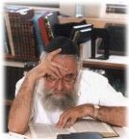
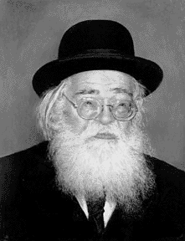
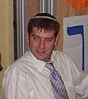

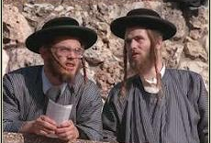
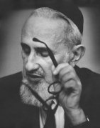
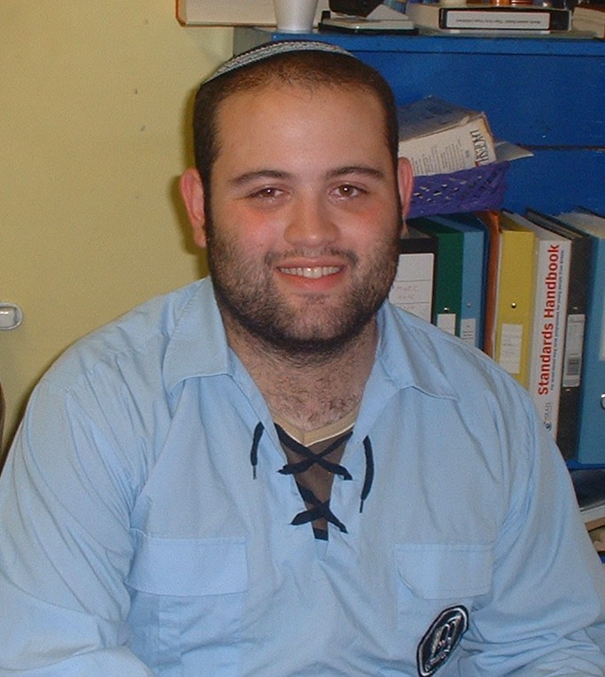

- How do we define who is frum?

Rav Lichstenstein, one of the Rosh Hayeshivot of Gush, in his book ‘By His Light’ essentially defines it from the famous penultimate Pasuk of Kohelet:

סוֹף דָּבָר, הַכֹּל נִשְׁמָע: אֶת-הָאֱלֹקים יְרָא וְאֶת-מִצְוֹתָיו שְׁמוֹר, כִּי-זֶה כָּל-הָאָדָם

The end of the matter, all having been heard: fear God, and keep His commandments; for this is the whole man.
Kohelet 12:13

What he is essentially saying is that there are two aspects to being “frum”, the internal aspect and the external aspect. One must be attached to G-d in the sense that they feel spiritual and experience a closeness to G-d and secondly one must also act in a certain manner i.e. keep his mitzvot. If either of these two is missing then you are not defined as “frum”. Look at the pictures above, in my opinion, all bar two of these people are frum, the two stereotypical frummest looking people, whilst looking frum and may very well feel frum, outwardly campaign with people who want to kill Jews, is that being frum? Yet on the other hand there is Rabbi Andrew Shaw who has no beard and wears a sruggy but has spent a good few years in Yeshiva and is trying his hardest to help Klal Yisrael, he may not look the conventional “frum” Rabbi, but he feels frum and practices Mitzvot and is thus considered frum according to our definition.
Look at the photos again - there is a range of different Hashkafot ranging from Rav Soleveitcheik (leadning Modern Orthodox thinker bottom left) to Rav Shach (fromer Rosh Yeshiva of Ponovitch top middle) and from Rav Amital (Rosh Yeshiva of Gush top left) to Andrew Davis (our Mazkir), but we can group these in to two different Hashkafot those of Modern Orthodox and Charedi!



The idea of being modern orthodox is based alot on the sources brought above and others from Rav Shimshon Rafael Hirsch etc so if we have all these sources why is there the other side of the coin i.e. being charedi? The answer in my opinion is quite simple and it comes up in conversation quite often with my charedi housemate, we are essentially walking a very narrow tightrope by joining both worlds together which is easily solved by being charedi. Take this anology for example, a hard boiled egg doesn’t break when dropped or thrown etc but you cant do much with it; on the other hand if you dont boil the egg you can make an omlette or fry it or boil it or scramble it or anything else but if you drop it, it breaks. What is this bloke on about again? Very simple to be charedi is much safer, it wont break but there isnt as much potential just like a hard boiled egg but to be modern orthodox gives rise to much more potential but you can easily fail and break just like a raw egg!

Truth is our aims are both the same, i.e. that of serving G-d and I am definitely not anti charedi, some of my best friends are charedi and there is a lot we can learn from their world e.g. the fact that they have gemachs to lend and give things to complete strangers is an amazing feat which we should try to emulate.

The point I am trying to get across is that we should be proud in what we believe in and not feel inferior to the charedi community but at the same time get on with them because:

“Kol Yisrael Ereivin Ze LaZe –
All of Israel is responsible of one another”
Ideas
Aleph
- If Avraham was around nowadays what would he look like?
- Place the hat on the rabbi.
- Make a fuzzy felt type thing before Shabbat of different types of clothes and people can make their own frummer.

Bet
- Get people to describe different things e.g. a picturesque view of the Lake District and then a few other things similar and then ask them to describe what a frum Jew looks like and then ask them why they described a charedi (they always do)?
- Do something along the lines of the egg analogy just don’t use eggs cos you won’t be allowed back to the shul!

