Chanukah

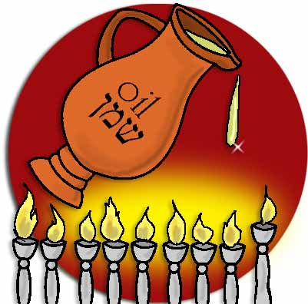

Aims

- What is Chanukah all about?
- The Mitzvah of lighting candles
- Togetherness and a family atmosphere

What is Chanukah all about?

The word Chanukah is itself an abbreviation of “Chanukat HaMizbeach” – The Consecration of the Altar. Judah the Maccabee decided to institute the recurring festival of Chanukah as a reminder of the purification of the Temple and the renewal of its services. From the first two books of the Maccabees we find evidence of the renewal of the Temple service. In the first book of the Maccabees we read how Judah the Maccabee offered up the first sacrifice on the 25th Kislev. Then followed eight days of sacrifice and celebration at the re-opening of the Temple and Chanukah was instituted to celebrate this re-opening.

But in the second book of the Maccabees we find a different version all together. According to this version Chanukah was instituted as a second Succot, Just like we have Yom Kippur Katan, Pessach Sheni and Shushan Purim. The Maccabees and the rest of the Jews had been prevented from keeping Succot and when the Temple was finally re-opened there were eight days celebrating Succot. The story continues that during this Succot celebration the Menorah was rekindled in the Temple and the Maccabees gave out word that the Jews should celebrate each year through both the Arba Minim of Succot and the lighting of Menorot.

It would seem though, that there then followed a Rabbinical ruling that ‘one must not confuse one festival with another’, and thus the celebrating using the Arba Minim was discontinued. After this, the custom of lighting candles remained and from then on the festival became known as the ‘Festival of Lights’.

Of course the most widely accepted reason for the festival of Chanukah is the story of one jar of oil lasting eight days. The basis of this story is the reason for our Chanukah prayers including the song:

Hanerot Haloni Anachnu Madlikim
We light these candles on account of the miracles

Indeed the lighting of the candles has really become the whole focus of Chanukah. So much so that there are a whole host of laws relating to the time, the place and way in which we light the Menorah. In the Gemara, Shabbat 21a, we find a discussion as to why we have Chanukah:

“What does Chanukah signify? When the Greeks entered the Temple, they defiled all the oil in the Temple. And when the kingdom of the Hasmonean House overpowered them and was victorious over them, they searched and found only a single crucible of oil that bore the seal of the High Priest, and it contained only enough oil for one day, and a miracle occurred and it lasted for eight days.”

The Mitzvah of Lighting the Candles

The essence of the Mitzvah of Chanukah is that one candle is lit in each home, even if the household consists of many people. However, those who are more particular can light one candle for every member of the household. And those who are still more particular can light the number of candles corresponding to the number of the days of the festival that have already occurred.

The candles may be lit from the setting of the sun until the marketplace is empty and they should burn for a minimum of half an hour after the starts come out.

A candle that burns from oil will give a purer flame and as the miracle occurred with oil there are many people who use oil, though candles are perfectly acceptable.

Without a doubt Chanukah has had a rather confused history involving the confusion between Succot, Temple opening and candle lighting. But now there is a general agreement that the focus is on the miracle of the oil and the heroism of the Maccabees in their defeating of the powerful Greek army. If we look at Al Hanisim that we say throughout Chanukah in the Amidah and in Benching, we will find that the miracle of the oil isn’t actually mentioned at all and if the miracle really was the major part of the festival then it is rather strange that it gets no mention. The main focus of the prayer seems to be the military victory, as we read:

You delivered the strong into the hands of the weak
And the many into the hands of the few

THE LIGHTS OF CHANUKAH

The lights of the Menorah never fail to have an effect on both the room they are lit in and the people that light them. Over the years, when many other aspects of Judaism have been forgotten by large amounts of people the custom of lighting the Chanukah candles has been one of the Mitzvot that have kept on. The lights, placed at the windows of our homes show not only the miracle of Hashem but also a sense of Jewish pride and a show of identity. The lit candles burning bright have come to symbolise the non-extinguishable flame of Jewish resistance. In Martin Gilbert’s book about Natan Sharansky, the following story is told:
On 3rd December 1980, at the beginning of the Jewish festival of Chanukah, and just out of the punishment cell, Sharansky lit the first of the traditional Chanukah candles, having made them himself out of little pieces of wax. This small act of memorial greatly agitated the guards who ordered him to put out the candles immediately. He refused, on the grounds that it was his duty and privilege as a Jew to perform the customs of his people. Again he was sent to the punishment cell.

The next year Natan lit the candles again despite the threats from the guards to do so. This time he lit all eight nights because the guards had come to the realisation that Sharansky’s internal flame of Judaism like the Chanukah lights could not be extinguished.

From the spirit of the Maccabees to the display of defiance of Natan Sharansky there is something about Chanukah that has always captivated the imagination of the Jewish people so much so that wherever they are and in whatever situation they are in, they still demand lighting the Chanukah candles. It was written at the turn of the century, that:

“The Maccabees’ victory proved that the Jews – then already an old people – possessed the secret eternal youth: the ability to rejuvenate itself through courage, hope, enthusiasm and devotion.

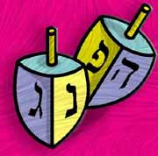
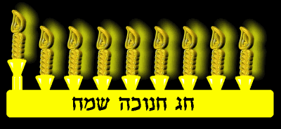
Togetherness and Family Atmosphere

Family values have become the social issue of the day. Many people will tell you that most major ills of modern society can be traced to a breakdown in the fabric of families.

The ideal place for a menorah is at the door of the house. In addition to publicizing the miracle, the menorah is positioned here so that the entrance to one's home is "surrounded by mitzvot" - i.e. the menorah on the left side and the mezuzah on the right. Chanukah brings together all the symbols of the Jewish home.

Every mezuzah, no matter how simple or elaborate the exterior casing may be, contains the exact same piece of parchment, inscribed with the Shema Yisrael: "Hear o' Israel, the Lord Our God, the Lord is One." This sentence contains the essence of Judaism. A Jewish home, more than anything else, is meant to be a place for fostering Jewish values and ideals. The mezuzah on our doorpost reminds us that a home is a place for learning, for growth and for spirituality, not just a shelter from the rain.

In many ways, the Jewish family is central to Chanukah:

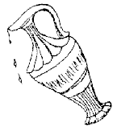
- The revolt against the Greeks was spearheaded by a family, the Hasmoneans.
- Another family, Chana and her seven sons (all of whom gave their lives rather than denying their devotion to God), stand as the ultimate symbol of dedication to Judaism.
- According to Jewish law, one should always try to light the menorah when the entire family is gathered together.
- The Talmudic terminology for the obligation to light the menorah on Chanukah is "one candle for each household."

During Chanukah, one's front door, the entranceway to Jewish family life, is to be surrounded by mitzvot. The mezuzah calls our mind to the values and ideals that are taught and discussed and lived in a Jewish home, while the menorah reminds us of the willingness of Jewish families to fight for the survival of the Jewish life.

Jewish survival and Jewish revival begins and ends in the Jewish home.
Games

Ideas for the meeting:

- The Chanichim all act out different Chagim for the rest of the kvutsah to guess what it is. Then you begin to act out Chanukah, but you include waiving the Arba Minim. At this point the Chanichim will scream and shout that you have got it wrong and you say…..

- Remember that most Chanichim love to talk about themselves so if the discussion has them at the centre then you should be alright. Ask them to describe exactly how they feel during different Chagim at different times. For example how do you feel during the Seder Service, how do you feel when you eat in the Succah and finally what sort of atmosphere is created when you light the Chanukah lights?

- Go to a small badly lit room and shut the door so it gets very dark. Slowly open the door and let the light come in. Try to describe how the light of Chanukah has been symbolically lighting up the Jews for so long. Now would be a good time to read out the story from the Ghetto. (Ask your Rashim)

- A bit of gambling is of the essence. Play the dreidle and gamble with sweets or something else, (seeing as money is not allowed!)

- Read through the picture story of Chanukah allowing the Chanichim to work out exactly what the story is. (Again ask your Rashim)

- Remember to have a laugh and prepare them for the family atmosphere at Bnei Akiva Winter Machanot.

