THEY BUILT OUR STATE

GOAL-to teach the chanichim as much as possible about the people who influenced the state of Israel.

INSTRUCTIONS-1.put each individuals picture in a corner of the room. In the middle of the room spread the piece’s of paper. Tell your chanichim to read the papers and match the papers to the people.
2.the game “Trivia”-divide your chanichim into two groups.the point of the game is to get 4 cards one from each color , the group that does that first wins.each color is a different person,when you land on a certain color you pick up a card that color.

SHABBAT-SHALOM
HADAS AND RACHEL.

בנימין זאב הרצל
1860-1904
* Was born in Budapest, Hungary.
* When the Anti- Semitism increased in Europe he felt the need for a
Jewish state.
* Was elected president of the World Zionist Organization in the first congress in Basel, 1897.
* Described his ideal in the book “The Jewish State” , 1896.
* Died at the age of 44, 1904.

דוד בן-גוריון
1886-1973
* Was born in October 16, 1886 in Plonsk, Poland.
* On September 7, 1906 at the age of 19 arrived in Jaffa on an old Russian boat.
* At 4 pm on May 14, 1948 he proclaimed the establishment of the state of Israel.
.מלחמת העצמאות * He served as Minister of defense during
* In 1960 he resigned from the government and left to Sde- Boker, a new kibbuts in the Negev.

מנחם בגין
1913-1992
* Was born in Brisk, Lithuania.
* Volunteered to join the polish brigade, accompanying it to Israel in 1942.
* Was elected Prime Minister in 1977.
* His greatest achievement was signing of the peace treaty with Egypt in
1979.
For this he awarded the Nobel Peace Prize.
* He removed Israeli settlement from Sinai for the sake of peace with Egypt.
* He resigned in 1983.

יצחק רבין
1922-1995
* He joined the Palmach, commanded the Harel Brigade in the war of independence and served as chief of Staff from 1964 to 1968.
* Was elected to Prime Minister.
* In 1995 signed an interim Israeli- Palestinian agreement.
* November 4, 1995 – he was assassinated at the close of a large assembly in Tel- Aviv in support of the peace process.

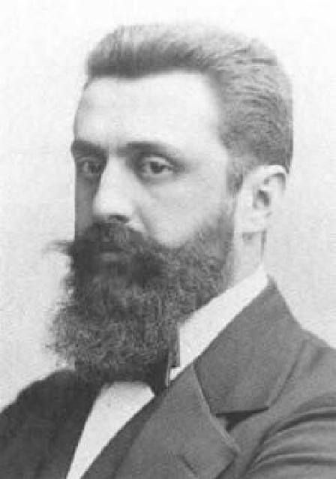
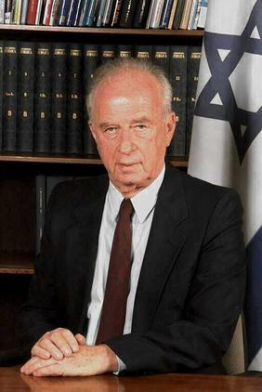
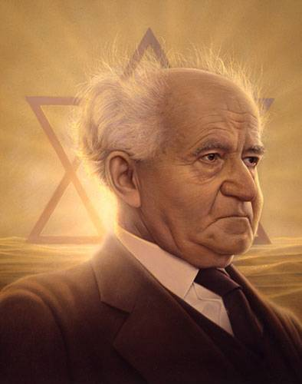
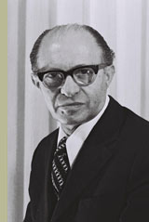

בנימין זאב הרצל
Budapest, Hungary | Where was he born?
Because the anti-Semitism increased in Europe | Why did he feel a need for a jewish state?
In the first congress in Basel,1897 | Where was he elected president of the world Zionist organization?
In 1896 | When did he describe the ideal of the jewish state?
1904 at the age of 44 | What year did he die?
1860 | What year was he born?
Journalist | What was his profession before becoming a congress man?

דוד בן- גוריון
1886 | When was he born?
1971 | When did he die?
Poland | Where was he born?
Heder | When he was a child he went to a______
1960 | When did he resign  from the government?
מלחמת העצמאות | During what war did he serve as minister of defense?
At 4pm on may 14th 1948 | When did he proclaim the establishment of the state of Israel?

מנחם בגין
1913 | When was he born?
Brisk, Lithuania | Where was he born?
1942 | When did he come to Israel?
He was elected to prime minister. | What happened in 1977?
Signing of the peace treaty with Egypt. | What was his greatest achievement?
1983 | When did he resign?
He removed Israeli settlement from Sinai. | What did he do for the sake of peace with Egypt?

יצחק רבין
1922 | When was he born?
An interim Israeli- Palestinian agreement. | What did he sign in 1995?
He was assassinated. | What happened in November 4, 1995?
In Tel- Aviv. | Where was he murdered?
During the war of independence. | When did he command the Harel Brigade?
From 1964 to 1968. | When did he serve as chief of staff?
73 | How old was he when he died?

