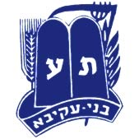
Dreidel crossword
B.A.N.R
Bnei Akiva New Rochelle

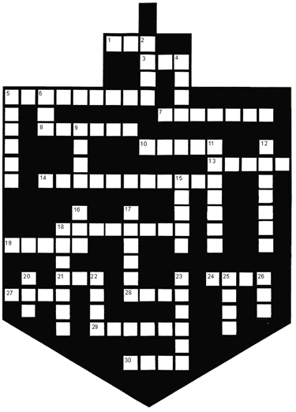
Across
1. The Maccabees found one _______ of pure olive oil.
3. I like to _______ fried donuts.
5. Fried donuts in Hebrew are called __________.
7. Some people place the Menorah opposite the __________ .
8. Others put their Menorah in the ____________.
10. Yehudis fed the Greek general cheese to make him thirsty. That’s why we eat ___________ foods.
13. The oil they found lasted for _________ days.
14. Chanukah begins on the ________________ day of Kislev.
18. A Jewish warrior was called a _____________________.
19. Mattisyahu was the son of Yochanan ________ Gadol.
21. To remember the miracle we eat food fried in _______.
24. We play _______ the dreidel.
27. We re-tell the story of Chanukah every ___________ .
28. A miracle: They found one jar of pure oil with the ______ of the Kohen Gadol on it.
29. Chanukah comes in the month of ________ .
30. The shamash candle is often made of _______ wax.

Down
2. Money given out on Chanukah is called Chanukah _______.
4. “In those days, at this ________”
5. A beautiful Menorah may be made of _____________.
6. The Greek armies were many, but the Jews were ________.
9. The ________ of the Maccabees' home town was Modin.
11. The most famous Maccabee.
12. The candle we use to light the Menorah is called the ___________
15. Many Chanukah foods, like latkes and donuts, are ______ in oil.
16. The Greeks wanted to _______ certain Mitzvos.
17. Potato pancakes are also called ___________ .
18. We light the ____________ on Chanukah.
20. The candle we kindle first is the _______ one.
22. We can _______ at the light of the Menorah, but we may use it for anything else.
23. Oil for the Menorah is made from_________.
25. We all love to ________ dreidel.
26. First letter on the dreidel

