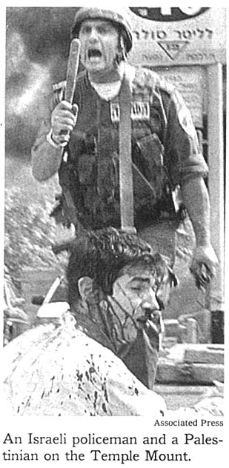Subject: To the Editor
Date: Mon, 02 Oct 2000 00:15:07 -0500
From: aaronnoach <aaronnoach@21stcentury.net>
To: letters@nytimes.com

Regarding your picture on page A5 (Sept. 30) of the Israeli soldier and the Palestinian on the Temple Mount - that Palestinian is actually my son, Tuvia Grossman, a Jewish student from Chicago. He, and two of his friends, were pulled from their taxicab while traveling in Jerusalem, by a mob of Palestinian Arabs and were severely beaten and stabbed.

That picture could not have been taken on the Temple Mount because there are no gas stations on the Temple Mount and certainly none with Hebrew lettering, like the one clearly seen behind the Israeli soldier attempting to protect my son from the mob.

Aaron Grossman, M.D.
6737 N Richmond
Chicago, IL 60645
(773) 743-1194

Subject: (no subject)
Date: Mon, 2 Oct 2000 14:54:39 EDT
From: Heshygiss@aol.com
To: letters@nytimes.com

CC: aaronnoach@21stcentury.net, JPeditor@aol.com

Dear Editor,
Even the typically biased and slanted NY Times Middle East reporting has hit a new low. Since the Times wishes to convey the belief that the Palestinians are all innocent lambs being tormented by an aggressive oppressor, it can not even conceive that the wounded and injured are NOT Palestinians. The current case in point is very personal to me. In the Saturday's Times on page A6, the picture of the "wounded Palestinian" is, in fact, my nephew, Tuvia Grossman, an AMERICAN Jewish student learning in Israel. His only crime was being Jewish. He was not in "crossfire" but merely the target of Palestinian lambs that stoned his cab, dragged him from the vehicle, smashed his head with stones and stabbed him in the leg. The Israeli soldier, whom you obviously wished to portray as victimizing the poor, wounded Palestinian was actually saving my nephew's life. A casual look at the background of the picture can tell anyone that it's not the Temple Mount at all. I believe that a retraction, in a prominent position in the paper, is necessary and an apology to the parents, forthcoming.

Howard Gissinger
2809 Avenue S
Brooklyn, New York 11229
718-998-2909

