Operation Kadesh,1956:
Israel’s 2nd war with Egypt. This was an operation aimed to keep terrorists away from Gaza strip, to disrupt Egyptian initiative for war against Israel together with Arab allies and to open the Tiran straits in the red sea for freedom of Israeli sail.

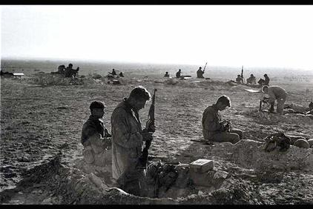

IDF SOLDIERS PREPARE TRENCHES AND CLEAN THEIR
WEAPONS IN SINAI PRIOR TO RENEWED FIGHTING WITH THE
EGYPTIAN ARMY AT THE MITLA PASS DURING OPERATION KADESH.

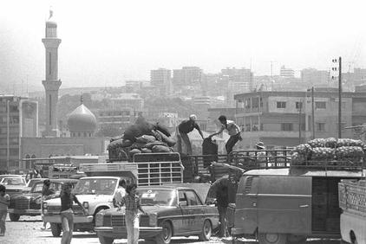

OPERATION "PEACE OF GALILEE. LIFE RETURNING TO
NORMAL AND FOOD SUPPLIES ARRIVE ON MARKET PLACE IN SIDON
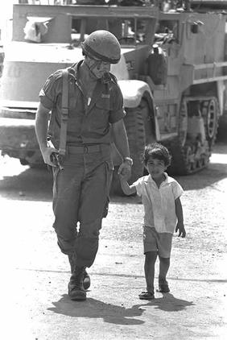
Lebanon war,1982 (“operation peace for Galilee”) : broke out when Israeli fources invaded Lebanon,and,within a few weeks of fighting with PLO (Palestine Liberation Organization) and Syrian forces, managed to occupy southern Lebanon, up to and including Beirut, and to drive the PLO out of the country.

OPERATION "PEACE OF GALILEE. ISRAELI PARATROOPER
WITH NEWLY "ADOPTED" FRIEND IN BEIRUT.

The six-day war, 1967: was fought between Israel and its Arab neighbors: Egypt, Jordan and Syria. As a result, Israel gained control of the Gaza strip, Sinai cape, the west bank and Golan heights.

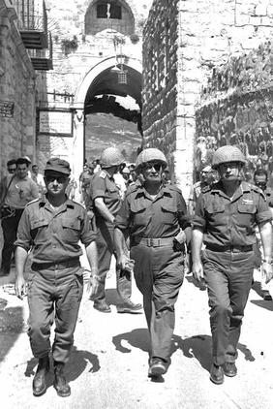
SIX-DAY WAR. DEFENSE MINISTER MOSHE DAYAN (C),
CHIEF OF STAFF YITZHAK RABIN (R) AND JERUSALEM COMMANDER UZI
NARKIS ENTER THROUGH THE LION'S GATE INTO THE OLD CITY.

Yom Kippur War,1973 : Egypt and Syria attacked Israel on Yom Kippur; Israel counterattacked and drove the Syrians back and crossed the Suez Canal into Egypt

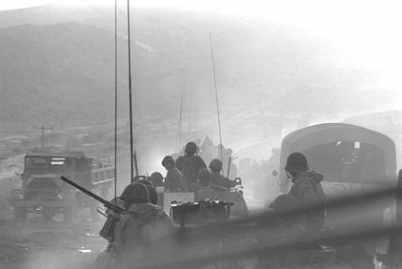

YOM KIPPUR WAR. ISRAELI UNITS MOVING INTO BATTLE
COUNTER-ATTACKING SYRIAN TROOPS ON THE GOLAN HEIGHTS.

YOM KIPPUR WAR. ISRAELI UNITS MOVING INTO BATTLE
COUNTER-ATTACKING SYRIAN TROOPS ON THE GOLAN HEIGHTS.

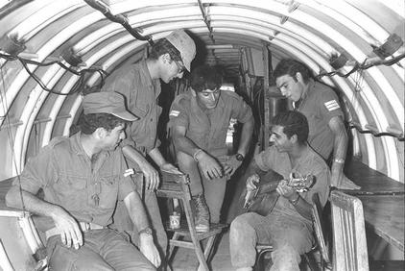
WAR OF ATTRITION. AN ISRAELI SOLDIER INSIDE A
BUNKER NEAR THE SUEZ CANAL AT KANTARA.
.
The war of attrition, 1968 – 1970: was a limited war fought between Egypt and Israel. It was initiated by Egypt as a way to make Israel’s occupation of the Sinai as costly as possible.

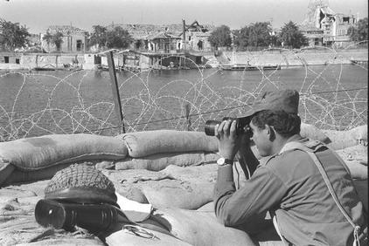
WAR OF ATTRITION. AN ISRAELI SOLDIER LOOKING
ACROSS THE SUEZ CANAL AT KANTARA
“The war of independence”, 1948 : The first in a series of wars in the Arab – Israeli conflict. It established the state of Israel as an independent state Palestine was split into areas controlled by Egypt and Transjordan.

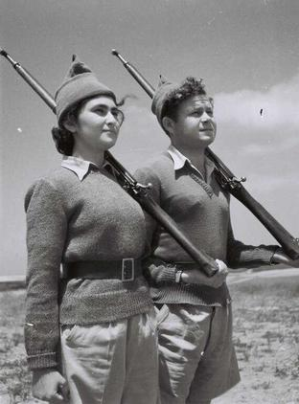
THE WAR OF INDEPENDENCE. IN THE PHOTO, NEW IDF RECRUITS.

