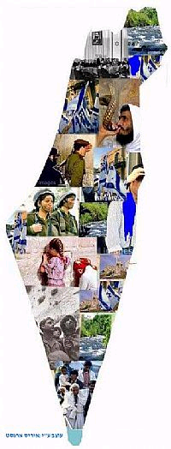
Scavenger hunt-Israel

By Daniella and Yonati Wagner
Goal:
Gaining knowledge about the map of Israel through a game.

Things to prepare:
1.Make a huge map of Israel, out of two Bristol boards.
2.Draw different major cities on it, and make questions about those cities.
Then cut out the map you made into puzzle pieces and place
them around the shul.
3.On the question sheets, write the letters of “am echad belev echad”
The game:
When your chanichim get to the puzzle pieces, ask them a question. If they get it wrong, you ask them another question. When they’ve answered correctly, the back of the question will have another place in the shul written on it. They go there. (Basically, it’s a scavenger hunt.) On the back of question sheet should also be a letter that in the end will spell out “am echad belev echad.” “עם אחד בלב אחד “ (see if any chanichim can figure this out.. if not add it in, at the end.) Once your chanichim are finished have them bring all the puzzle pieces together and put the map of Israel together. THEN GIVE YOUR SHPEAL of why it’s important to know about Israel’s geography, etc. , after they’ve used up all their energy running around.

Here are some questions/statements you can use, or make up your own:
What is a southern city in Israel? (Eilat )
Which president moved to Sedi Boker in order to settle the Negev? (David Ben Gurion)
In which city was the declaration of Independence proclaimed? (Tel Aviv.)
Which is the largest city in the Negev? (Beer Sheva)
The compass rose- says north, south, east, west in Hebrew
(צפון דרום מזרח מערב)
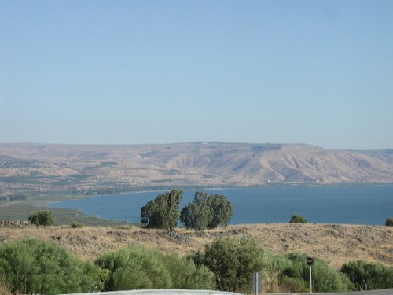
This is a picture of which part of Israel? (Golan)

This name is not found in the Torah at all, and is first mentioned as one of the cities that was captured by Yehoshua when the Jews entered into the Promised Land. (Jerusalem)
To which city did Yehoshua send meraglim? (Yericho)
A northern city, this is one of the four holy cities (Tzafat or T’verya)
To which place did 1000 Jews run away from the Romans and saw this place as their last refuge? (Massada)
This city was once called Elonei Mamrei and Kiryat Arba and is known as one of Eretz Yisrael's four holy cities. (Chevron)
Which city has the largest port in Israel? (Haifa)

