How do they behave in this subject?   | How do we make the subject related to them?   | Do we know enough about the subject?   |   What do they already know about this subject? | Additional knowledge?  
How do they feel about the subject?   | What do they think?  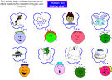 | Could they be against the subject?   | Change their behavior?   |   How do you make the subject realistic to them?
Do we have enough information? Where can find more?   | Group change?  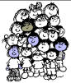 | How will we divide the subject?  What should we talk about, what to leave out?   | How can we create positive expectations/ interest?   | Individual change?  

