Tradition

Aims:

- To learn why the Torah stresses the word generations

- To show them the importance of passing the Torah down and learning

- To make sure that we are not the generation that breaks the chain

Nir Regev
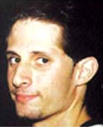
Nir Regev, 25, of Nahariya was one of 21 people killed in a suicide bombing carried out by a female terrorist from Jenin in the Maxim restaurant in Haifa. The Islamic Jihad claimed responsibility for the attack.
The blast devastated the restaurant, of joint Jewish-Arab ownership, on Hahagana Boulevard near the southern entrance of the coastalcity. It was packed mostly with regularSaturday customers. The bomber, Hanadi Jaradat, a 29-year-old lawyer from Jenin, managedto get past Maxim's security guard before blowing herself up in the middle of the restaurant. The security guard, an Israeli Arab, was killed in the attack, along with three other Israeli Arab employees of the restaurant. The victims included five members of the Almog family from Haifa and five members of the Zer-Aviv family from Kibbutz Yagur. Four children were killed and 60 people were wounded in the bombing. A student at the University of Haifa, Nir Regev was set to complete his degree in statistics and political science in several weeks, after submitting his finhal paper. He worked in a local branch of Bank Hapoalim and lived in a rented flat with two friends. Nir was having lunch at Maxim with a friend, Olga, after they had spent the morning at the beach. Nir died upon arrival at Rambam Hospital, while Olga suffered moderate wounds.Nir Regev was buried in Nahariya. He is survived by his parents, Ora and Eli, current commander of the IDF naval officers' training school in Acre, a brother Assar, 30, and sister Einat, 19.

The idea of tradition and passing things down from generation to generation is a major principle in judasim so much so that it is the name of this weeks sidra and we generally find that a name encapsulates the essence of what something is. So lets have a quick look at what there is to learn about this prinicple this week:

כה בראשית פרק
יט וְאֵלֶּה תּוֹלְדֹת יִצְחָק, בֶּן-אַבְרָהָם: אַבְרָהָם, הוֹלִיד אֶת-יִצְחָק. כ וַיְהִי יִצְחָק, בֶּן-אַרְבָּעִים שָׁנָה, בְּקַחְתּוֹ אֶת-רִבְקָה בַּת-בְּתוּאֵל הָאֲרַמִּי, מִפַּדַּן אֲרָם--אֲחוֹת לָבָן הָאֲרַמִּי, לוֹ לְאִשָּׁה. כא וַיֶּעְתַּר יִצְחָק לַה לְנֹכַח אִשְׁתּוֹ, כִּי עֲקָרָה
הִוא; וַיֵּעָתֶר לוֹ יְהוָה, וַתַּהַר רִבְקָה אִשְׁתּוֹ.

19) These are the generations of Yitzchak the son of Avraham: Avraham was Yitzchak’s father. 20) When Yitzchak was 40 years old, he married Rivka, daughter of Betu’el the Aramean from Padan Aram and sister of Lavan the Aramean. 21) His
wife was sterile, and Yitzchak pleaded with G-d for her sake. G-d granted his plea and Rivka became pregnant.
Bereishit Chapter 25

- Why does the Torah stress this idea of generations?
- Why do you think that the Avot are so desperate for
children? (Rather than accepting their ‘fate’ they constantly
plead against it!)

Well like I said earlier passing things down from generation to generation is extremely important in Judaism and if the Avot didn’t have another generation to pass it on to then what would have been the point in them trying to make a difference in the first place. In fact possibly the most important prayer that we say three times a day stresses this point and is in fact also the source of our obligation to learn Torah.

דברים פרק ו
ד שְׁמַע, יִשְׂרָאֵל: ה אֱלֹנוּ, ה אֶחָד. ה וְאָהַבְתָּ, אֵת ה אֱלֶֹיךָ, בְּכָל-לְבָבְךָ וּבְכָל-נַפְשְׁךָ, וּבְכָל-מְאֹדֶךָ. ו וְהָיוּ הַדְּבָרִים הָאֵלֶּה, אֲשֶׁר אָנֹכִי מְצַוְּךָ הַיּוֹם--עַל-לְבָבֶךָ. ז וְשִׁנַּנְתָּם לְבָנֶיךָ, וְדִבַּרְתָּ בָּם, בְּשִׁבְתְּךָ בְּבֵיתֶךָ וּבְלֶכְתְּךָ בַדֶּרֶךְ, וּבְשָׁכְבְּךָ וּבְקוּמֶךָ. ח וּקְשַׁרְתָּם לְאוֹת, עַל-יָדֶךָ; וְהָיוּ לְטֹטָפֹת, בֵּין עֵינֶיךָ. ט וּכְתַבְתָּם עַל-מְזֻזוֹת בֵּיתֶךָ, וּבִשְׁעָרֶיךָ.
4) Listen Israel, G-d is our Lord, G-d is One. 5) Love G-d your Lord with all your heart, with all your soul and with all your might. 6) These words which I am commanding you today must remain on your heart. 7) Teach them to your children and speak of them when you are at home, when travelling on the road, when you lie down and when you get up. 8) Bind [these words] as a sign on your hand, and let them be an emblem in the centre of your head. 9) [Also] write them on [parchments affixed to] the doorposts of your houses and gates.

Shema: Devarim Chapter 6

- What should you teach to your children?
- What do you think it means by your children – is it just literal?

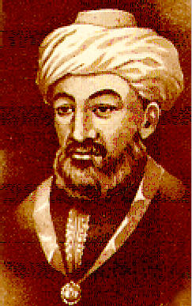
הלכות תלמוד תורה פרק א
א נשים ועבדים, פטורים מתלמוד תורה; אבל קטן--אביו חייב ללמדו תורה, שנאמר "ולימדתם אותם את בניכם, לדבר בם" (דברים יא,יט). ……..
ב …………. מצוה על כל חכם וחכם מישראל ללמד את כל התלמידים, אף על פי שאינן בניו: שנאמר "ושיננתם לבניך" (דברים ו,ז)--מפי השמועה למדו, בניך אלו תלמידיך:

1) Women and servants are exempt from the mitzvah of learning Torah, but a child-his father is obligated to teach him as it says “Teach them to your children, to discuss them” (second paragraph of the Shema)…
2) ……. It is an obligation on all wise men of Israel to teach all their pupils even if they are not their son as it says “Teach them to your children”(Shema) and we learn that your children are your pupils.
Rambam: Mishneh Torah: Laws of Learning Torah Chapter 1
So we have an obligation to pass the Torah down from generation to generation which is an unbelievable thing to do on especially on a Jewish level, but we are not the only people to realise the importance of this.
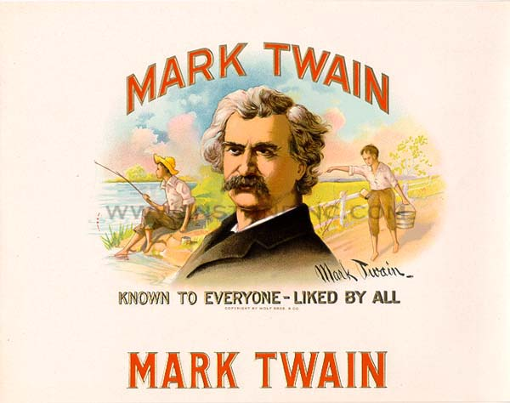
“If the statistics are right, the Jews constitute but one per cent of the human race. It suggests a nebulous dim puff of stardust lost in the blaze of the Milky Way. Properly the Jew ought hardly to be heard of; but he is heard of, has always been heard of… . He could be vain of himself, and be excused for it. The Egyptian, the Babylonian and the Persian rose, filled the planet with sound and splendour, then faded to dream-stuff and passed away; the Greek and the Roman followed, and made a vast noise, and they are gone; other peoples have sprung up and held their torch high for a time, but it burned out, and they sit in the twilight now, or have vanished. The Jew saw them all, beat them all, and is now what he always was, exhibiting no decadence, no infirmities of age, no weakening of his parts, no slowing of his energies, no dulling of his alert and aggressive mind. All things are mortal but the Jew; all other forces pass, but the Jew remains. What is the secret of his immortality?”
Mark Twain 1899

“Tradition, tradition. Without our tradition, our lives would be as
shaky as… as… as a fiddler on the roof”

Tradition: n. unwritten body of beliefs, facts etc. handed down from
generation to generation; custom, practice of long standing. (Collins
Gem dictionary)

In order to pass something down there must first be something to pass down!

Avram had a phenomenal mind and recognised his Creator when he was 3 years old, arriving at his conclusion by observation and reasoning. “Maybe I should worship the earth,” he mused, “because its production is that which sustains us. But then the earth is not all-powerful since it depends on the heaven. The ruling power of the ground is the sun, which keeps the world alive with its warmth and light. The sun must be the mighty god who created me and the universe around me!”
Avram prostrated himself before the sun, but when night fell and the sun vanished to make way for the moon, Avram reasoned that the moon must be divine. He abandoned this thought when he realised that the moon shone only by night. Finally by observing the regular rhythm of day and night, of the seasons and of all natural laws, Avram inferred the presence of an omnipotent and wise Creator. “How is it,” Avram asked himself, “that the Heavenly bodies rise and set at an appointed time? There must be a higher intelligence directing them!”
(Adapted from ‘The Midrash Says’)

- If you were Avraham’s son – Yitzchak – would you not feel daunted by the task of taking over from such a great man and have to try and think of new ways of spreading his message?

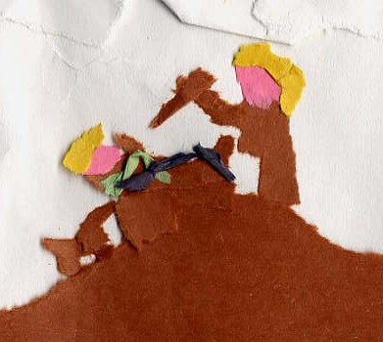
Well, to follow on from previous weeks in bordering on heresy, Yitzchak didn’t actually do that much. OK slight exaggeration but his life was very different to that of Avraham’s, he never left Israel, he re-dug the same wells that Avraham had dug and someone else went to find his wife for him; in fact he lived a very passive life. There is a very important message to learn from this which is in essence “if it ain’t broken don’t fix it”, sometimes what is needed is not innovation but consistence just being that link in the chain to make sure that it is not broken. If there is a break in the chain the following story might not be so far from reality.

THE LAST JEW

My name? My name is not important. Who am I? I am the last British Jew. The year is 2050; the place is the Natural History museum in London. I am in a glass-fronted cage, on exhibit. People pass me on their way, staring and pointing, sometimes laughing at me, the freak on show. On the walls are hung the remnants of the Jewish culture; a tallit, a Sefer Torah, a siddur, tefillin etc., and on a little metal table, nailed to the floor is a menorah. Each day as I sit here, I wonder how the hundreds of thousands of Jews who lived in Britain could have vanished away. My grandparents used to talk to me about the Jewish communities in the 19th and 20th centuries; the larger populations in Golders Green, Hendon, Salford and Gateshead; about Jewish organisations like Bnei Akiva, FZY and others. I remember my father telling me how successful and well off the British Jew was. All this completely disappeared. I contemplate the reasons, remember the events and search for the answer. I believe I know the answer to why the Jews disappeared. Small things that happened gradually. Families stopped attending Shabbat services, stopped sending their children to cheder, the Shabbat candles were never lit. My grandfather told me that they were still good Jews - they attended the Yom Kippur services, held the Pesach seder every year. The history books say that soon, this too, ended. To attend the Kol Nidre service became a chore, not an honour, to hold a seder became a task. The rituals of Judaism began to vanish. This was the first step… I was reading of a Rabbi Levy who pushed for equality between the Jews and everyone else in Britain. In time the Jews did become equal and accepted in society. The Jew was at the same level as the Christian and the hatred of the Jew began to die off. With all this equality, all differences were put aside. Jews stopped putting mezuzot on their doors. When asked if they were Jewish, they would give a brisk “no”, or wouldn’t answer at all. A new form of Judaism emerged, with a more liberal approach, they couldn’t see that it couldn’t exist. Judaism needs Jews, but Jews also need Judaism. Without one, the other was dead. And then there was that awful period 40 years ago. The Arab nations became strong. They wanted Israel destroyed, and they acted accordingly. With 2 nuclear pellets, 5 million Israelis were obliterated and the holy land was charred beyond all recognition.
When the news was announced, to the Jews in Britain, we said, “What could we have done?” And Britain was not alone in such an attitude. The Jews of America, South Africa and France, also adopted such an opinion. It wasn’t so long ago that one man orchestrated the destruction of over a third of our people. At that time they all swore that they would never forget. They swore that they would always support Jews across the world. They pledged their donations to Israel and vowed their allegiance for the progress of all Jews. In time, the donations stopped coming and the vows were forgotten. How forgetful a people can be! When the people lost pride in themselves, their religion and Israel, they lost everything. I am the last British Jew. In less than 20 years, I too shall die. Never again will another Jew set foot in this planet, as there are no more Jewesses. My G-d, Hashem, where did we forsake you? How could we forsake you? Why did no one realise until now, when it’s just too late?

Make sure that it isn’t our generation who breaks the chain!
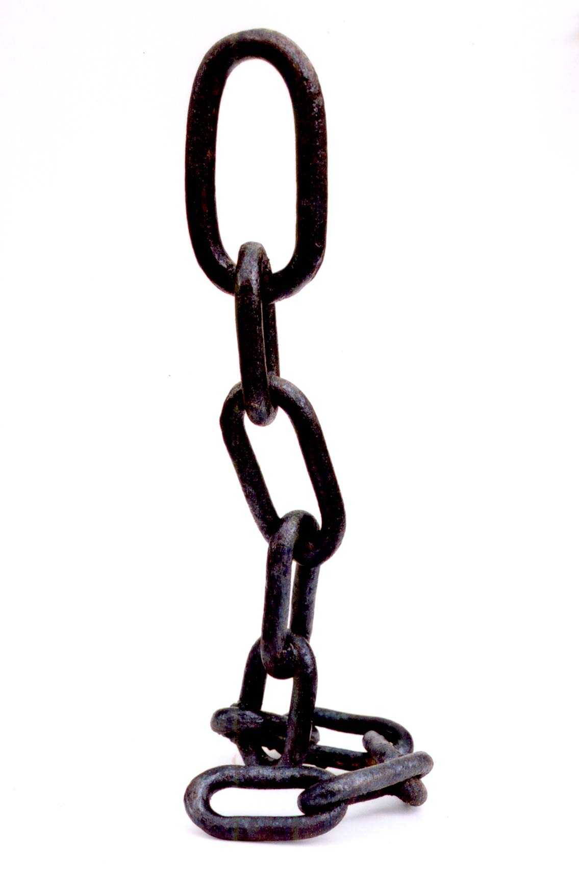

Ideas

- Come in discussing a revolutionary new idea, or way of life
Balloon debate – different lifestyles (all new and mental) -
which should be the one we live by and why? Lead into
discussion on the lifestyle we have now and where, when and
how it began.
- The weakest link – gets across aim subtly, and quiz questions
can be on the lives of our Avot
- Changing Rooms – there is a pile of clothes on the floor and
everyone else is lined up on the other side of the room. The
first person in the line is the runner and must run to the
pile, grab one item and take it back to the others, then run
back for another item etc until all items have been taken
(quite active). The others in the line must stay still and just
pass one item of clothing at one time along the line (quite
passive). The last person in the line must put all the clothes
on properly, but can only take the clothes once they have
been passed along the line, and everyone has touched them
(quite active). You can time them and try to get them to
beat their record. Would it work without the people in the
middle? They may be bored out their brains after a while,
but they play a vital role in the process and without them,
the chain would be broken!

Chain Games:
- Humming game
- Passing the chairs along the room to the other side
- Relay races
- Chinese whispers of actions

