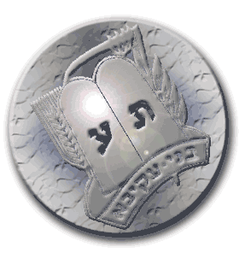

Someone who bowled a strike | Someone who knows what the theme of Sniff was last week | Someone wearing a red shirt/sweater | Someone who ate chulent this past Shabbat
Someone who goes to sniff regularly | Someone who went bowling within the last month | Someone who can say all 3 Brachot that we say at Mifkad. | Someone who went to a Bnei Akiva camp
Someone who is wearing both the color Blue and the color White | Someone wearing size 7 bowling shoes | Someone who’s been to Israel | Someone who can sing all the words to Yad Achim

Someone who went to a Bnei Akiva camp | Someone who knows what Parsha it was last week | Someone wearing a green shirt/sweater | Someone who was born in November
Someone who can sing all the words to Yad Achim | Someone who went bowling within the last month | Someone who is wearing both the color Blue and the color White | Someone who bowled a strike
Someone who can say all 3 Brachot that we say at Mifkad. | Someone wearing size 7 bowling shoes | Someone who’s been to Israel | Someone wearing something with a sports team on it

