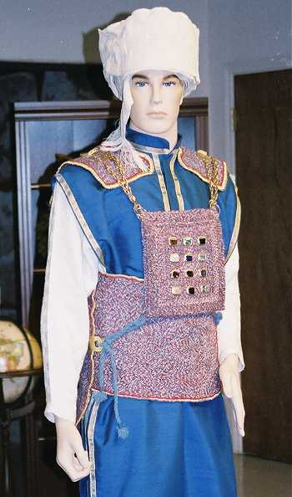
Peula – The Bigdei Kehuna
(For Parshat Titzaveh or Pikudei)
Prepared by Michael Sedley, Toronto
‏כ"ג אדר תשס"ד  March 16, 2004

Objective
To learn about the Bigdei Kohen Gadol (Garments of the Kohen Gadol)

Materials
- One King-size bar of chocolate
- Fork and knife (preferably not plastic)
- Die (1 dice)
- The 8 Bigdei Cohen Gadol (see below)

Method
First go through each of the Bigdei Cohen Gadol, show how they were worn.
Then we play the chocolate game:
- Group sits in a circle with the chocolate, fork, knife and begdim in the middle
- Pass the die around the circle, each person rolls the die then passes it to the person on their left.
- If someone rolls a 6, they must run to the middle, put on each of the 8 garments, then using only the fork and knife, cut and eat a piece of chocolate.
- If someone else rolls a 6, the person in the middle must stop whatever s/he is doing, remove the garments, and return to the circle so that the new person can try to get the chocolate.

Bigdei Kohen Gadol
You will need to make each of the 8 Bigdei Cohen Gadol.
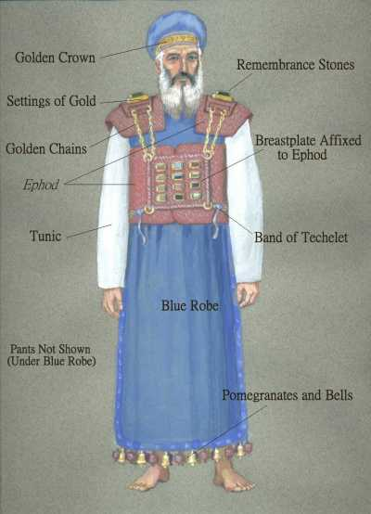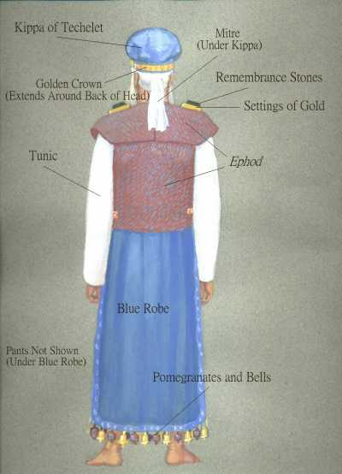

These Garments can be made as follows:

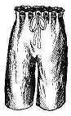
Michnasei bad (pants – worn under the Katonet)
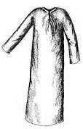
Use large sized pajama pants

Katonet (Tunic)
Use dressing gown

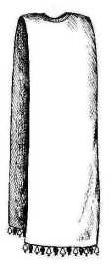
Me’il (Blue Robe)
Large sheet with hole in the middle.
Round one of the corners to make sure that there is no Chiyuv tzitizt on the garment.
If you want to get fancy, make Pomegranates and bell shapes on the bottom

Avnet (long belt)
Get a long piece of ribbon or rope

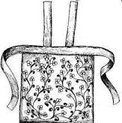
Efod
Use an apron, or cut a piece of material in the shape of the efod

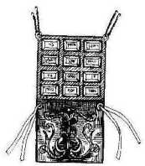

Choshen (Breastplate)
Make a Choshen out of cardboard.

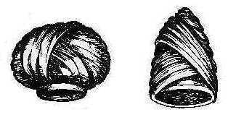

Mitznefet (Turban)
Get a long piece of material that can be wrapped around the head.

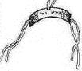
Tzitz (Golden Headband)
Make a golden headband out of cardboard and gold paper. It should have string so that it ties in the back.
On the Front it should say “קודש לה'”

Background information
This information is provided for the Madrich so that he can be ahead of the chanachim.
DO Not read this aloud to the Chanachim – that would be boring, however you should read it (or learn Parsha) before the Peula.
Source: http://www.chabadonline.com/scripts/tgij/paper/Articlecm.asp?ArticleID=1325

A total of eight types of garment should be made. All Kohanim (priests) should wear the ketonet (tunic), michnasayim (breeches), mitznefet or migba'at (hat or turban); and avnet (sash). In addition, the Kohen Gadol (high priest) should wear a me'il (cloak), efod (apron), choshen (breastplate) and tzitz (crown).
The Efod
And they shall make the efod of gold [thread], blue, purple and scarlet [wool], and fine twined linen, artistic work.
The Efod
The Efod resembled an apron worn backwards, so that it covered the back of the wearer from above the waist down to the ankles and overlapped in the front. A sash tied in the front beneath the heart, and two bands extended up the wearer's back to his shoulders.
On the ends of these bands (which rested on the shoulders of the wearer) G-d tells Moses to place two shoham (onyx?) stones in gold settings. The stones should be engraved with the names of the twelve tribes of Israel: "six of their names on one stone, and the other six names on the other stone, according to their birth."
The Breastplate
The second garment that Moses is instructed to make is "the breastplate of judgment." A rectangular piece of fabric (woven of the same materials as the Efod) should be folded in half to make a square pouch measuring half a cubit by half a cubit (approximately 10 inches x 10 inches). Upon its front, in gold settings, twelve gemstones should be arranged in four rows:
A row of a ruby, a chrysolithe, and a beryl: this shall be the first row.
The Choshen (before folding)
And the second row: a turquoise, a sapphire, and a diamond.
And the third row: a ligure, an agate, and a jasper.
And the fourth row: an emerald, and a shoham, and a jade...
And the stones shall be with the names of the children of Israel, twelve, according to their names, like the engravings of a signet.
Within the folded cloth under the gems should be inserted the "Urim and Tumim."
The Breastplate should hang upon the High Priest's chest, firmly bound to the Efod by means of gold chains extending from the Breastplate's upper corners to the fittings of the Efod's shoulder stones, and ribbons of blue wool binding golden rings on the Breastplate's lower corners to corresponding rings attached to the Efod's sash---this to ensure that "the Breastplate shall not budge from the Efod."
The twelve stones were each inscribed with the name of one of the twelve tribes of Israel:
And Aaron shall bear the names of the children of Israel on the Breastplate of Judgment upon his heart, when he goes in to the holy place, for a perpetual remembrance before G-d.
The Cloak and the Crown
The Cloak (me'il)
And you shall make the cloak of the Efod all of blue [wool].
There shall be a hole for the head in the middle... Beneath, upon the hem of it, you shall make pomegranates of blue, purple and scarlet, round about its hem; and bells of gold between them round about. A golden bell and a pomegranate, a golden bell and a pomegranate, upon the hem of the Mantle round about.
It shall be upon Aaron when he comes to minister; and its sound shall be heard when he goes in to the holy place before G-d...
The fourth priestly garment commanded to Moses is the Tzitz ("crown")---a gold plate inscribed with the words "Holy to G-d" that was affixed to the forehead of the Kohen Gadol.
The Tzitz

The Other Four Garments
These four garments--Efod, Breastplate, Cloak and Crown--are exclusive to the High Priest. The other four should be worn by all Kohanim. These are:
The Tunic
The Ketonet: A tunic made of pure linen, covering the entire body from the neck to the feet, with sleeves reaching to the wrists.
The Mitznefet or Migba'at: A long band of linen cloth that was wound around the head as a head covering. On the ordinary Kohen's head it was wound as a cone-shaped hat (migbahat), while the Kohen Gadol wore it as a broad, flat-topped turban (mitznefet).
The Turban, wound as a "Mitznefet" (left) for the Kohen Gadol
and as a "Migba'at" (right) for the ordinary Kohen
The Avnet: A long cloth sash that was wound many times around the waist. The Kohen Gadol had two types of sashes: one of linen and multi-colored wool with "embroidered work" for use throughout the year, and one of pure linen for the Yom Kippur service. (The Torah does not specify how the ordinary Kohen's sash should be made; some say it was like the Kohen Gadol's year-round sash, while others say that it was like the one he wore on Yom Kippur).
The Michnasayim: "And you shall make them linen breeches to cover their nakedness; from the waist to the knees they shall reach."
The Breeches
And you shall put these upon Aaron your brother, and his sons with him; and you shall anoint them, and consecrate them, and sanctify them, that they may minister to Me.
The priestly garments were worn as follows: The ordinary Kohen put on the Breeches, over which he wore the Tunic, and wound the Turban upon his head and the Sash around his waist. (His feet remained bare under the floor-length tunic).
The Kohen Gadol first put one these four garment as worn by the ordinary Kohen (except that he wound his head-covering differently, as per above). Then, over the Tunic and Sash he draped the Cloak of blue wool---basically a long piece of cloth with a hole in the middle for the head, which hung down in front and in the back. The "Cloak" all but covered the Tunic, leaving only a narrow band exposed beneath its bell-trimmed hem.
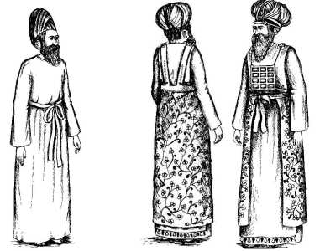
The Kohanim in their Priestly Garments: the ordinary Kohen (left)
and the Kohen Gadol, front and back (right)
Over the Cloak were tied the Efod (which left a portion of the Cloak exposed beneath it) and the Breastplate. The Crown was placed on Kohen Gadol's forehead, and fastened in place by means of blue wool ribbons extending over his Turban and around his temples to be tied behind the head.
And they shall be upon Aaron, and upon his sons, when they come in the Tent of Meeting, or when they come near to the Altar to minister in the holy place, that they bear not iniquity and die. It shall be an everlasting statute to him and his seed after him.

