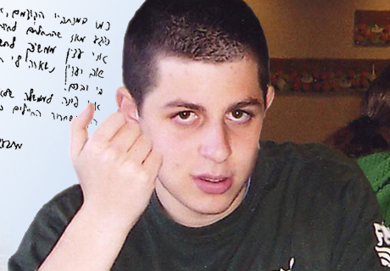
Gilad Shalit (21) was born on 08/28/1986. He is the son of Aviva and Noam Shalit from Mitzpe Hilla in the Western Galilee and the brother of Yoel (24) and Hadas (17).
Since the attack at Kerem Shalom on Sunday, 06/25/2006, Gilad has been held in the Gaza Strip by Hamas. In June 2007, Egyptian mediators received a letter written by Gilad in which he stated that he was alive and well. In June 2008, Israel received an audiotape proving that Shalit is still alive.
When Gilad was 11 years old, he wrote a story about the relationship between a shark and a fish. In it, he writes about a young fish and a young shark who’s families hate one another. The youth, however, get to know one another and want to keep their friendship. Gilad’s family decided to publish this book, hoping that he will be released.
To Gilad – Your mother and father, Yoel and Hadas, and all of your family and friends miss you terribly. They wish to see you and your smile already, and to embrace you in a strong and loving embrace.

