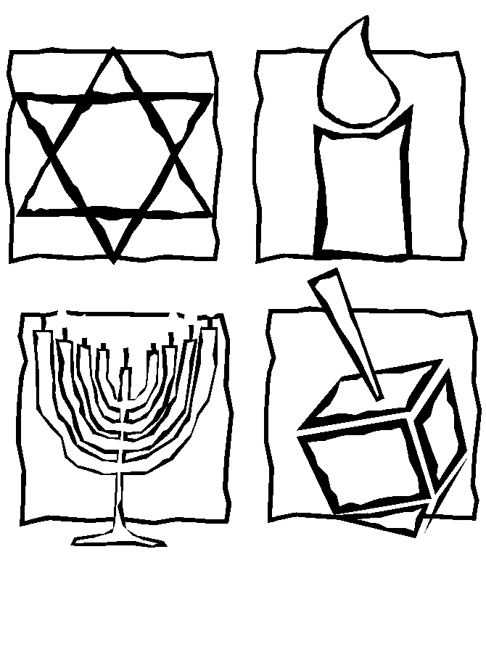
Chanukah
December 13, 2005
5th grade advisory

Colorful transparencies
Instruction for the advisors – 5th grade

Please read the following instruction (till the end) and follow them with your students step by step:

* Before you start: Cover the tables with newspapers:

- Give each child a transparency.
- Tell the students to make sure the transparency is right side up.
(The right side is the side with the sticker, the striped side).
- The students should color the picture inside the black lines.
Encourage them to make it colorful and unique as possible..!
- Ask the students to crinkle the aluminum-foil into a ball (not too tight) and then open it up. Be careful not to tear the foil!
- Ask the students to put the aluminum foil under the transparency - staple them together. Cut the aluminum foil the same size as the transparency.
- Put the poster board under the aluminum foil, and staple the three layers together.
- Cut the poster board the same size as the transparency.

- Ask each student to write his name on the bottom of his pictures. (not too big…)

Have a great time!
Avivit & Riki

