Simcha from the Mekorot
For: Chevraya Bet (Grades 9th-12th)

Goals: In this peulah we will try to talk about Simcha and what it really means to us.
Are there reasons for our happiness or for us thinking that we are happy?
How can we make the pressure for happiness less stressful?

Peulah: Start with raising a question: Who thinks of himself as a happy person? Why?

Read the following story out loud.
Rav Broka was in the city market and Eliyahu Hanavi was there with him. Rav Broka asked: "Is there someone in this market who deserves Olam Haba?" Eliyahu answered: "No". In the meantime, two brothers came into the market. Eliyahu said: “These are people that will go to Olam Haba." So Rav Broka went up to the people and asked them: "What do you do?" They answered: “We are happy people and we make sad people feel happy. When we see a fight between two people we do our best to make peace between them."

Why do you think that out of all of the people in the market, these were the only people that deserved Olam Haba? Does happiness have such high importance in Judaism? If so what kind of happiness? Pay attention to the fact that they weren't only happy for themselves they also tried to make other people happy. Maybe you being happy in an environment that doesn't have much happiness in it isn’t enough. They also broke up fights between people to increase the amount of happy people, is that necessary?

Hand out the daf mekorot. Each chanich will have to decide which source he identifies with the most and why? What kind of Simcha does the source represent?
Are there a few kinds of happiness? What are they? Why are they different?
Is there a certain kind of happiness that we should strive to have? How can we know if the reason we are happy is the right one?
Happiness can come in all kinds of forms, the question is it real happiness?
Take the following sentences and either read them out loud (or make cards out of them and spread them around or hand a page with them to each chanich). Ask the chanichim to decide which of them are true expressions of happiness. If they find that too difficult to answer, ask them to divide them into different types of happiness. If they choose to divide, ask them to try and give names to each type of happiness.

- I am so happy to wake up in the morning!
- Finally getting the dress that I’ve been dreaming about made me the happiest person alive!
- Last night was the happiest night of my life I got so drunk I was singing on the tables and I felt so free and happy!
- Today is the happiest day of my life- I got accepted to the school I've wanted to go to!
- Last week my neighbor became the happiest man I know around- he won the lottery.
- I just got this huge thing that was bothering off my chest- this is so great! I'm so happy!
- My sister just became the happiest person, she just had a baby after being married for 7 years.
- Last night I hardly had any homework so I got to watch tons of TV - that made me very happy!
- I'm so happy- I just gave this beggar on the street all of my small change.
- I just passed this really hard stage in my favorite computer game, this makes me so happy.
- I made up with my friend after not talking to her for an entire month. That's a relief -I'm happy.

Read the following source, written by Rav Shlomo Aviner in a response to a question that he was asked regarding Simcha.
Question: Is it natural that people will be happy from entertainment and humor?
Answer: Yes it is natural for a person to enjoy and be humored by entertainment shows, wine and humor.
Question: Is that real happiness?
Answer: That is Real happiness. But, said Kohelet, in the end there is nothing left of it. It brings on disaster and it doesn't fill up our lives. The pleasure becomes a plague. This kind of Simcha doesn't solve the problems in life; it doesn't fill the person with happiness. Pleasure isn't happiness. The pleasure only last a short while. Happiness, on the other hand, is a constant feeling, permanent, that life is good, that it is worth living, that is happiness! The pleasures don't give happiness, they fade away and after the pleasure- plague, you are ashamed of yourself. The pleasure has another trait- it gets meaningless after a while, and then you need a new one a stronger one and then stronger. In our days the entertainment business is worth billions of dollars. But, says Kohelet, it doesn't solve the problems of our life. He talks about the happiness that comes from entertainment as an option that must be checked and tried, since this is a way of life that says: Don't focus so much on research, Enjoy Life! This theory doesn't allow killing or stealing, but as long as you aren't hurting someone else, you can enjoy yourself. This theory says that a person isn't happy because he doesn't allow himself to be happy.
This is the way we always tried to fight. The Hashmonaim fought against the Greeks... Our war was against the culture that grew in Greece that was based only on pleasure -in a way of life that was full of corruption... Rav Kook says that that war was against the gluttony and the not proper pleasures. The purpose of life is not pleasure and nothing else.
( Rav Shlomo Aviner. Commentary to Kohelet)

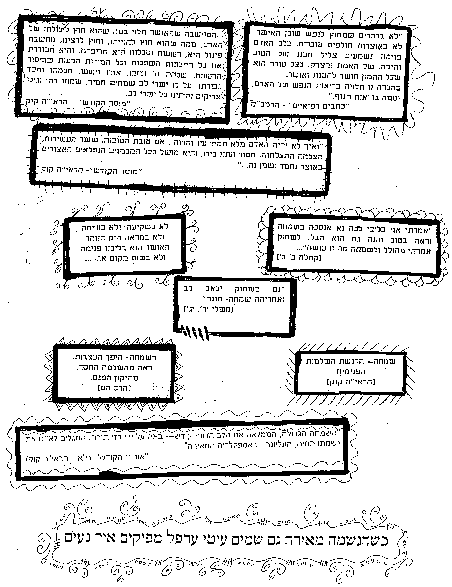

Closing: It's not that we shouldn't be happy with the things we've got and with new things that come our way, we just have to be smart enough to understand that what's really important doesn't lie in a fortune we inherit or in the moments when we brake loose and do whatever is on our minds. We should appreciate the little things in life and try to achieve more of a spiritual happiness and less of a material one! This can happen as soon as we start thinking of things- not as a given but look at everything as a present given from God. Every little thing can make us happy but if we look at everything as a whole as a world that God created we will be able to achieve happiness.

Written by- OFRA KOREN AND SHIRA KATZ.

