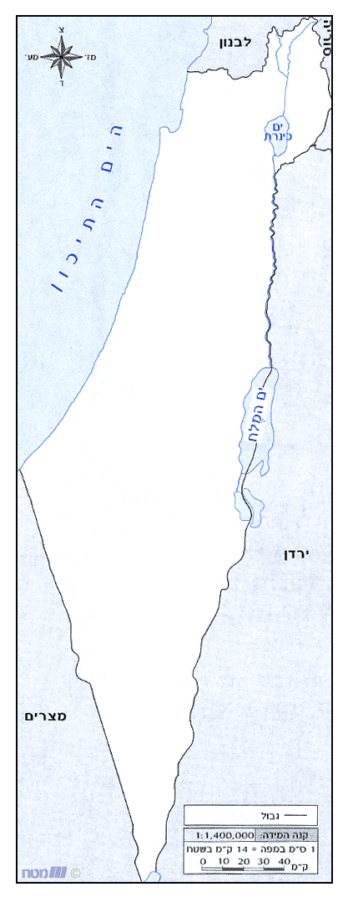

Find these places on the map:
*
*
*
*
*
*
*
*
*
*
*
*
B.A.N.R
Bnei Akiva New Rochelle

* Yerushalayim- the holy city...
* Tveriah (aka Tiberias)
* Tel-Aviv
* Ra’anana
* Haifa
* Eilat
* Modi’in- where the Maccabim lived
* Chashmonaim- named after…
* Be’er Sheva
* Beit Rimon (where Aviva lives)
* Elazar- Near Efrat. Named after
* Elazar Hamaccabi
* Tzfat

"לכל מקום שאליו אני הולך
אני הולך לארץ ישראל"

