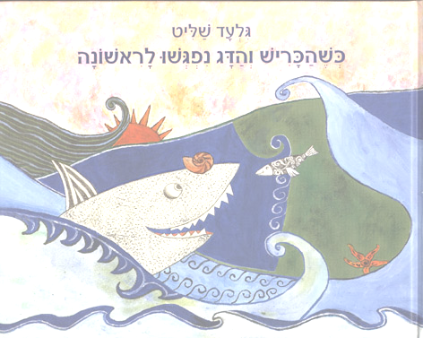

When Gilad Shalit was 11 years old, he wrote a story about a shark and a fish. 8 years later he was kidnapped by terrorists. Today, 11 year olds are reading his story, hoping for his release.

A small and gentle fish was swimming in the middle of a peaceful ocean.

All of a sudden, the fish saw a shark that wanted to devour him. He then began to swim very quickly, but so did the shark.

Suddenly the fish stopped and called to the shark, why do you want to devour me? We can play together.
The shark thought and thought and said okay fine, lets play hide and seek! The shark and the fish played all day long until the sun went down.

In the evening, the shark returned to his home.

His mother asked, “How was your day my dear shark? How many animals did you devour today?”
The shark answered, “Today I didn’t devour any animals, but I played with the animal called fish.”

“That fish is an animal we eat. Don’t play with it.”

At the home of the fish the same thing happened.

“How are you little fish? How was it in the sea today?” Asked the fishes mother. The fish answered, “Today I played with an animal called shark.” “That shark is the animal that devoured your father and your brother. Don’t play with that animal!” Answered the mother.

The next day in the middle of the ocean, neither the shark nor the fish were there. They didn’t meet for days, weeks and even months.

Then one day they met. Each one immediately ran back to his mothers, and once again they didn’t meet for days, weeks, and months.

After a whole year passed, the shark went out for a nice swim, and so did the fish. For a third time, the shark said, “You are my enemy, but maybe we can make peace.” The little fish said, “Okay.”

They played secretly for days, weeks, and months until one day the shark and fish went to the fish’s mother and spoke together with her. Then they did the same thing with the shark’s mother. And from that same day, the sharks and the fish live in peace.

