Matan Torah

Goals:
- The chanichim will understand that a group is much more powerful than an individual when to establish change in the world.
- The chanichim will understand that a group that wants to promote an idea needs rules.

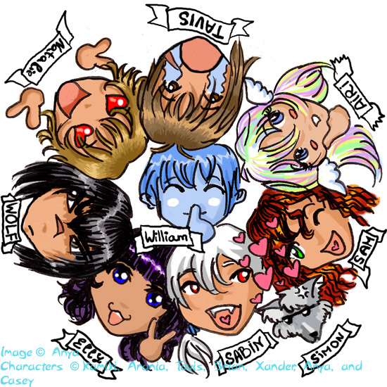
Steps:
1. Icebreaker
2. Can you do it alone?
3. Story
4. Short discussion
5. What makes us a group?
6. Chairs game
7. Summary

Things to prepare:
1.cards for finding a common to the group.

1. Icebreaker:
This is a very short game in order to get to know the new group and to break the ice. (Not needed if you know the kids already, but sometimes it’s a good idea anyway to loosen people up.)
Make the chanichim to stand in the order of their: shoe size/birth date/ name in the ABC…
2. Can you do it alone?
Tell all your chanichim: each one of you now has 5 minutes to ….
After they are finished, tell them to do the same task all together.

Ask: Where were the results better – on your own or with the whole group?
3. Story:
Read this story to the chanichim. Be exiting so they will listen to you:
A very old man was about to die. He had 9 sons. When he was lying in his bed – he called all his sons and told them:
I’m going to die soon. There is only one thing I want you to do for me.
He gave each one of them a pencil and asked him to break it into two. The brothers broke the pencils one after the other. They thought this was a bit strange thing to ask, and they had no idea what the point was.
When they finished, the father gave the youngest brother 5 pencils and told him: try to break all of them together.
The brothers did not know why would they father ask them to do such a stupid thing, but they were embarrassed to ask
The little boy tried and tried, but he could not break it.
Some of the brothers thaught he wasn’t strong enough, so the tried to break them, too. The pencils passed from one to the other. After a long time, one of the brothers managed to break them.
Then the father told them: there is only one thing I want you to remember: when you are together, strong and keeping the bond between you, it will be very hard to beat you. If you will not build up this connection, each one of you will break easily.
4. Short discussion:
# What does this story have you do with our parsha?
Am Israel got the torah, the biggest task of our life, only when they were a big group.
Ask: Why wasn’t the torah given to Abraham a long time ago – and he would pass it on? Why did Hashem wait so long?

In order to reach the goal of the torah “לתקן עולם במלכות שדי”, one man wouldn’t enough. Only a strong group that is committed to each other and to the group, would deliver a strong message to the world, a message that will be much harder to break.
5. What makes us a group?
Tell the chanichim: we’re trying to find one thing the whole group has in common.
Show the chanichim different cards – whoever agrees with the cards should stand on the chair and whoever doesn’t should sit down.

Ask the chanichim: did we find anything that we all have in common?
If we all wear blue and white or we all like bananas – does that makes us a group and be enough so we can make a change in the world?

6. Chairs game:
Make a circle of chairs and tell the chanichim to stand on them. Take out one chair at a time and tell them they should try to stay standing on the chairs without falling to the floor.

7. Summary:
When we have a strong basis and ideas we all believe in (like the chairs) it is easier for us to fulfill our task. But when we don’t keep our shared basis (take out chairs) it is hard for us to make a significant change in the world.

What is our group basis what makes us a group?
The torah and mitzvot. We should all remember this is the first thing that made am Israel a group and this is what will keep us together, all over the world.
If we will keep the torah and its rules, the Torah will keep us connected


