Introduction to a Beit Knesset

Introduction
By: Aviad Tabory

A shul is endowed with kedusha. We also know that there are certain halachot which apply to this kedusha, for example selling a shul or using it for purposes other than davening. Our shiurim will try to understand what are the implications of this kedusha. We will also discuss certain Halachot that have to do with shuls.

Does a Shul have Kedusha?

First of all, we must understand that kedusha has two meanings. One is a mystical meaning. We are not referring to this concept. When we talk about Kedushat Beit Knesset, we are talking about the second type which is a halachic kedusha. This kedusha is not created by Hashem but by human beings. This type of kedusha creates ramifications (Nafka Mina’s). What does kedusha mean? It means special, different, unique and designated for a specific purpose. If a shul has kedusha, how did this kedusha come about? (Discuss these questions with the chanichim: What does kedusha mean examples of kedusha, etc.)
The Gemara in Megilah 29a calls a shul a Mikdash Me’at .What does this mean? Is this comparison a halachic one? The Gemara (daf 26b) goes on to differentiate between Tashmishai Kedusha and Tashmishai Mitzva. Tashmishai Kedusha are objects which are holy, for example: a Sefer Torah and teffilin. Tashmishai mitzva are a luluv and tzizit. What is the status of a shul?
The Ran, on daf 8b, disagrees with the Ramban on this question. He holds that a Shul has kedusha on a derabanon level, while the Ramban holds that the Kedusha of a Shul is like a tashmish mitzva. The Rambam might have a third opinion. In the context of the Sefer Hamitzvot, mitzva number 65, the Rambam explains the issur to desecrate any part of the Beit Mikdash and this issur, according to him, includes desecrating shuls. This would mean that the Rambam holds that a shul has tashmishai kedusha on a bibical level.
What created this kedusha? Rav Soloveitchik explains that kedusha is brought down to this world through torah. This explains why a sefer torah, teffilin and mezuzza are different than a luluv and tzizit. (The ramification of this difference is that tashmishai kedusha have to be buried in the ground (Geniza). Therefore, explains Rav Soloveitchik, a Jew who dies has to be buried in the ground, for every Jew has a connection to a sefer torah.) The kedusha of a shul, according to this idea, is made by the sefer torah, which stands at the center of every Shul. The kedusha of the Beit Mikdash emanates, according to our principal, from the luchot.

The Level of Kedushat Beit Knesset

We compared our shul to a Beit Mikdash but the Gemara in Brachot clearly differentiates between the two. While in both places it is not allowed to use the building as a short cut in order to save time, in a shul one may enter wearing shoes, but in the Mikdash one is required to enter barefoot. Why is there a difference? The Gemara answers: the same way one would not use his own house for a short cut one cannot use a shul for this. What does this mean? Rav Soloveitchik explains this idea by referring to the difference between Yom Tov and Shabbat. Yom Tov, unlike Shabbat, has a chiuv (obligation) of simcha. We also dress better on Yom Tov than on Shabbat. Why is there a distinction between Shabbat and Yom Tov? The Rav explains that on Shabbat Hashem comes into our house while on Yom Tov we visit Hashem in his house. When one comes to visit the king in the king’s house, one must dress properly. When the king comes to our house we must dress nicely but we feel at home! Now we can understand the difference between a shul and the Beit Mikdash. A shul is basically our home into which we invite Hashem. Therefore, we are allowed to behave there in a similar way to the way we behave in our own houses. The Beit Mikdash is Hashem’s home and the standards of behavior are higher.
2
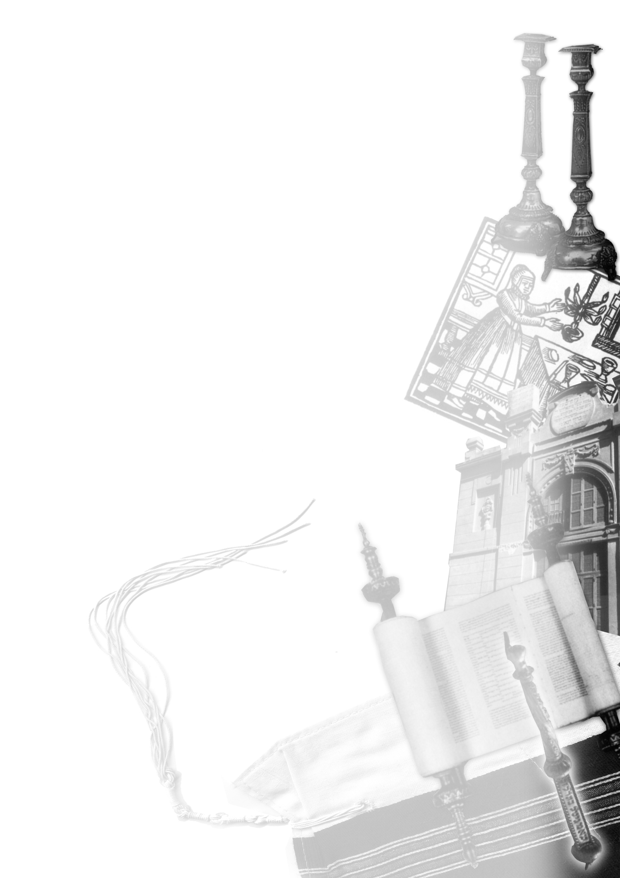
We will discuss a few issues that have to do with the sanctity of a shul.

Mechitza

The Gemorah in Succah discusses the “Takanah Gedolah” which was made in the time of the second Temple. The Gemorah explains that on Succoth there were separate areas for men and women. While the men were in the “Azara”, the women were on the balcony watching from above. This Gemorah is the source for separating pews in a Shul. What are the requirements for this Mechitza? What is the purpose of it? We will try to answer these questions.

The Purpose of the Mechitza

There are two important sources brought in the works of the Rambam about the purpose of the mechitza. In hilchot luluv he explains that its purpose is so that men and women won't mix with one another. In his commentary on Tractate Succah, he explains that the purpose is for them not to see each other. Obviously, there is a great difference between the two reasons. According to the first reason, a mechitza does not have to extend fully from the ceiling to the floor. But, according to the second opinion the mechitza has to provide more than just a separation between the sexes.
These two opinions are a source of argument among the Poskim. Rav Moshe Feinstein accepted the first reason and therefore, required the mechitza to be 18 tefachim (60 inches). The late Rebbe of Satmar accepted the second reason mentioned in the Rambam.
When is one required to have a mechitza? The Gemara was talking about a party in the Beit Mikdash, not about prayer there. Rav Kook understood that the demand of having a mechitza in a shul is because of its resemblance to the Mikdash. The same way a shul has an ark, torah scrolls and a parochet, it has an ezrat nashim as did the Mikdash.
Why have a mechitza while davening? Rav Soloveitchik dealt with this question and offered a new way of thought. The Rav argued that the idea of a family praying together is taken from the Christian world. In our religion, prayer is not a family experience but rather a way of worshiping Hashem. This act of worship is done by each individual as they face Hashem. Prayer, according to the Rav, is a personal rendezvous with Hashem.

Usage of a Shul for Other Purposes

We will now discuss other ramifications which are a result of kedushat Beit Knesset.
Eating in a Shul: This is theoretically a desecration of kedushat Beit Knesset but we find a custom in many shuls to eat seudah shlishit or even to make Kiddush after davening.
3
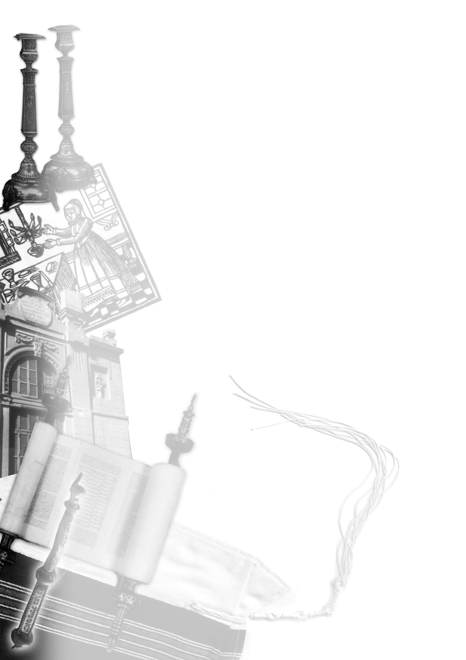
What about performing Jewish ceremonies in a shul? Is a wedding or a brit allowed? According to the Chatam Sofer, there might be other problems involved. The Chatam Sofer was concerned about the new customs that were made by the Reform movement. He suspected that these changes were done to harm Judaism and therefore was very strict when these changes were brought to his attention.

4

