Liars Club

By Yoni Halpern
Goal: the chanich will understant that lying is not a way to solve problems
Steps:

1.The truth game
2.Story
3.Discussion
4.Riddle

Things to prepare:
Candy
Cards
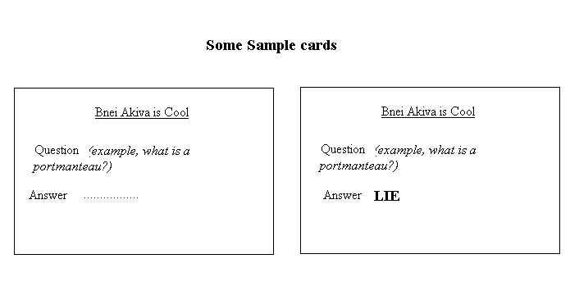
Some kids (preferably grades 3-5)

1.Game
This is a peula about lying. One kid will be telling the truth and another two will be lying. The audience has to recognize which one is the truth teller and which are the liars. The cards can have anything on them. If the madrich happens to be studying for SATs, s/he may choose to use strange words and their definitions. Otherwise it can be strange, funny facts, or difficult parsha questions or something Israel related. Kids like words that have funny sounds like linoleum or rutabaga.

Procedure:
Make 1 card with the real answer and 2 more with the word lie at the bottom. Do this for a number of different questions
The peula is set up like a game show. The Host gives each contestant a card. The more detailed the card is, the more the Host can ask the contestants. Once the contestants have had enough time to read their cards, the host asks each one of them a question in turn. The truth teller should answer truthfully (though not verbatim what he reads from his card) and the liars should answer liarly. The host can also ask more difficult questions like “Tell us a story involving a portmanteau… etc.” At the end of each round, the host asks the audience to vote which one of the 3 contestants is the truth teller. If they’re right, give them candy. If they’re wrong, give the liars lots of candy.

2. Story
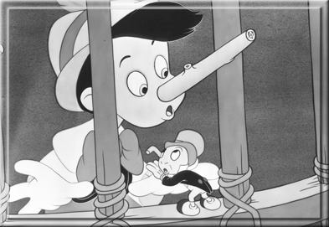
Four students didn’t come to school on the day of a big ethics exam. The next day they come to school and their professor asks them “Where were you yesterday?” They answer that they had all gone out of town in one car and the tried to get back in time for the test but one of the wheels had fallen off and the simply couldn’t get back until later. The professor said it wasn’t a problem and he would make up a new test for them. The next day they were all put in different rooms. When they opened the test, they noticed it had one question worth 100% of the marks. “Which wheel was it?”

3. Discussion:
Is it easier to lie or to tell the truth?
Short term vs. Long term
What makes a lie bad in the first place?
Are lies always bad?
When is a lie okay?
Etc.

4. A Riddle (for lots of candy)
You find yourself on an island. I don’t know how. On this island there are two tribes. One always tells the truth and one always tells lies. You come across two Natives and you have no idea what tribe they’re from. In fact, you don’t even know whether they’re from the same tribe or not. You turn to the first one and ask him, “Are you a truth teller?” He answers back “Poomee Oomee” The other one says “He says yes, but he’s a big liar.” Who’s telling the truth? The chanich will deal with dilemmas of saying the truth or lying and the results that lying can cause..

Brother where are you?
Following the themes of brotherhood in the parshot of Bereshit.

By Reva Lockshin

Goal: To have the chanichim think about their roles as siblings, and as siblings with all of Am Yisrael.

Steps:

1.Game 1: Headbands- with a twist

2. Game 2: The Perfect Sister/Brother
3.story

Things to prepare:
1.headbands (step 1)
2.red and blue cards (step 2)

Game 1: Headbands- with a twist

Two people get headbands, to wear on their heads.
- Don’t let them see each other’s headbands!
- The two people get the following instructions: you are famous pair of siblings. You may ask the audience general questions (yes/no) (e.g. are we still alive?) or questions about how you get along with each other (e.g. do we throw things at each other?)
- When you guess who you are, you win and the next pair comes up.

Prepare the headbands before Shabbat! If you don’t just send the pair out the room and then tell the group who they are.

Examples of pairs: Yaakov and Eisav, Cain and Hevel, Leah and Rachel, Mary Kate and Ashley Olsen, Serena and Venus Williams, Moshe and Aharon.

Now ask the chanichim about the characters they just were. Which siblings were nice to each other, which were not? What nice things to do some of the siblings do for each other? What mean things? Talk about what makes a good sister or brother.

Game 2: The Perfect Sister/Brother

Prepare blue and red cards before Shabbat with short sentences on them. The game is as follows: You have been given the opportunity to trade in your brother/sister and get anew one who is perfect in every way.
Split the chanichim into 2 or 3 teams.
Ask the teams trivia questions about the parsha, movies, whatever you want. Every time they get one right you let them choose one of the blue cards. Every time they get one wrong, you give them one of the red cards.

Blue cards:
Lets you play with their presents
Doesn’t tell on you

Plays with you when you’re bored
Remembers your birthday
Does your chores
Is really cool
Makes you laugh
More…

Red cards:
Makes a mess in your room
Borrows stuff and breaks it
Is annoying
Is mean
Treats you like a baby
Acts like a baby

When you decide the game is over, each team has to try and convince the other team why they have won, e.g. “Our new sister may be annoying and messy, but she always plays with us and never forgets our birthday”. Let them debate what the most important attributes in a sibling are. Now ask them to take a good look at themselves and evaluate what they are like as siblings.

3. Story:
Leo lived in a small village in Russia with his mother and father, little brothers and sisters. Life in the village was very simple. Leo’s father worked and a tailor and the rest of the family watched the chickens and geese that lived in the little coop on the side of their small hut. There were only thirty families in the village and everyone lived in small crowded huts just like Leo’s family. In the summer after doing their chores, all the children of the village would play outside until late at night, but in the winter they hardly left the house. Russian winters were cold and bitter. The snow fell up to your knees, the wind stung your face, and you tried to spend as much time indoors as possible.
But one winter, tradegy struck when the village was struck by a plague. One by one, children and adults became sick and could not get out of bed. The village doctor said that there was medicine that could cure everyone, but he didn’t have it in the village. The doctor said that he would travel to the big city to get the medicine, but the people of the village begged him not to, so he would stay and take care of them. “If you leave, we will all die before you get back with the medicine!” No one knew what to do. That night, Leo came to talk to the doctor. “Send me!” he said. “I am young and healthy and don’t have a family to take care of”. The doctor thought it was a good idea. He wrote out a prescription, and told Leo how to get to the city and where to go when he got there. Leo went home to pack his bag.
At home, Leo’s little brother saw him packing his bag, and starting packing a bag is his own. Annoyed, Leo asked Yosef what he was doing,
“I’m getting ready to go to the city with you, to get the medicine,” said Yosef.
“what do you mean?” said Leo. “Who told you where I was going? Who said you could come? You know it’s a three day journey into the city. Are you able to walk that far in the snow?” Yosef didn’t answer and just kept on packing. Finally Leo said: “Okay come with me. It will be nice to have the company.”
Leo and Yosef’s father hardly noticed that they were leaving. He was too bust fussing over their mother, who was sick in bed. He blessed them, thanked them and sent them on their way. The boys walked and walked, and in three days they reached the city. They were freezing and their legs ached, but as soon as they got the medicine they turned around to head back to the village.
On the first day of walking back, there was a huge snowstorm; the boys had to hold hands to stay together because they couldn’t even see each other through the snow. All of a sudden Leo screamed and fell down. He had tripped on a log hidden by the snow. His leg was twisted and he could not walk.
“Listen Yosef,” he said. “You must go on to the village and bring them the medicine. They need it right away. Leave me here, and when yu get to the village you can send someone to get me.”
“No,” was Yosef’s firm reply. “I can’t leave you here. You can’t walk and if you remain here in the snow for 4 days you will die.”
“So how will we get the medicine to the village?“You will carry the medicine”
“But I can’t walk…” - “And I will carry you.”
And Yosef lifted his brother onto his back and began to walk. And two days later, Yosef walked into the village with Leo on his back, holding the medicine in his arms. The doctor sent both boys to bed and used the medicine to cure the people of the village. Afterwards he saw to Leo’s broken leg. The village was saved and both boys were heroes.
The next summer, when the people of the village were once again outside all day together, people used to ask Yosef about his amazing tip with his brother.
“How did you do it?” they would ask. “Wasn’t Leo heavy to carry for two whole days?”
“Heavy?” Yosef would reply. “He’s not heavy. He’s my brother”.

Introduction :

Welcome to the latest Bnei Akiva Choveret Hadracha, "What do you think About...?" This choveret is a new experiment in Bnei Akiva of Toronto
Creativity, a collection of fabulous peulot on an assortment of topics, created
By madrichim and rashei snif around the city about the issues that they (and
You) care about. You, readers of the choveret, should feel free to use these
Excellent peulot, but should also understand that only you really know your
chanichim, really know what matters to them, so you can make them the best
peulot they can get. Please feel free to send us your ideas - we hope to be
Posting your new peulot on the soon-to-be Bnei Akiva website, IY"H. Keep up the Creativity, keep up the great hadracha!
Good luck!

