מצוות התלויות בארץ

סוג הפעולה: הצגה מפעילה
מטרה: להכיר את המושג "מצוות התלויות בארץ"" ומשמעותו, וללמוד אודות מצוות אחדות.
גיל: בי"ס יסודי
זמן: 10-15 דקות
עזרים: שני סטים של שלטים עליהם כתוב (רצוי מנוקד): לקט, שכחה, פיאה, מעשר עני, נטע רבעי.
תלבושת של איכר – חולצת כפתורים משובצת, כנסי חאקי, כובע קש רחב שוליים/כובע טמבל.
עלומת שיבולים יבשות
מגל (מבריסול/קרטון)
מהלך הפעילות: יש לחלק את הקבוצה לשתי קבוצות, ולתת לכל אחת מן הקבוצות שלטים עליהם כתוב: לקט, שכחה, פאה, מעשר עני, נטע רבעי. בכל פעם שהאיכר (המציג) מזכיר אחת מן המצוות הללו על הקבוצה לזהות שמדובר בתיאור של מצווה התלויה בארץ ולהרים את השלט המתאים.

Mitzvot dependent on the land of Israel

Hey Kids, Please don’t step on the crops!! Don’t step on the wheat. Ahh, are you the new workers that came to help me? Great, I can always use another pair of hands, especially during the harvest time.
So come on, to work. Here is a MAGAL just remember, we don’t touch the eastern corner of the field. Everything over there belongs to the poor people- they will come and collect it later. Hey! Why are you still sitting?
What, you didn’t come to work? Ahh, you came to collect? You are from the Tzedaka organization that comes everyday to gather wheat and fruit for the poor. So as I said before, the eastern corner is all yours you can take what ever you want. Oh and there are two bundles of wheat that my workers forgot in the field yesterday by the shed- you can take those as well.
Hey!! Why are you looking at me like that? You are not from the Tzedaka organization? The truth is you are not dressed like them. So where are you from? Ahhhh you are from America, New York City.
Where is NY? Is it further than Egypt? And you came here all the way by boat just to visit my field in Eretz Israel?
WOW I’m so excited!!
Ok, so welcome to my field. My name is Ephraim and I am a farmer in Eretz Israel. For many many years the farmers at Moshav_______ believe that the best way to have a good crop is to take very good care of our fields and to observe all the Mitzvot that have to do with our land. Just like it is written in the Torah.
I know it is different for you in ….what that place called? But here we are so lucky that we have the privilege to do mitavot only on the fields and vineyards of Eretz Israel.
Let me explain to you what I mean. If, for example, a farmer forgets a bundle or two of wheat in the field at the end of the day, he leaves it in place and doesn’t go back for it.
The poor can then come and collect the bundles that were forgotten. I don’t care; let my workers forget a bundle or two, but not too much. If it s more than 3 bundles and they start becoming forgetful, I make them go back and pick the bundles up. My friend a farmer in Egypt he is very strict and if one piece of wheat falls he asks his workers to pick them up. But here in Eretz Israel it’s an important Mitzvah to leave the wheat that fell behind for the poor. And believe me it pays. You have to believe in Hashem that he will give us everything we need and we should be happy that we can do Chesed and give to others who don’t have.
I’ll tell you the truth, at first it wasn’t easy. A few years ago we decided, in our Moshav, to expand and we planted orange trees. On the third year from planting the trees, sales people came and saw the beautiful delicious oranges and offered us a lot of money to buy the oranges. I said no, even though it was a great offer because the Torah says: you can’t eat from the fruit of the tree for the first 3 years.
You probably ask yourselves, how do I remember how old the trees are? Well, I’ll tell you a secret….come here…Every year on Tu Bi’shvat we celebrate the trees birthday and that’s how we know how old they are.
Anyway, back to my story…The sales people wanted me to sell the oranges now for a good price and I refused. I told them to come back after Tu Bishvat of that year, then the trees will be 4 years old and I would be able to sell. They said no and left. After Tu Bishvat we sold the oranges to other sales people from Jerusalem for a much higher price!!
You see, you have to have faith and believe that Hashem will take care of you. I believe that because I fulfill the Mitzvot that are special to the land of Israel, Hashem blesses me with wonderful fruit and wheat every year!
20 years already that we, Baruch Hashem, get rain that doesn’t damage the land, but nourishes it and gives it water to grow. Aach! Eretz Israel is great! Everything is the opposite. When you gives things up you end up doing better. You really feel Hashem is watching over you for the Mitzvot you do.
Oh, I’m talking so much and I have plenty of work to do.
You want to help? You have come all this way so maybe you want to have the opportunity to fulfill a Mitzvah that you can only do in Eretz Israel.
Who would you like to help?
We have to take out of this fruit basket a 1/10 (tenth) of the fruit and leave it for the poor. This is after I have already taken out, from the basket, a donation required for the Cohen and Levi.
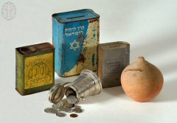




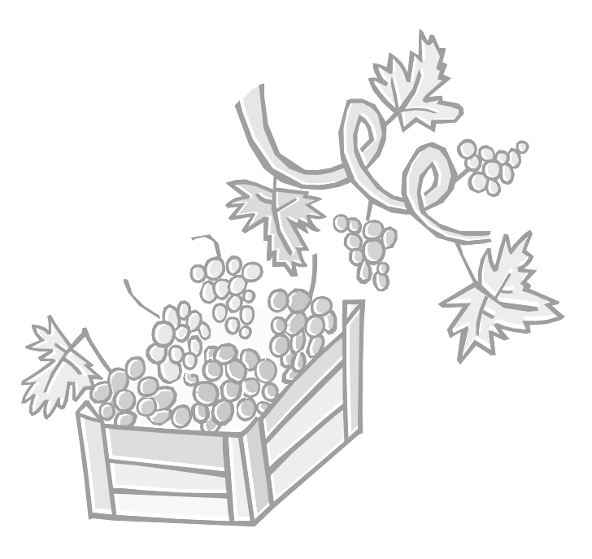
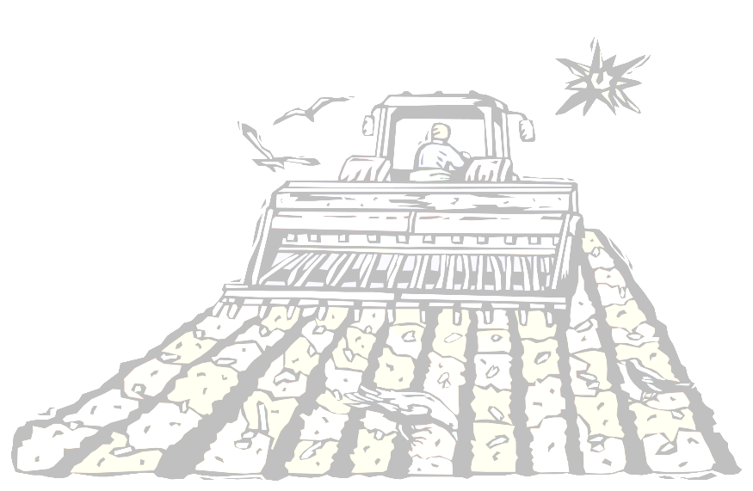
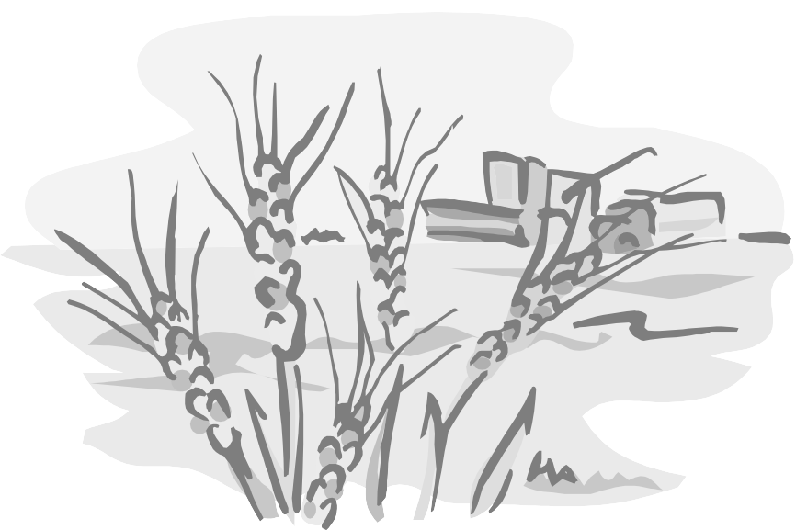
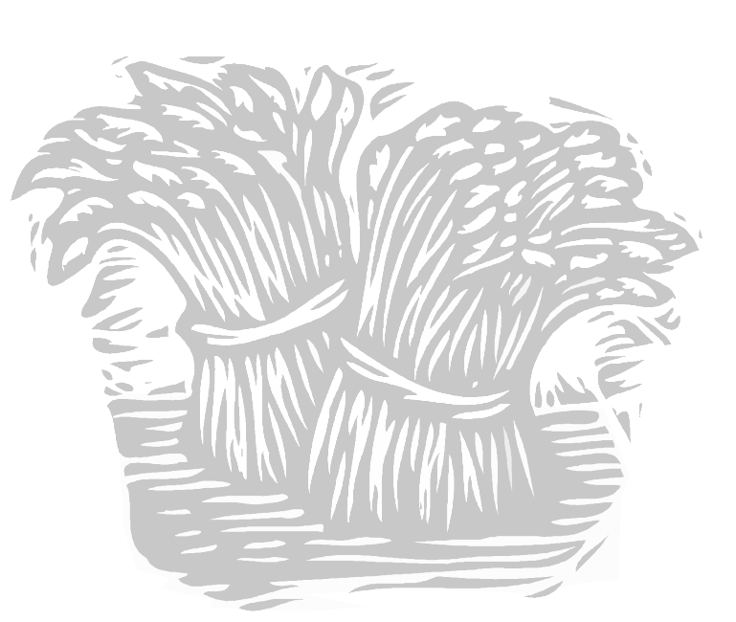

Leket
לֶקֶט

Shichichah

שִׁכְחָה
Peah

פֵּאָה

Peret

פֶּרֶט
Olelot

עוֹלְלוֹת

Shemitah

שְׁמִיטָה
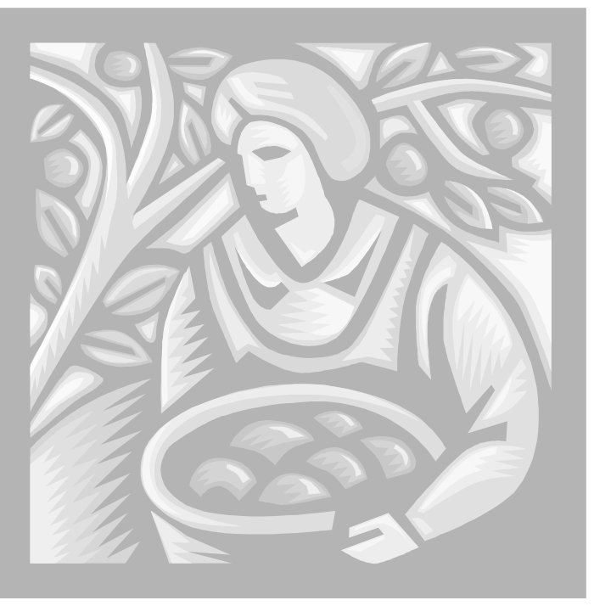
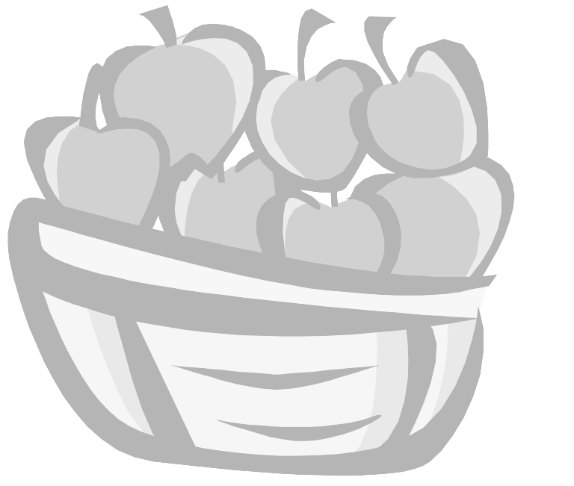
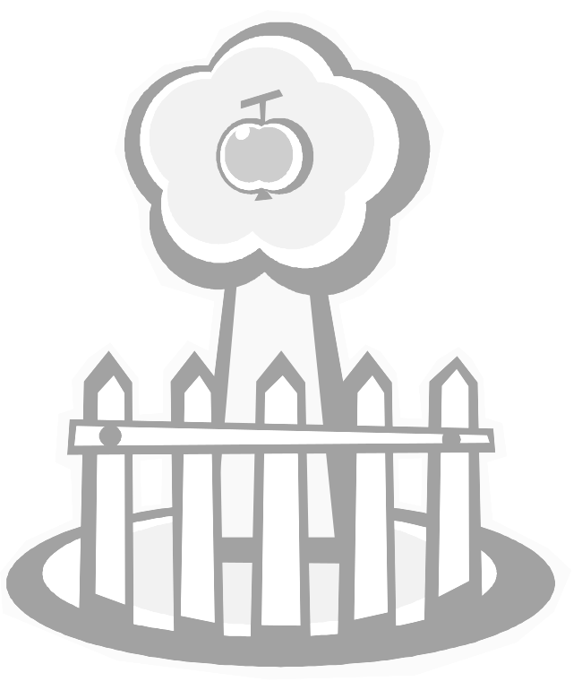
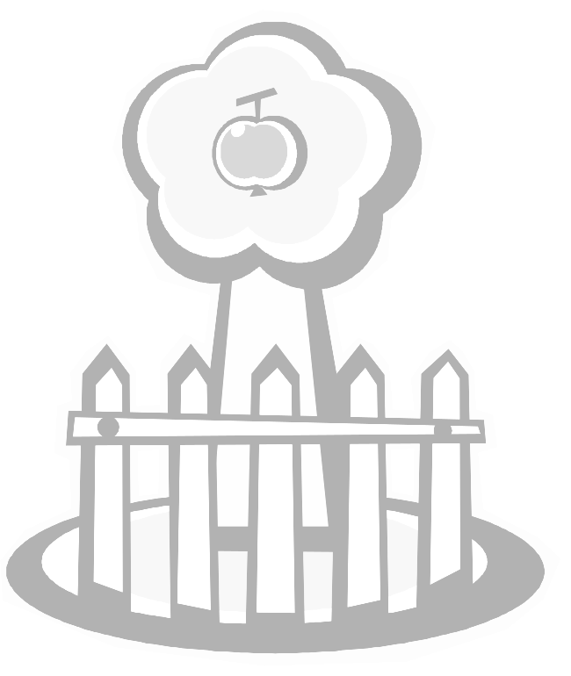
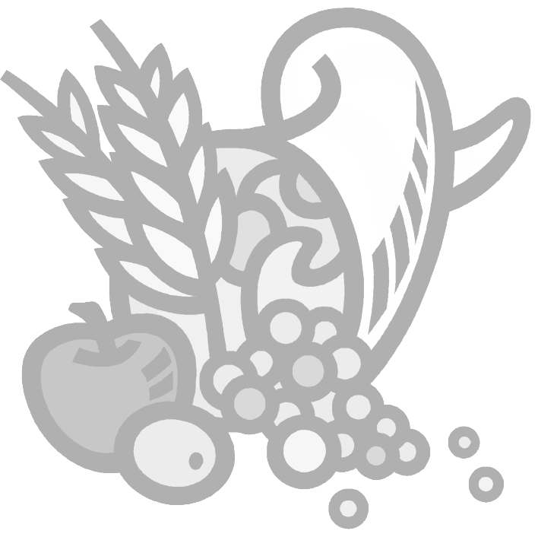
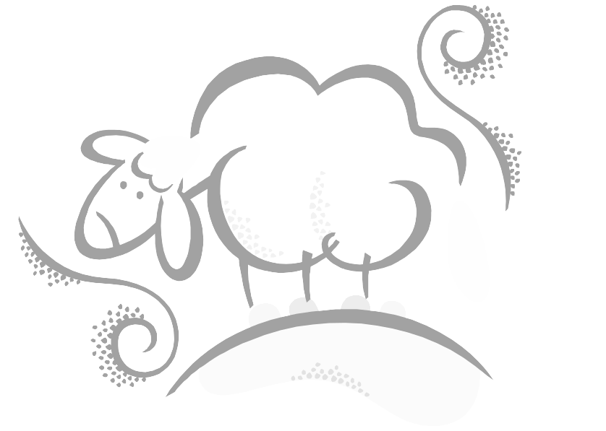
Bikkurim

בּיכּוּרִים
Orlah

עוֹרְלָה

Neta Revai

נֶטַע רְבָעי
Termot & Ma’asrot

תְּרוּמוֹת וּמַעַשְׂרוֹת

Ma’aser Ani

מַעֲשֵׂר עָנִי
Reshit HaGez

רֵאשִית הַגֵז

During the 3rd and 6th years of the Shemitah cycle, one tenth of the harvest is set aside for the poor.

We are commanded to bring the first ripe produce of the season from the Seven Species that Israel is blessed with to the Beit HaMikdash.

You may not eat or derive pleasure from the fruits of a fruit-eating tree for the first three years that it bears fruit.

You may not eat the fruits of a fruit-bearing tree during the 4th year in a state of ritual impurity or outside Jerusalem, unless you redeem the fruit with a coin. If you are in a state of purity and in Yerushalayim, you may eat such fruit without redeeming it.

You must give a percentage of the harvest to the Kohen and Levi.

If you have at least 5 sheep, you have to give some of the first wool that you shear to the Kohen.

You cannot collect individual stalks that fall from your hands during the harvest.
You must leave them for the poor.
You cannot return to collect individual stalks that were accidentally left behind in the fields during the harvest. You must leave them for the poor.
During the harvest, you are required to leave some stalks standing in the corners of the field for the poor.

When removing grapes from the vine, you must leave individual grapes that fall for the poor.

When removing grapes from the vine, you must leave the small bunches behind for the poor.

Once every seven years, you must stop working the land. Whatever grows is considered ownerless and anyone can come and take it.

