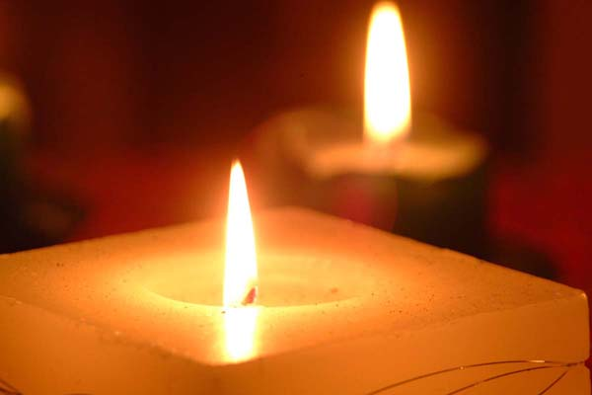
We always have to remember even when we are enjoying ourselves that there has been a lot of suffering in Israel and families will not be the same again. However, we must remember them and our lives must go on to keep their legacy alive. Israel will always be ours and no one will remove us from our homeland again.
“A nation that forgets its past has no future.” Elie Wiesel

Pvt. Yehuda Bamberger
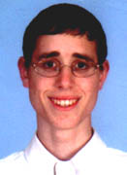
Dec 27, 2002 - Pvt. Yehuda Bamberger, 20, of Karnei Shomron was one of four yeshiva students killed in Otniel while working in the yeshiva kitchen, serving the Shabbat meal to some 100 students in the adjacent dining room.
Around 7:30 P.M. Friday, two terrorists from the nearby village of Dura in the Hebron area infiltrated Otniel, cutting the fence. They wore army uniforms, carried M-16 rifles, ammunition and hand grenads. The yeshiva, located a short distance from the fence, is a large, well-lit building, and the terrorists chose it as their target. About 100 yeshiva students were gathered in the ground-floor dining hall, waiting for the Friday night Shabbat meal. The two terrorists began to spray the building with bullets from the outside and one entered the kitchen via a service entrance. The four unarmed yeshiva students who were working in the kitchen were killed.
St.-Sgt. Noam Apter, who was on kitchen duty, managed to lock the door to the adjoining dining room before he was shot dead, saving the lives of the students seated at the tables, who opened fire from the dining room. The two terrorists from the Islamic Jihad, which claimed responsibility for the attack, were later killed by IDF forces.
Yehuda Bamberger was the eldest in his family. He completed his high school studies, majoring in computers, at the Karnei Shomron yeshiva, headed by his father, Zvi Bamberger. He loved to study, and his father described him as a "walking encyclopedia." Yehuda began his IDF service at the Otniel hesder yeshiva, combining Torah study with army service, and was to have begun paratroop training on Tuesday. He chose to remain at the yeshiva for Shabbat in order not to interrupt his studies and was killed in the attack.

Pvt. Yehuda Bamberger was buried in Karnei Shomron. He is survived by his parents, Zvi and Avigail, and six brothers and sisters.

