Declaration of Independence

Friday 14th May 1948 - Erev Shabbat 5th Iyar 5708

Eretz Israel [Hebrew: The Land of Israel] was the birthplace of the Jewish people. Here their spiritual, religious and national identity was formed. Here they achieved independence and created a culture of national and universal significance. Here they wrote and gave the Bible to the world.

Exiled from their land, the Jewish people remained faithful to it in all the countries of their dispersion, never ceasing to pray and hope for their return and for the restoration in it of their national freedom.

Impelled by this historic association, Jews strove in every successive generation to to re-establish themselves in their ancient homeland. In recent decades they returned in masses. Pioneers, ma'pilim [Hebrew: immigrants coming to Eretz-Israel in defiance of restrictive legislation] and defenders, they made deserts bloom, revived the Hebrew language, built villages and towns, and created a thriving community controlling its own economy and culture. Loving peace but knowing how to defend itself, they brought the blessing of progress to all inhabitants of the country.

In the year 5657 (1897), at the summons of the spiritual father of the Jewish State, Theodore Herzl, the First Zionist Congress convened and proclaimed the right of the Jewish people to national rebirth in its own country.

This right was recognized in the Balfour Declaration of the 2nd November, 1917, and re-affirmed in the Mandate of the League of Nations which, in particular, gave explicit international recognition to the historic connection between the Jewish people and Eretz-Israel and to the right of the Jewish people to rebuild its National Home.

The Nazi holocaust, which engulfed millions of Jews in Europe, was another clear demonstration of the urgency of the re-establishment n Eretz-Israel of the Jewish State, which would open the gates of the homeland wide to every Jew and confer upon the Jewish people the status of a fully privileged member of the comity of nations.

The survivors of the European catastrophe, as well as Jews continued to migrate to Eretz-Israel, undaunted by difficulties, restrictions and dangers, and never ceased to assert their right to a life of dignity, freedom and honest toil in their national homeland.

In the Second World War the Jewish community of this country made a full contribution in the struggle of the freedom- and peace- loving nations against the forces of Nazi evil and by the blood of its soldiers and its war effort, gained the right to be reckoned among the peoples who founded the United Nations.
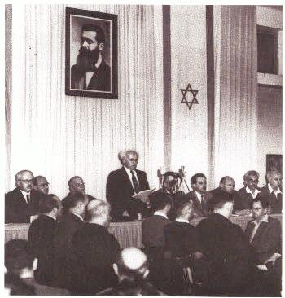
David Ben Gurion reading the Declaration

On November 29, 1947, the General Assembly of the United Nations adopted a Resolution calling for the establishment of an independent Jewish State in Eretz-Israel, and called upon the inhabitants of the country to take such steps as may be necessary on their part to put the plan into effect.

This recognition by the United Nations of the right of the Jewish people to establish their independent State is irrevocable. This right is the natural right of the Jewish people to be masters of their own fate, like all other nations, in their own sovereign State.

ACCORDINGLY, WE, MEMBERS OF THE PEOPLE'S COUNCIL, REPRESENTATIVES OF THE JEWISH COMMUNITY OF ERETZ-ISRAEL AND OF THE ZIONIST MOVEMENT, ARE HERE ASSEMBLED ON THE DAY OF THE TERMINATION OF THE BRITISH MANDATE OVER ERETZ-ISRAEL AND, BY VIRTUE OF OUR NATURAL AND HISTORIC RIGHT AND ON THE STRENGTH OF THE RESOLUTION OF THE UNITED NATIONS GENERAL ASSEMBLY, HEREBY DECLARE THE ESTABLISHMENT OF A JEWISH STATE IN ERETZ-ISRAEL, TO BE KNOWN AS THE STATE OF ISRAEL.

WE HEREBY DECLARE that, with effect from the moment of the termination of the Mandate being tonight, the eve of Sabbath, the 6th Iyar, 5708 (15th May, 1948), and until the setting up of the duly elected bodies of the State in accordance with a Constitution, to be drawn up by the Elected Constituent Assembly not later than the first day of October, 1948, the People's Council shall act as a Provisional Council of State, and its executive organ, the People's Administration, shall constitute the Provisional Government of the Jewish State, to be called "Israel".

THE STATE OF ISRAEL will be open to the immigration of Jews and for the Ingathering of the Exiles from all countries of their dispersion; will promote the development of the country for the benefit of all its inhabitants; will be based on the precepts of liberty, justice and peace as invisaged by the prophets of Israel; will uphold the full social and political equality of all its citizens, without distinction of race, creed or sex; will guarantee full freedom of conscience, worship, education and culture; will safeguard the sanctity and inviolability of the shrines and Holy Places of all religions; and will dedicate itself to the principles of the Charter of the United Nations.

THE STATE OF ISRAEL is prepared to cooperate with the agencies and representatives of the United Nations in the implementation of the Resolution of the General Assembly of November 29, 1947, and will take steps to bring about the economic union over the whole of Eretz-Israel.

WE APPEALto the United Nations to assist the Jewish people in the building-up of its State and to admit Israel into the family of nations.

WE APPEAL - in the very midst of the onslaught launched against us now for months - to the Arab inhabitants of the State if Israel to return to the ways of peace and play their part in the upbuilding of the State, on the basis of full and equal citizenship and due representation in all its bodies and institutions - provisional or permanent.

WE EXTEND our hand of peace and unity to all the neighbouring states and their peoples, and invite them to establish bonds of cooperation and mutual help with the sovereign Jewish people settled in its own land. The State of Israel is prepared to do its share in a common effort for the advancement of the entire Middle East.

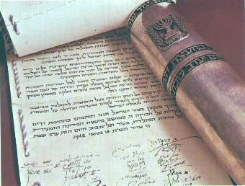
WE APPEAL to the Jewish people throughout the Diaspora to rally round the Jews of Eretz-Israel in the task of immigration and development and to stand by them in the great struggle for the fulfillment of the age-old dream - the redemption of Israel.

PLACING OUR TRUST IN THE ROCK OF ISRAEL, WE AFFIX OUR SIGNATURES TO THIS PROCLAMATION AT THIS SESSION OF THE PROVISIONAL COUNCIL OF STATE, ON THE SOIL OF THE HOMELAND, IN THE CITY OF TEL-AVIV, ON THIS SABBATH EVE, THE 5TH DAY OF IYAR, 5708 (14TH MAY,1948).

