10 minutes about...
Ilan Ramon
The First Israeli Astronaut

Background:
Ilan Ramon was the first Israeli astronaut on the Space Shuttle Columbia (STS-107) that was launched on January 16, 2003. The seven astronauts died on February 1, 2003, when Columbia broke apart during reentry into the atmosphere over Texas on its way to Kennedy Space Center in Florida.
Going to space...
1. Ask the students: pick 2 things you would take with you to space. Let each student explain about one of the things he chose.
2. Ask again: what do you think an astronaut would take with him to space? Would Israeli/jewish astronaut choose different objects?
3. Tell the students about Ilan Ramon’s choice:
Ramon carried several personal souvenirs with him into space. His wife gave him four poems and his father gave him photographs of the family. His 15-year-old son, Assaf, and Ramon's brother, Gadi, both gave him letters to be unsealed and read only after he was in orbit. Israel's president, Moshe Katsav, gave him a credit card-size microfiche copy of the Bible. He also took a pencil drawing titled "Moon Landscape" by a 14-year-old Jewish boy, Peter Ginz, who was killed at Auschwitz.
Being the first Israeli astronaut -- I feel I am representing all Jews and all Israelis," Ramon said. Referring to his mother and grandmother, who both survived imprisonment in Auschwitz, he added, "I'm the son of a Holocaust survivor -- I carry on the suffering of the Holocaust generation, and I'm kind of proof that despite all the horror they went through, we're going forward."
A Czech-Jewish boy of Prague was very intelligent and advanced kid retaining his aspiration to knowledge also during his stay in Theresienstadt Ghetto and later in Auschwitz concentration camp. Peter Ginz could be an example of excellent personality in these days. He draw before his death in a gas cell many pictures and wrote notes connected with space.

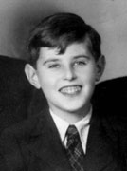
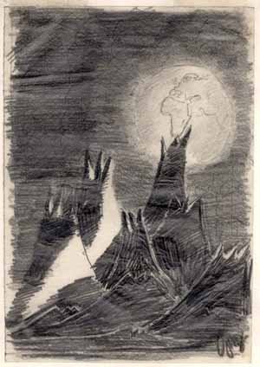

Peter Ginz (1928-1944)

Show the picture and explain
About Peter Ginz.

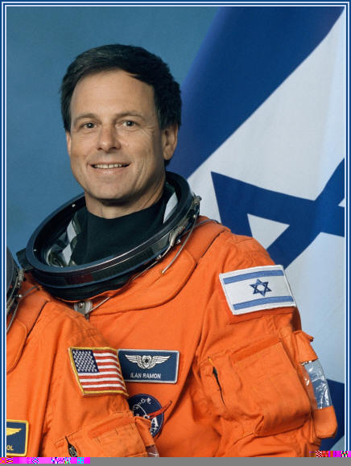

"Moon Landscape"

Ilan Ramon (1954 – 2003)

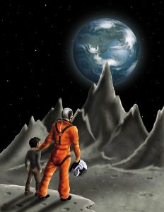

“I wanted to commemorate the spirit of both these great souls, Ilan and Peter, by repainting young Peter’s landscape in such a way as to show both of them, side by side, looking on the Earth from the vantage point of the dream they shared...as I like to think they now are.”

Painting by Barry Munden

