Bottom of Form
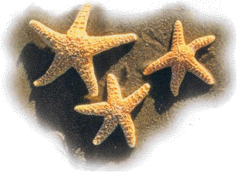
The StarFish
~ Author Unknown ~
An old man awoke just before sunrise, as he often did, to walk by the ocean's edge and greet the new day. As he moved through the morning dawn, he focused on a faint, far away motion.
He saw a youth, bending and reaching and flailing arms, dancing on the beach, no doubt in celebration of the perfect day soon to begin. As the old man approached, he realized that the youth was not dancing to the bay, but rather bending to sift through the debris left by the night's tide, stopping now and then to pick up starfish and then standing up to heave them back into the sea.
He asked the youth the purpose of the effort.
"The tide has washed the starfish onto the beach and they cannot return to the sea by themselves," the youth replied. "When the sun rises, they will die unless I throw them back into the sea."
The old man surveyed the vast expanse of beach that stretched in both directions beyond eyesight. Starfish littered the shore in numbers beyond calculation. The hopelessness of the youth's plan became clear and the old man said, "But young man, don't you realize that there are more starfish on this beach than you could ever save before the sun is up? You cannot possibly expect to make a difference!"
The youth paused briefly to consider the old man's words. He then bent down, picked up another starfish and threw it as far as possible into the sea. Turning to the old man, he said, "I made a difference to that one!"
Bnei Akiva Cleveland

