
Suggestions to Bnei Akiva Leaders

As a Madrich/a, you are an informal leader for younger children. Consider this a great honor as well as a great responsibility (as most good things in life) in which you have the ability to maximize your potential. The following are some general ideas about what it means to be a Madrich/a and how to go about entering the world of Bnei Akiva:

- Firstly, be aware of the trust put in you when you are alone with a group of children. The role is both physically and educationally demanding. You have the opportunity to influence a life, for good or bad. Because of this, you have a responsibility to represent the ideology of Bnei Akiva to your Chanichim, not only through peulot, but also by personal example. The most influence you have on your Chanichim does not come from the Peulah, but rather the way you embody what is taught in the Peulah. Everything you do in Bnei Akiva and anywhere else, whether it is your intention or not, your Chanichim might see. You can never know what they pick up--just remember that and let it sink in.

- Perhaps the best way to feel as though you are seeing progress with your Chanichim is to set a goal for yourself. Obviously, your goal will not be the same for a Chevraya Taf Madrich as it will be for a 6th grade girls Madricha, but having a goal will allow you to do several things:
- It will remind you of your purpose.
- It will allow you to reflect on your successes and failures.
- It will ensure that you are not a babysitter, but rather a Madrich/a.
- It will affect the way you handle situations with your Chanichim outside Bnei Akiva.
- It will most likely create a theme for you to establish throughout all your Peulot.

Every Peulah is created by planning in advance which is as important as the presentation during Snif.
- The more a Madrich/a is involved in planning the Peulah, the more suitable it will be for his/her Chanichim. Although the entire Snif will concentrate on the same theme, the success of your group ultimately depends on your preparedness as well as the interest level you create. If you are passionate, they will be passionate as well.
- Delivering a Peulah is a skill, which will develop with training and experience. You will find that although it may be difficult in the beginning, it will seemingly become easier as you better identify how to pursue the task at hand.

Finally, it’s time consuming to be a Madrich/a and there are many expectations involved.
- Madrichim should take part in all activities planned for their Chanichim, even if they are not directly involved in the programming.
- Madrichim should attend all Hadracha meetings and courses
- Madrichim should attend participate in Chevraya Bet activities as well as fundraising programs.

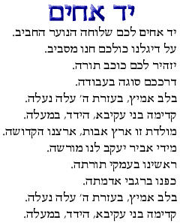
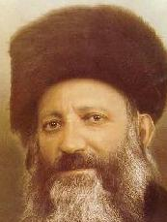
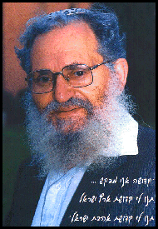
Yad Achim, the Bnei Akiva Anthem…Learn it!
Influential Bnei Akiva Rabbanim
Harav Avraham Yitzchak HaCohen Kook
Harav Moshe Tzvi Neriah
We walk in his light

