Ideas to get them to come… 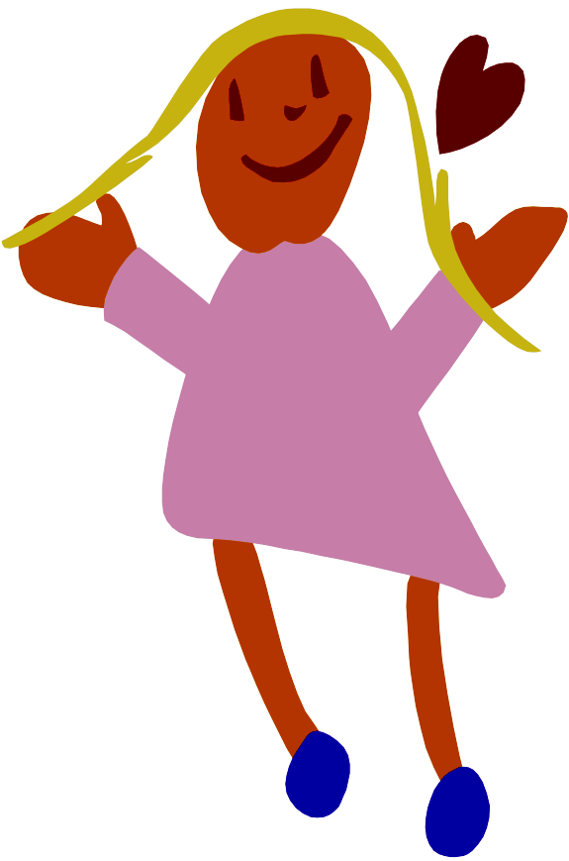

Prizes:
- Raffle- A few kids winning each week a small prize.
- Bnei Akiva Dollars – kids getting Bnei Akiva Dollars for good things like coming and participating and “buy” with them prizes.
- Bring a friend – The new Chanich and the one that got him to come win a prize.
- Jellybean Jar- for every Chanich that comes we put a jellybean in a jar, when full after many weeks than all Snif wins a big prize ( trip/ bowling… and eat the jelly beans).
- Contest- Between the age groups, who has more that come / come Kachol Lavan.
- Super Snack- every few weeks give out a special candy or candy bar they really want.

Special Events and programs:
- Shabbat meals with special program.
- Shabbat theme.
- Shabbat Eruach – Staying at a different Snif.
- Snif Play.
- Special guests.

Pure Fun:
- Movie and pizza night.
- Bowling.
- Ice Skating.
- Games
- …

Love:
- Call him up – A kid that a teenager takes an interest in him feels someone cares and will want to come again to be with his madrich.
- Talk to him – understand who he is and what goes on in his life.
- Love and respect him- everybody has something you can love. Focus on that and he will feel it and it will become contagious- he will love and respect you.

