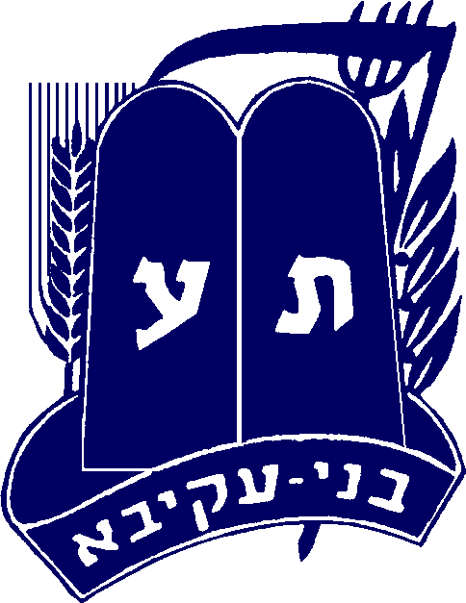
Galil NY/NJ chanuka 2005

Basic Structure:

- Welcome
- Game
- Food and Chanuka questions.
- Wrap up

- Welcome – sign up the kids get their name and collect their payment. Make sure you have someone there to tell the parents when to pick them up.

- The Game –
Split the group into two groups, give each a chanuka related name (or let them choose their own) and ask them to make up a cheer or a hip hop song for their group. Make a point chart and give points to each group according to the performance. Create in advance crowns or something to give to each group to identify it from the other.

In order to give structure to the contest between the groups, create what we call in Hebrew: a "chavila overet"- which means: a passing package. To make one, you take a small prize and wrap it in newspaper. The prize could be candy – like a bag of laffy taffies or something like that. Each wrapping of newspaper you put a note with the word "משימה" (which means task or mission) or with a question (a list of questions will be given later). You need to wrap it many times, about 20-30 wrappings. (you can make more but then make sure that some don't have notes, or your party will take 3 hours…)

How does it work? - Two options:
- Have a tape with chanuka songs, a madrich turns on the music, and then randomly stops. while the music plays, the package moves from person to person. When the music stops, the person that is holding the package opens one wrapping.

- Have a dradle, put the package in the middle. The dradle goes around and each child gets a spin. If he gets a NUN (נ'), he can open up one wrapping, if he succeeds to do it before the next person gets a NUN.

A person opens up the wrapping and gets a question – if he answers correctly, his group gets 100 points. (you can also give him a candy). If he answers wrong, you can either let someone else answer, or just give the right answer. If he gets a mission - both groups or representatives of each group need to do it and the winning group gets the points – 200 points.

The group that reaches the prize gets it and gets a few points…
If you want to make it interesting: the child that opens the package and finds a משימה takes it out of a כד שמן full with different missions and that way he chooses what to do.

Ideas for missions:

- Chanuka word game - Each group needs to write as many words related to chanuka, the group that finds the most, wins.
- The crazy gelds - Put in two bowls a chocolate coin and cover them with flour, two people need to find the coins and take them out only by blowing and using their teeth. The first person to succeed, wins.
- The crazy chanuka candle – You tie a chanuka candle with a string to the waist of two children, leaving the candle dangling in back of them. The height of the candle should be a little more than a coke bottle (2 liter) off the floor. Then you put 2 empty open coke bottles behind them and they need to get the candle in the bottle – the first one to succeed wins.
- Makabim against the Greeks – each person gets a balloon. They should be filled to a good size and approximately the same. Each group goes to the opposite corner of the room. The goal is to pop the other groups balloons while keeping your balloon un popped. The first group to finish the other groups balloons and still having a balloon wins. Note a person that his balloon was popped should not pop other kids balloons and should remove himself promptly from the game.
- The chauka presents – Make three boxes for each group that look like presents in three sizes. Make a station where the group needs to throw coins (pennies) onto the boxes. (Lets say - each group gets fifty pennies) and they stand behind a line and need to get the coins to land on the presents. There are three boxes, 10 points for the biggest box, 20 for the medium sized one, and 30 for the smallest one.
- Sending shemen zayit zach – This is basically a relay race with a twist. Put for each group a full bucket of water near them and an empty bucket of water at the other side of the room. The goal is to pass water (shemen…)from one bucket to the other. the group which fills the empty bucket the most, wins. You give each group a small plastic cup (a shot glass could be interesting) and give them 3-5 minutes. The group to fill more wins…
- The hot sufganiya – This is also a relay race- each child gets a plastic spoon and each group gets a sufganiya. they need to take the sufganiya on the spoon without dropping it, touch the opposite wall, and give it to the next kid (if you really want to make it interesting you can have them hold the spoon with their teeth.

Cool Missions harder to pull off :(most shuls won't let to run these games indoors):

- Same as the makabim against the Greeks but instead of balloons use lit candles and the other group needs to put them out – the group left with lit candles when the other groups are extinguished wins.
- Turn off the candles! – put 8 candles in a row in two stations, give each representative a water gun, The first to turn off all candles wins.
- The Yucky Stoner game – Stand each group (separate boys and girls) in a line, give the first person in each group a sufganiya in his mouth. The first group to get the sufganiya to the last person's mouth wins. Note- no using hands or anything, meaning you need to pass it from mouth to mouth.
- Dripping candle art – give each group to draw something using colorful chanuka candles and dripping it on paper (a Bnei Akiva semel for example) the group with the best one wins. (or it can just be a fun thing to do with all the kids)

3) Food and Chanuka questions:

Set up tables with nosh for the kids and also sufganiyot. After they eat and drink a little you can ask general chanuka questions that the person that knows the answer will get chanuka geld or even give out raffle tickets and then you can do a raffle at the end, and give out bigger prizes. (chanuka questions attached in separate file)

4) Wrap up:

Do a mifkad, if you have time play some "chanuka" games like : "I am sitting under a chanukiya waiting for a candle" Or fruit salad but instead of names of fruit use different names of holidays (and make yom kippur the one that makes every one change places or something like that), or other fun game adaptations.

Don't Forget :

- Massive advertisement- Flyers at sniff and at Shabbat groups and school… Phone calls… Get it on the shul bulletin n o w!
- Make sure you have a big room to do it in.
- Food – Sufganiyot…
- Prizes – chanuka geld or other –dradle filled with candy … Bnei Akiva Bands…
- Make sure you have everything you need to run the game and the missions.
- AND – VERY IMPORTANT : take pictures of the event, Print them up and put them up in your shul!

Good luck!!!

Pinchas Schatz

1. Why do we celebrate Chanukah for 8 days?
2 Why do we eat latkes and jelly doughnuts on Chanukah?
3 When do we light the Chanukah candles?
4 Who fought against the maccabim?
5 On which animal did the Greeks ride on?
6 What do we add in birkat hamzon and shmona esre on Chanukah?
7 Which city in Israel is named after the Maccbim?
8 Whose signature was on the jug of oil?
9 What is the candle that lights the other candles called?
10 What do the children get on Chanukah?
11 What are the five sons of Matityahu called?
12 What type of olive oil was used to light the Menora in the Mikdash and how was it made?
13 What Bracha do we say on the first night of chanuka, and don’t say on any other night?
14 How many candles do we light on chanuka? (not including shamashim)
15 What month’s Rosh chodesh occurs during chanuka?
16 What does it say on the draidle? What is the difference between an Israeli draidle and why?
17 What city were the makabim from?
18 Which son of Matityahu died killing an elephant he thought was ridden by the Greek king?
19 What was the wicked Greek King’s name?

Answers:
- The Miracle of the “nes pach hashemen” that lit for 8 days
- Foods full of oil – to remind us of the miracle.
- Right after Ma’ariv (for more detail look up)
- The Greeks 5)Elephants 6) Al Ha’nissim
7) Makabim, Chashmonaim, Matityahu, Modi’in,
8) The Kohen Gadol 9) The Shamash
10) Chanuka Geld/ Presents
11) Yehuda, Elazar, Shimon, Yonatan , Yochanan
12) Shemen Zayit Zach – the first drop of oil from the olive
13) She’hechyanu 14) 36 15) Tevet
16) Nun,Gimmel,Hey,Shin – the Israeli Draidle has a Pey instead of Shin – The miracle was “Po” here and not sham
17) Mo’diin 18) El’azar 19) Antiyochus

