Written by: Menachem Grossman

9th grade Oneg, Parashat lech-lecha, Bnei Akiva Cleveland
Why Israel?

סוף פרשת נח תחילת פרשת לך- לך
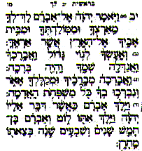
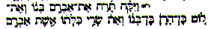
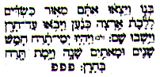

בראשית רבה פרשה לט, ח

Rabbi Levi said: when Avraham was walking through aram naharayim and aram nachor, he saw the people eating and drinking and being reckless. He said: I wish not to have a part of this land. As he was entering Eretz Canaan, he saw the people busy weeding at the time of weeding, hoeing at the time of hoeing, and said: I wish to have a part in this land!
Hashem said at that moment: לזרעך אתן את הארץ הזאת

דברים יא, ח-יז

Therefore shall you keep all the commandments, which I command you this day, that you may be strong, and go in and possess the land, which you are going over to possess; And that you may prolong your days in the land, which the Lord swore to your fathers to give to them and to their seed, a land that flows with milk and honey.
For the land, which you enter to possess, is not as the land of Egypt, from where you came out, where you sowed your seed, and watered it with your foot, as a garden of vegetables; But the land, which you are going over to possess, is a land of hills and valleys, and drinks water from the rain of the skies; A land which the Lord your God cares for; the eyes of the Lord your God are always upon it, from the beginning of the year to the end of the year.
… Take heed to yourselves, that your heart be not deceived, and you turn aside, and serve other gods, and worship them; And then the Lord’s anger be kindled against you, and he closed the skies, that there should be no rain, and that the land yield not her fruit; and lest you perish quickly from off the good land which the Lord gives you.

רמב"ן יא, י

“For the land, which you enter to possess, is not as the land of Egypt” - but better than it!… but know you that it is not like the land of Egypt [where one can find sufficient water] to irrigate it with his feet from the streams and the pools… instead, it is “a Land of hills and valleys, and drinketh water as the rain of heavens cometh down”, not in any other way, therefore it requires that God cared for it always by giving it rain because it is a very thirsty land and needs rain all year.

