Collected by: Cleveland

PALESTINIAN LIES AS AN INTEGRAL PART OF THE STRUGGLE AGAINST ISRAEL
Senior Palestinian officials have been waging a constant campaign of disinformation, spreading lies to divert the media's attention from the Palestinian Authorities' complicity in terrorist acts. The Palestinian Authority seeks to build a web of false accusations against Israel. These falsehoods are repeatedly resurrected in the hope that they will be accepted by world public opinion, if not by elements in the Middle East. Following are some examples of this Palestinian policy against Israel.
Accusing the IDF of Harming Civilians & Holy Places:
Case #1:
The Palestinian Claim: Palestinian television claimed in 2 April 2002 reports that a priest named Jack Amateis was killed and dozens of monks were injured in an IDF operation in Bethlehem.
The facts: According to Reuters on 2 April 2002, sources related to the church in Israel denied the above: Reuters announced that "A Selesian official told Reuters Amateis later phoned the Vatican embassy in the Holy Land, to say he was safe. There was fighting, but there were no victims among the Selesians. We can confirm that Amateis is alive, said the official".
The priest himself was interviewed by the MINSA agency (on 3 April, according to AFP) and confirmed that he and the nuns in the convent are safe.
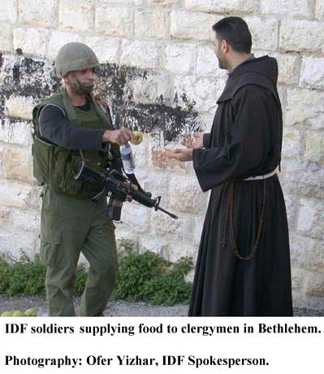
On 4 April, the Vatican's Ambassador to Israel, Cardinal Pietro Samari, apologized to the Israel Defense Forces for the incorrect and false report of the supposed death of a priest in St. Mary's Church in Bethlehem.
The IDF Spokesperson re-emphasizes that this is another instance of false Palestinian propaganda that served to embarrass the Cardinal, the media and the entire world.
Case #2:
The Palestinians: In an interview with El-Jezira Television on 3 April, Arafat claimed that Israeli forces were attacking Saint Mary's church and encircling the Church of the Nativity in Bethlehem. According to Arafat: "They burned the mosque that was located in the Church of Nativity and ruined many churches and mosques".
The facts: There is no truth in the Palestinian claims according to which a mosque in front of the Church of the Nativity was burnt. No other mosques or churches in Bethlehem were ruined by the IDF in the recent operations.
Case #3:
The Palestinians: The "WAFA" (Palestinian Press Agency) internet site claimed on 2 April that IDF forces bombed the new mosque in Tulkarem following the muazzin's call for the mid-day prayer.
The facts: Such an event never occurred. This is total fabrication.
The Palestinians seek to foist the myth that Israel is intentionally damaging Islamic and Christian religious sites. This message is repeated ad nauseam in an attempt to provoke Islamic and Christian communities in the Middle East and world over.
Case #4:
The Palestinians: On the 2nd of April 2002 Palestinians spread news which were broadcasted in a number of television channels (including the Abu-Tiab TV and a local Ramallah station), and claimed that 30 Palestinians were killed inside the Preventive Security Service HQ in Betunia during the encirclement of IDF forces.
The facts: On the 2nd of April the people who were at the compound left the building. No Palestinian was killed in the parameters of compound.
Case #5:
The Palestinians: On 30 March, Jibril Rajub claimed in an interview to Syrian ANN television and in another interview later, that there are no men wanted for terrorist acts hiding in the Bitunia compound of his security forces. Furthermore, he claimed that only his own men, along with women and children, were located in his compound.
The facts: On 2 April, five wanted suspects involved in terrorist acts, including senior Hamas operatives who organized terrorist operations in Judea and Samaria, were captured in Jibril's Bitunia compound.
Accusing the IDF of Violating Ambulances & Hospitals:
Case #6:
The Palestinians: The Palestinian Authority accused the IDF of carrying out a massacre in the Ramallah hospital.
The facts: This is an absolute falsehood.
On 31 March 2002, following the receipt of reliable intelligence concerning the whereabouts of a large number of wanted suspects hiding in Ramallah hospitals, IDF forces entered the city's hospitals. This was done in order to carry out searches and verify the identities of those people in the hospitals. The IDF soldiers carried out their missions in a manner respectful to those in the medical facilities and withdrew.
The IDF Spokesperson has strenuously denied false Palestinian claims concerning a massacre or mass murder in the Palestinian hospitals. This is another example of the baseless incitement fomented by the Palestinian Authority against the State of Israel and the IDF.
Palestinian False Claims of Attempts To Arrest Terrorists:

Case #7:
The Palestinians claimed on numerous occasions that the Palestinian Authority (PA) had arrested Palestinians involved in terrorist acts. On 2 October, the PA announced it had arrested Atef Abayat, head of the Tanzim in Bethlehem (a Fatah organization responsible for terrorist acts, also operating under the name Al - Aqsa Brigades). Abayat was involved in numerous terrorist shooting attacks, which killed many Israeli civilians. The PA also claimed to have arrested Raaed Karmi, who was personally responsible for the murders of Israeli civilians.
The facts: Israel knew that Atef Abayat was not arrested. On 18 October, Atef Abayat and 2 other terrorists were targeted by IDF while strolling freely in the Bethlehem area and organizing more terrorist attacks. Raaed Karmi was also targeted by the IDF.
Palestinians Evade Responsibility for Terrorist Attacks
Case #8 - The Murder of Government Minister Zeevi:
The Palestinians: Arafat consistently claimed in press interviews that the murder of Israeli Government Minister Rehavam Zeevi was committed by Palestinian collaborators working with Israel. On 19 February, Arafat was still making this claim in an interview to the French newspaper "l'Humanit?": "The murderers of Zeevi are collaborators with Israel and we arrested their brothers. They admitted to us that their whole family works for Israel".
On 21 February, the day the French newspaper published the interview, the murderers were arrested and interrogated by security organs of the Palestinian Authority, following heavy pressure from Israel. The transcripts of the interrogation were captured by the IDF in Arafat's Ramallah compound, and they clearly do not show any connection to Israel.
Allegations that Israel is committing terrorist acts against her own civilians are not accidental or new to Arafat. In that same interview to the French newspaper, Arafat claims: "In the terrorist attack in the Tel Aviv club (the Dolphinarium), the terrorist was transported by a man who arrived from Jordan with a visa from the Israeli embassy and is now under Israeli protection…Israeli Prime Minister Rabin himself was murdered by a man who worked for the Israeli General Security Service and who fled to the U.S.
The facts: The murder of Minister Zeevi was committed by members of the "Popular Front for the Liberation of Palestine (PFLP)" in October of 2001. That information was transmitted by Israel to the PA immediately after the murder. Arafat knew for some months who committed the Zeevi murder. The Dolphinarium terrorist act (June 2000) was committed by terrorists from the Hamas infrastructure in Judea and Samaria.

Case #9 - Murder of TIPH Observers:
The Palestinians: Arafat said in a 29 March 2002 interview on Abu Dhabi television that "…in addition to all their [the Israeli's] acts in Ramallah, Gaza Strip and other places, there was the incident in Hebron. How dare they commit such a crime. They attacked and killed 3 men of the international force: 2 Turks and one Swiss nurse".
The facts: The murder of the TIPH (Temporary International Force in Hebron) observers on the evening of 26 March was committed by the Palestinians. International bodies working with TIPH also acknowledged the Palestinian responsibility for that murder.
A TIPH vehicle travelling near Halhul was ambushed by an armed Palestinian, even though the passengers identified themselves as members of TIPH and their vehicle was clearly marked as a TIPH vehicle. The Palestinian terrorist murdered two observers and lightly wounded another. The testimony of the wounded Observer revealed that the Palestinian terrorist wore a Palestinian Police Uniform and was equipped with an AK-47 Kalashnikov weapon. The Palestinian terrorist fired three magazines at close range at the Observers, even though the force identified themselves as international observers. The IDF expressed its sorrow and shock for the cold blooded murder of innocent people.
Accusing Israel of Using Depleted Uranium
Case #10:
The Palestinians: For many months, Arafat accused Israel of using depleted uranium. Arafat claims, in an interview to the French paper " l'Humanit?" (21 Feb. 2002) that Israel "makes use of banned weapons like depleted Uranium, and this information was confirmed in the U.S. report".
In a 27 March speech given by Arafat and broadcast by El-Jezira TV (A speech originally intended for the Arab summit in Beirut) he says: "The Israeli government and the occupying army are not reluctant to use weapons that are banned internationally. That includes depleted uranium gasses and even toxic waste".
The facts: Israel does not use depleted uranium against the Palestinians. In truth, contrary to what Arafat claims, the U.S did not confirm that Israel used depleted uranium against the Palestinians.

The "Karine A" Affair Case #11:
The Palestinians: Arafat has consistently dened his or the PA's involvement in the Karine A arms ship intercepted by the IDF. In a 19 January interview with Egyptian television, Arafat claimed: "Let us see who can prove that this ship belongs to the PA. It is a well known fact that there is no connection between us and the Iranians on that subject… Had we wanted to import arms, we could import them from any of our Arab brothers. No Arab country would say "No". Hence, why should I import the arms from Iran?."
Ammunition seized by IDF forces on the ship" Karine A "early Thursday .3.1.02 (morning)
Picture :IDF Spokesperson's Unit
The facts: The arms ship "Karine A", which carried on board many tons of quality weaponry, including anti-tank and anti-aircraft missiles, was a smuggling operation run by Palestinian Authority. According to the evidence found on board, the weaponry originated in Iran. The smuggling was financed and organized by Fuad Shubaki, the head of the financial administration of the Palestinian General Security Services and an Arafat confidant. The ship's captain and crew were members of the Palestinian Naval Police.
Arafat gradually retracted part of his denials in the "Karine A" affair.
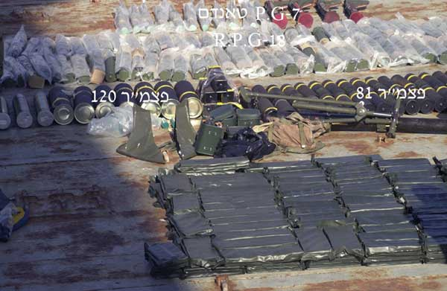
Ammunition seized by IDF forces on the ship" Karine A "early Thursday .3.1.02 (morning)
Picture :IDF Spokesperson's Unit
Conclusions:
There is a lesson to be learned from all of these lies. As Abraham Lincoln said, "…You can't fool all of the people all of the time…"
The involvement of the PA, Arafat and his senior assistants in organizing and funding terrorist attacks has been proven.
As time goes on, Israel will eventually unveil the web of PA lies, which the Palestinians are trying to conceal in their ongoing campaign of disinformation to the media.
