Tu B’shvat

This Peula is suitable for all ages. Choose the parts and questions that are relevant for your chanichim.

Goal:the chanich will gain more information about the holiday by a game.

Steps:
- clues – the 7 spices.
- game
- a Zionist date
- summary

1.Clues – the 7 spices:
devide your chanichim into a few groups. give each group a clue – the answer is one of the 7 spices.ask each group what was her answer and what is the connection between all the answers.

2. Bingo/Tic-tac -to:
prepare bingo boards for each chanich.read the riddles and let the chanichin mark their square in a creative way (Shabbat).
Riddles:
1. My oil was used to lit the menorah in the temple in chanucka. (olive)
2. I don’t need a lot of water,so I can live even in the fields of the negev. (barley)
3.to bishvat is called ___________ lailanot =trees. (rosh hashana)
4.”TU” refers to the ________ day of shvat (15)
5.we are made out of dry grapes (raisons)
6.the first wineyard in the bible was planted by (noah)
7.the first tree mentioned in the bible (eitz hadaat)
8.a different for tree in Hebrew (ilan)
9. the insitute that is in charge planting trees in Israel (keren kayemet leisrael)
10. the prophet micha says about days of peace: “and each man will sit beneath his grapevine and his ________ tree and no one will fear”(fig)
11. some people say I have 365 fruits, exactly like the number of mitzvoth in the torah. (pomegranate)
12. bread is made out of me (wheat)
13.under which tree did yonah the prophet sit ?(kikayon)
14. Under which tree did Dvorah the prophet sit ?(alon)
15. A school in Toronto that has the word tree in it. (eitz chaim)
16.who was ILAN ramon – was he a tree? (the first Israeli astronaut)?
17.what is the bracha we say on a banana? (“בורא פרי האדמה”-because it grows on a bush)
18.if you plant a new tree, after how many years can you eat the fruit?(5)
19.they year we are not supposed to work,plant or enjoy fruits (shanat shmita)
20.which Israeli institute whas established on tu bishvat?(the Knesset)

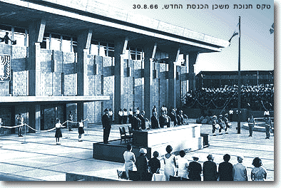

, On the 14th of February, 1949 (Tu Bishvat 5709), the Constituent Assembly, which within two days became the first Knesset, held its first meeting in the Jewish Agency building in Jerusalem.
At that first sitting, the President of the Provisional Council of State, Dr. Chaim Weizmann, stated in his opening address: "It is with a sense of honor and awe that I rise to open the Constituent Assembly of the State of Israel, the first Jewish assembly of our day, in Jerusalem, the eternal city. At this great moment in the history of our people, we give thanks and praise to the God of Israel by whose grace we have been privileged to see redemption, after generations of suffering and misery... Knesset members! I congratulate you on your first meeting. Remember that the eyes of the whole Jewish world are upon you, and that the yearning and prayers of past generations accompany you. May we all be worthy of this great moment and this immense responsibility..."
(Translation from Lorch, N., Major Knesset Debates)

Because that first convention of the Constituent Assembly occurred on Tu Bishvat, the Knesset celebrates its "birthday"
on that day each year

.I am one of the oldest and common trees in the land of Israel. you can find trees like me, thousand years old in the Galilee.
I was major actress in the story of Chanukah: when the people of Israel wanted to lit the menorah in the temple,they used only one small can of my oil – the only one they could find. But guess what? My oil lit the menorah 8 days and it was a big miracle.
Today,when ther’s no temple you can just find me in the super-market,un the vegatable section,in a can or a bottle.
Who am I?

.we both look a little bit the same.
The _______ is considered one of man’s most basic crops – from _______ flour bread is produced. On Shavuot, the festival of first fruit – the first of the ______crop would be brought to the temple.

The _______ is an important grain in Israel.Because it requires less water than no. 1 , it grows even in the fields of the Negev. The harvest begins in the month of Nissan and two weeks later it was brought to the temple as a part of the pesach festival in Jerusalem.

. I have rich red flowers, and dark red fruit. my shape is very interesting, if you go to your sinsgo ge on shabbat – you may see me made out from gold – decorating the torah.
Even the high priest used my shape to decorate his garment in the temple.
Some people say I have 356 pieces of fruit inside, like the number of mitzvoth in the torah.they wish each other on Rosh Hashana after they eat me: “may you have lots of ______ like in the pomegranate”
Who am I?

Man has been using me since earliest times: Noah planted the first vineyard mentioned in the bible after the flood.
You can find me in red or green.i can even provide wine – dry or sweet,that makes people happy.i am a symbol to the bounty of the land of Israel/
Who am I?

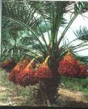
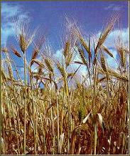
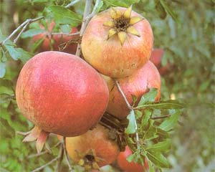

I’ll start from the beginning: prophet micha has mentioned me in his vision of peace of land: “ each man will sit beneath his grapevine and his _______ tree and no one will fear”.that’s true,my tree makes so much shade,you can just sit and relax and eat some of my fruit in a very hot day in the summer.you can eat me dry or fresh.i am a symbol of fertility.

.i usually grow up with a few houndred frits like me,on a very tall tree.this tree is very useful,especially in the holiday of suukot:the branches are being used for civer,the fibers for rope and the trunk for building.
By the end of the summer-we are picked from the trees,when we are already yellow and being eaten fresh or dry.
Oh!I forgot! I have a major part in rosh hashana too.the honey that is made out of me,is being eaten together with the apple – when everyone blesses each other “may yoh have a good and sweet year”.
Who am I?

Bingo Tu Bshvat

Bingo Tu Bshvat

ולמה זכו אילנות לראש השנה המיוחד לעצמם?
ראו שניתן ראש-השנה לבני-אדם, באו ואמרו: כתוב בתורה 'כי
האדם עץ השדה'. נמשל אדם לעץ ועץ לאדם. ואם כך, מה אדם יש
לו ראש-השנה, אף עץ בדין הוא שיהיה לו ראש-השנה. וכיוון
שדיברו אילנות דברים של טעם נתקבלו דבריהם. אמרו להם:
באיזה חודש נקבע ראש-השנה שלכם? השיבו אילנות: כיוון שאנו
צריכים למים קבעוהו בשבט שמזלו דלי.
(הימן הירושלמי)

שירת העשבים/נעמי שמר
לנטוע במו ידי
יזכני ה' יתברך לנטע במו ידי
עצי פרי בסביבות ירושלים לקיים
".וכי תבואו אל הארץ ונטעתם"

הגר"א מוילנא

דע לך
שכל רועה ורועה
יש לו ניגון מיוחד משלו.

דע לך
שכל עשב ועשב
יש לו שירה מיוחדת משלו.
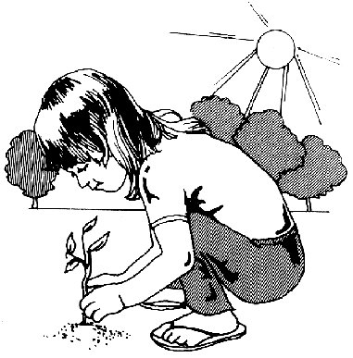
ומישרת העשבים

נעשה ניגון
של רועה.
וכשהלב
מן השירה מתמלא ומשתוקק
אל ארץ-ישראל,
אור גדול
אזי נמשך והולך
מקדושתה של הארץ עליו.
ומישרת העשבים נעשה ניגון של הלב

