The Omer
Goals:
Aleph Aims | Bet Aims
To learn about the Omer, and more specifically Lag Ba’omer  To learn about the life, times and teachings of Rabbi Akiva | To learn about Lag ba’omer in connection with Rabbi Akiva  To understand some ideas as to why BA is named after Rabbi Akiva
Suggested Age: chevraya aleph
Suitable for Shabbat
Materials: prepare 3 or 4 fictional or non-fictional characters to explain why Bnei Akiva should be named after them

Introduction

VOLUME TWENTY ISSUE SEVEN ---------- 17/05/03 ----------- Behar ----------- (c) Rabbi Akiva
Spiritually, the start of the Omer period begins transforming us as a people from having a slave mentality, dependent and oppressed, toward becoming an increasingly independent people, a people exploring all the possibilities and responsibilities of freedom.
Thus the Omer is the time we transform ourselves. We change from newly free people, just beginning to explore the possibilities of growth, awareness and self-definition. We start as a collection of wanderers and seekers and become a spiritual community of souls open to receive that which is revealed.
Central to this period in the Jewish calendar is the festival of Lag ba’omer and more specifically Rabbi Akiva, who is possibly one of the most important figures in Jewish history, and whose teachings are still so relevant and inspirational today.

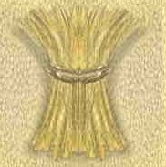
What is the Omer?
When the Temple was standing, barley was the first agricultural crop in Israel to be ready for harvest in the early spring. Ancient near eastern cultures had different ways of expressing gratitude to the spiritual forces which contributed to a healthy harvest. During Biblical times, a sheaf of barley (known as the Omer), selected from the choicest of the barley grown within the land of Israel, was brought to the Priests as an offering (Lev 23:10-12).

The Omer was brought to the Temple each day for the next 49 days, during which time the next, and most important grain, the wheat, was ripening. Counting these 49 days is known as Counting the Omer. These 49 days of the counting of the Omer culminate on the 50th day, the first day of Shavuot, the Festival of Weeks. The Omer period begins on the second day of Pesach, the day after we gain our freedom from slavery. Since Jewish days begin after sunset, the first day of the Omer period falls on the evening of the second Seder to the evening of the second Seder, on the sixteenth of the Hebrew month of Nisan.
Hadracha Top Tip no.21
Never undermine a co-madrich in front of your chans. (DS)

Sefirat Ha’omer
According to the Torah (Leviticus 23,15), we are obligated to count the days from the second night of Passover to the day before Shavu'ot, seven full weeks. This period is known as the Counting of the Omer. An omer is a unit of measure. On the second day of Passover, in the days of the Temple, an omer of barley was cut down and brought to the Temple as an offering.
Every night, from the second night of Passover to the night before Shavu'ot, we recite a blessing and state the count of the omer in both weeks and days. So on the 16th day, you would say "Today is sixteen days, which is two weeks and two days of the Omer".

Because the twenty-four thousand students of Rabbi Akiva (a Sage of the Talmud) died in a thirty-three day period during the time of the counting of the Omer we are required to follow certain practices of mourning for a thirty-three day period during this time. Thus we may not cut our hair, perform weddings, or listen to music during this period. This period of mourning ends on Lag BaOmer, the 33rd day.

Lag Ba’omer
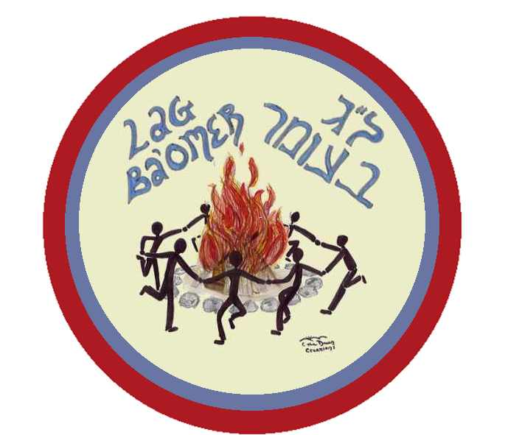
As already written we are commanded by the Torah to count forty-nine days starting from the second day of Passover. On the fiftieth day we celebrate the festival of Shavuot, commemorating the Giving of the Torah. "Lag BaOmer" is the thirty-third day of counting the Omer. The word "Lag" means 33 because it is comprised of the letters "lamud" and "gimmel," corresponding to the numerical values of "30" and "3."

The greater the potential there is for growth and building, the greater the potential there is for destruction. Consequently, in eras when the Jewish People have not lived up to their potential, the Omer period has become one of tragedy.

In the time of Rabbi Akiva, who witnessed the destruction of the Second Temple and who was the greatest Torah Sage of his generation, twenty four thousand of his disciples died in an epidemic. The underlying spiritual cause of the epidemic was the students' lack of respect for each other. This sad event and others took place during the Counting of the Omer. As a result, the Omer period has become one of semi-mourning in which we don't hold weddings or festivities, nor do we shave or get haircuts. But because the epidemic was suspended on the 33rd day -Lag BaOmer- Lag BaOmer has become a joyous day of celebration.
After all his students died, Rabbi Akiva "started over" and began teaching other students. One of his foremost students was Rabbi Shimon bar Yochai, the author of the Zohar. The Zohar, which means "The Shining Light," is the basis of the secret teachings of the Torah. Some people light bonfires on Lag BaOmer and sing songs in honor of Rabbi Shimon bar Yochai, who revealed the teachings of the Zohar to the world on Lag BaOmer.

According to tradition, the day that Rav Shimon bar Yochai passed away was Lag BaOmer, the eighteenth of Iyar. Even though the death of such a great sage is a sad event, there is also joy surrounding the fact that he attained his final reward, and the fact that he revealed many deep secrets of the Torah to his students on his dying day. The fire which surrounded the house, preventing any but Rav Shimon's closest students from approaching, serves as a basis for the custom of lighting bonfires on Lag BaOmer.

Rabbi Akiva-Hero and Martyr
One of Israel's greatest sages, Rabbi Akiva ben Yosef, was a scholar, a teacher, a shepherd and a revolutionary.
A revolutionary? In the year 70 of the Common Era, the Romans destroyed the Second Temple and the Jews were exiled from Jerusalem. The emperor promised to rebuild the city, but his plan was to rebuild it and rename it Aeila Capitalina, dedicating it to the Roman god, Jupiter. This outrageous act, along with the harsh laws forbidding the study of Torah and the observance of many of the mitzvot, led to the Bar Kochba revolt over 60 years after the destruction of the Temple, in the year 132 CE.
One day someone said to him "Akiba, why do you break the Roman law by teaching Torah? Do you wish to be imprisoned--or worse?"
Akiba answered him with this story: "Once upon a time a very hungry fox was walking along a stream when he noticed that the stream was full of fish--any one of which would make a great lunch. He came close to the edge of the stream and attracted the attention of one of the fish. He said to it, "You are in great danger! People are coming with nets to catch you. But I have come to rescue you. Come with me and I will take you to a safe place far from this stream and the nets that are coming..." The fox moved closer and reached out for the fish. The fish swam back a safe distance from the shore and said: "How foolish do you think I am? If I go with you and leave my home in the water I will certainly die. If I stay here--I will keep my life AND I can watch out for the nets and try to escape."
As fish will surely die without water, so the Jewish people will surely die without the Torah. As water is home to the fish, Torah is home to us. Breaking the law by studying Torah may be dangerous but NOT studying Torah is far more dangerous....

While Shimon Bar Kochba was the military commander of the revolt, the spiritual leader was Rabbi Akiva. He had such faith in Bar Kochba that he believed him to be the Messiah, which, unfortunately, he was not. It was during the Bar Kochba revolt that the 24,000 of Rabbi Akiva's students died in a plague. The rabbis understood this plague to be a result of the students lack of respect for each other, and, despite their high level of intellectual development, their lack of proper moral comportment was fatal. Devastated by the death of his pupils, and the failure of the Bar Kochba revolt, Rabbi Akiva nevertheless persevered and continued teaching his surviving students.
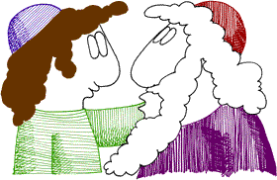
Rabbi Akiva – The Simple Shepherd
Where did Rabbi Akiva get the strength to persevere while watching all but 5 of his students die, his country in revolution, and while being tortured himself?
Akiva ben Yosef ben Avraham was not always a great sage. In fact, he was the son of a convert who was once a thoroughly ignorant and illiterate shepherd. So poor and downtrodden a figure was Akiva ben Yosef that his father-in-law, one of the wealthiest men in Israel, disinherited his daughter, Rachel, for marrying him.
At the age of forty, Akiva's life changed suddenly. One day, while out tending his flocks, he noticed a rock with a strange hole going straight through it. This hole was created by constantly dripping water. Akiva ben Yosef decided then and there to go and learn Torah, for if dripping water could bore a hole into solid rock, then even he, a forty year old man could learn Torah through constant effort. He had to start from scratch, for Akiva ben Yosef did not even know the aleph-bet!
Fully supported by Rachel, his wife, he went to study Torah for 12 years. When he returned he overheard his wife tell a friend that she would gladly let him learn for another 12 years. And he did. When he finally returned, he had become the great sage and acquired his 24,000 students.
Like Moses, Rabbi Akiva started as a shepherd. He became one of the greatest sages of the Jewish people with enough wisdom to unravel the intricacies of the law, guide the populace, and inspire an army.

Despite Roman decrees against teaching Torah, the aged Rabbi Akiva continued to teach. Akiva was arrested by the Romans. Some say he died in prison. Tradition, however, says that after being imprisoned for three years, he was put on trial and sentenced to death. While the Romans were torturing him to death, he recited the Shema and explained to those present that now he understood the true meaning of loving the Lord with all they heart, soul, and might.

So why are we named after Rabbi Akiva?
There are a number of distinct divisions throughout Rabbi Akiva’s life. He started out as a shepherd, then became a Talmid Chacham, then he became a fighter for the freedom of his people, and finally he died as a martyr.
He embodies a number of distinct character traits. He was mainly self-confident with a powerful will. He was diligent, determined and always persevered with what he did. Above all, he was modest.
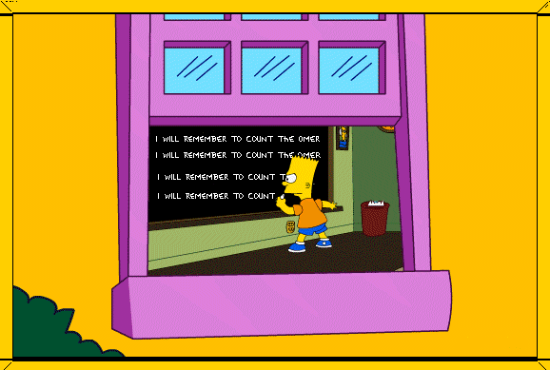
There are five possible aspects or reasons as to why Bnei Akiva is named after him:
- Rabbi Akiva cared for and fought for Torah, Am Yisrael and Eretz Yisrael.
- He placed a very strong emphasis on the importance of treating each other correctly and caring for all Jews.
- Despite his humble, poor and ignorant beginnings, he rose to be one of the greatest scholars ever.
- He fought and gave up his life for what he believed in
- He was most of all a Tzaddik and a Talmid Chacham.
Understandably, these are all traits that we aim to mirror as members of Bnei Akiva, and as a true dugma to our movement we can look at his life and teachings as a shining light to all we believe in.
a little helper...
Think of Games where numbers play a crucial part (Aim: to show the importance of counting down to something)

Aleph GAMES

- Countdown: whilst clapping to a beat, go round the circle counting to 100- harder than it sounds!
- Count-up: Have to count 1-10 as a group shouting out numbers, if number said at the same time- go back to the beginning!
Bet GAMES

- Bnei who?: conduct a balloon debate involving Rabbi Akiva and three other characters (fictional or non-fictional). They have to prepare a speech as to why they think Bnei Akiva should be called after them. Lead this to a discussion as to why BA is named after Rabbi Akiva- and its ideology!?
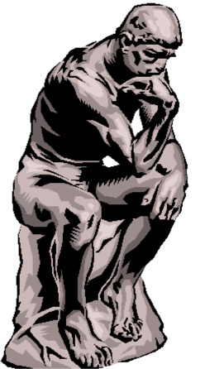
Do we all have to be at the level of Rabbi Akiva, or is it more important to fulfil one potential.
How far should we go in keeping up our beliefs?
How can we as members of Bnei Akiva emulate Rabbi Akiva in practice?

Hadracha Choveret: A Publication of the Bnei Akiva Chinuch Department
2 Hallswelle Road, London NW11 0DJ T: 020 8209 1319 F: 020 8209 0107 E: chinuch@bauk.org

